Name ............................................................................ class:.........................

[](http://www.google.com.sa/imgres?q=hand+point+clipart&hl=ar&safe=active&biw=1366&bih=650&gbv=2&tbm=isch&tbnid=fTEcVcIRrVsPLM:&imgrefurl=http://www.canstockphoto.com/hand-pointing-6997110.html&docid=PGaieFFih5ZJ6M&imgurl=http://comps.canstockphoto.com/can-stock-photo_csp6997110.jpg&w=399&h=415&ei=rcHgTp-TFY-MswbNraCLCQ&zoom=1)[](http://www.google.com.sa/imgres?q=group+of+little+boys+clipart&hl=ar&safe=active&biw=1366&bih=650&gbv=2&tbm=isch&tbnid=9GDQ4Gt1TEECtM:&imgrefurl=http://www.clutterfreekids.com/&docid=tjPTq6RgfaO9WM&imgurl=http://clutterfreekids.com/library/kids-clipart.gif&w=640&h=380&ei=R8XgTrv3NMT5sgbL1eD-CA&zoom=1)  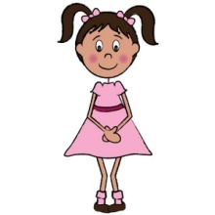

**I he she we you**

my his her our your

His

My

Your

Her

Our

…… am Saudi

……… is Rana

……… is Omar

......... are a student

....... are friends

……………country is Saudi Arabi.

………………name is Rana

………………name is Omar

……………………coat is nice

…………………school is beautiful

She

I

He

We

You

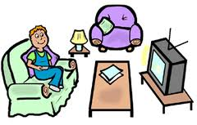

1-We are sisters

2- This is …………………living room

1- Is this ( you – your ) bed room ?

2- No, it's ( my - I ) bathroom .

3- ( We – Our ) garden is beautiful .

4- ( My - I ) bag is small.

5- This is Leen . This is ......... bed .

6- This is Ahmad . This is ......... pen .

[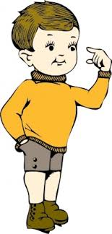](http://www.google.com.sa/imgres?q=little+boy+clipart&start=21&hl=ar&safe=active&sa=N&biw=1366&bih=650&gbv=2&tbm=isch&tbnid=w3KLZpMXgB9aHM:&imgrefurl=http://www.easyvectors.com/browse/other/little-boy-clip-art&docid=TTj54DZSue46ZM&imgurl=http://www.easyvectors.com/assets/images/vectors/afbig/little-boy-clip-art.jpg&w=204&h=425&ei=u7LjTrT5DuvY4QSgmLiNBQ&zoom=1)

1- He is Nader.

2-This is …………….... hair .

[](http://www.google.com.sa/imgres?q=little+girl+clipart&hl=ar&safe=active&biw=1366&bih=650&gbv=2&tbm=isch&tbnid=QQfdFjp60Dh3UM:&imgrefurl=http://www.sodahead.com/fun/girl-with-umbrella-cute-or-lame/question-1692577/&docid=Wke-i4kx1sm6NM&imgurl=http://3.bp.blogspot.com/_60Zh4hjqrM8/TL0IP87gOtI/AAAAAAAAAg8/-BiQomCyuJU/s1600/73051-Royalty-Free-RF-Clipart-Illustration-Of-A-Cute-Little-Girl-Wearing-A-Rain-Coat-And-Rubber-Boots-And-Standing-Under-An-Umbrella.jpg&w=300&h=450&ei=I8TgTsLiBsmu8QP7we2bCQ&zoom=1)

1- She is Layla .

2- This is .…………... chair

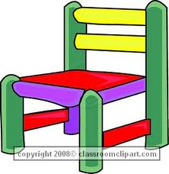

**C:\Users\Sara\AppData\Local\Microsoft\Windows\Temporary Internet Files\Content.IE5\ITRU5UXH\MC900413478[1].wmfreorder the letters :**

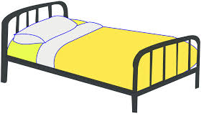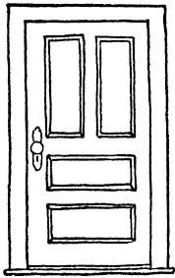

**odro bde ouehs**

**................ .......... ..............**

**Name the correct objects :**

**1- This is a.............** 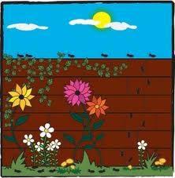

**2- This is a ............. **

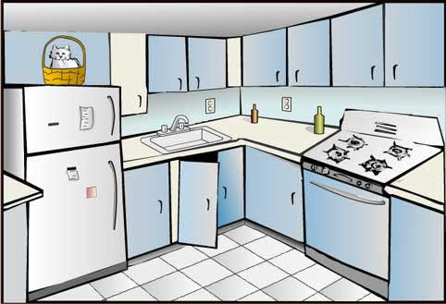

**3- This is the .............**

**4-This is a...............**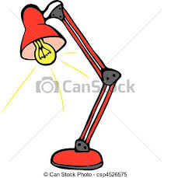

1- Is this ( you – your ) bed room ?

2- No, it's ( my - I ) bathroom .

3- ( We – Our ) garden is beautiful .

4- ( My - I ) bag is small.

5- This is Leen . This is ......... bed .

6- This is Ahmad . This is ......... pen .

1-What is your first name ?

…………………………………………

2-What is your last name ?

………………………………………………….………….

3- Where are you from ?

……………………………………………………………

**Listen and number :**

**chair ( ) shop ( ) shoes ( ) teacher ( ) she ( )**