
Kingdome Of Saudi Arabia
Ministry Of Education
Education Management Of ……………………
Education Office ………………….
School : ..............................

المسار : البرنامج المشترك | العام الدراسي : 1434/1435هـ
Work Paber Of

Secondary Stage

The Principle | Supervisor | Teacher
............................ | ............................ | ............................

Unit (1) Trends Lesson 1
1. Match the words with the correct examples.
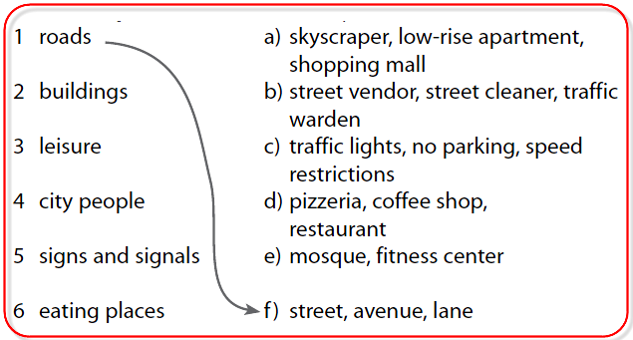
2. Read these descriptions of two people.
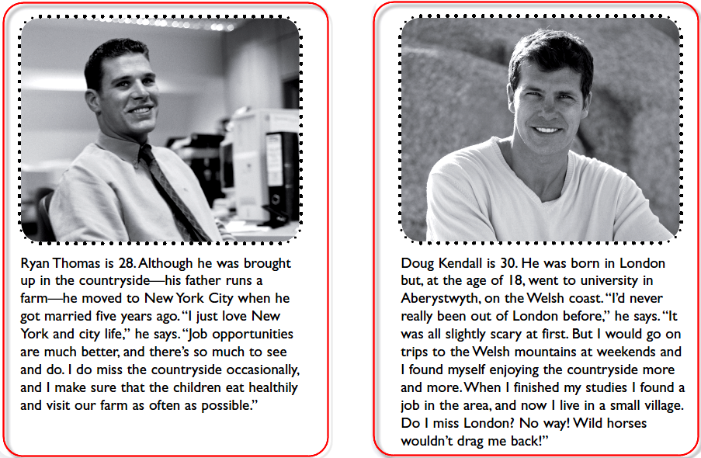
_What score would Ryan and Doug get on the City or country quiz?
……………………………………………………………………………………………………………………………………………………………………………………………….
Unit (1) Trends Lesson 2

1. Match the articles of clothing in the box to the appropriate area of the body.
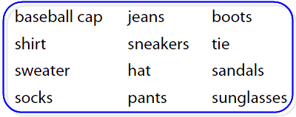
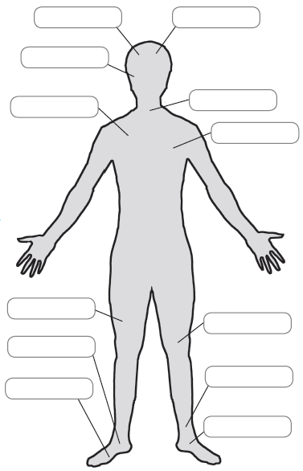
2. Write three sentences about what you are wearing.
……………………………………………………………………………………………………………………………………………………………………………………………….

Unit (1) Trends Lesson 2

1.Put the words in the correct order to form sentences:
1. shoes / pair / tennis / a / white / of
……………………………………………………………………………………………………………………………………………………………………..
2. Yellow / red / and / a / shirt
……………………………………………………………………………………………………………………………………………………………………..
3 .gold / small / a / pair / earrings / of
……………………………………………………………………………………………………………………………………………………………………..
4. horrible / cotton / dress / blue / a
……………………………………………………………………………………………………………………………………………………………………..
5 .plastic / black / a / jacket
……………………………………………………………………………………………………………………………………………………………………..
6. skirt / suede / beautiful / blue / a
……………………………………………………………………………………………………………………………………………………………………..

2. Read the text and put the correct title at the top of each paragraph.
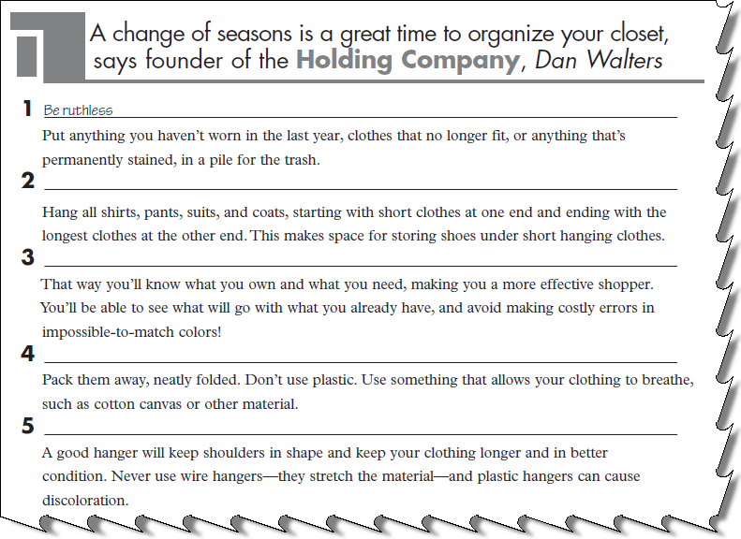
Unit (1) Trends Lesson 3

- Put the letters in order to form seven things you can buy:
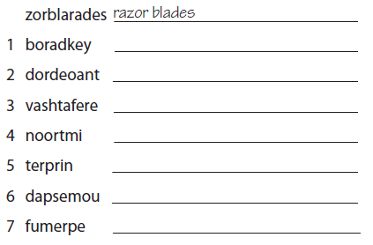
- Complete the tables with the words in the boxes:
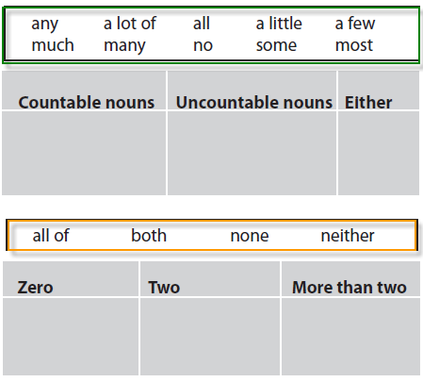

Unit (1) Trends Lesson 3

- Complete the sentence with an appropriate quantifier.
1. Which one do you like, the red or the blue? ______________ of them! I prefer green.
2. How many of the shops did you visit? __________________ of them. I feel exhausted.
3. Can you answer__________________ questions about detergent? It will only take a minute.
4. Theo had __________________ money in the bank and bought a new car.
- Complete the paragraph with the words in the box.
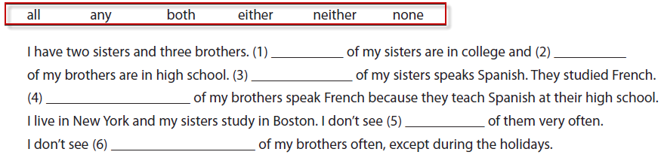
- 3. Read the text then Check (✔) the statements T (true) or F (false):
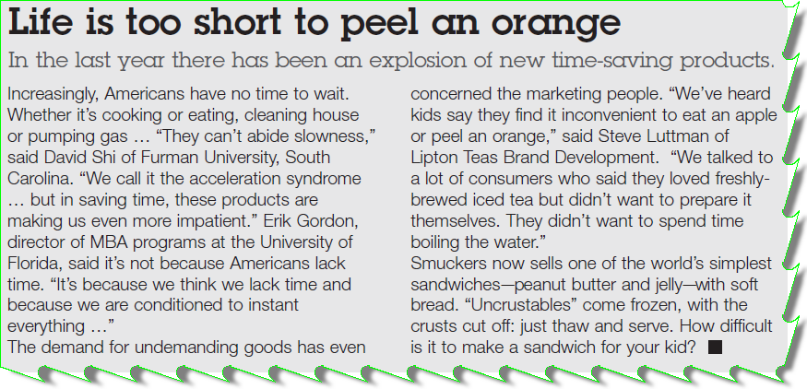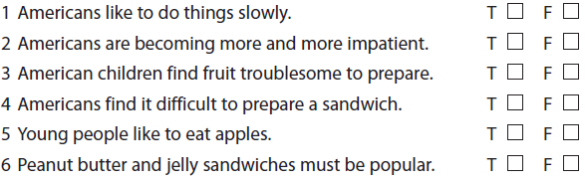
Unit (2) Big moments Lesson 1

1-Match the feelings in the box with the pictures:
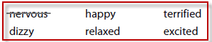
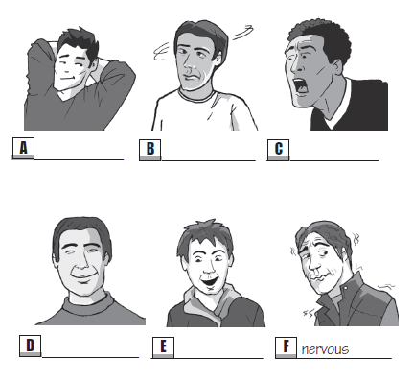
2. Recall the story of the sky-diver. Complete the sentences with the words from the above exercise:
1. Barry and I were so __________________ about going sky-diving.
2. I felt apprehensive, not __________________ , when I jumped out of the plane.
3. I was so __________________ when my main parachute opened.
4. I felt really __________________ looking down at the beautiful view below.
5. After landing safely, I felt __________________ when I tried to stand up.
3. If you had interviewed Ned to write this story, what questions would you have asked him?
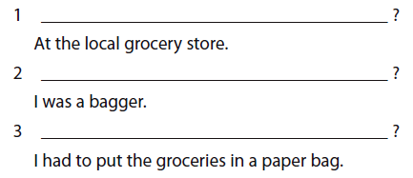
Unit (2) Big moments Lesson 2

1. Check (✔) the correct sentence:
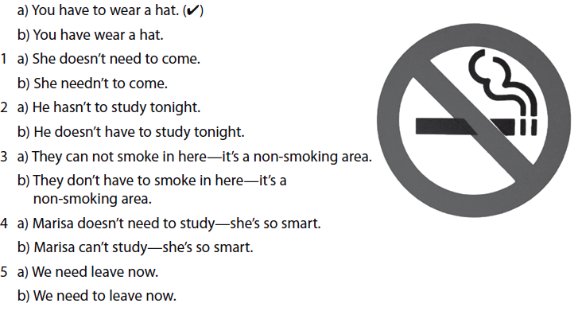
- Complete the sentences with have to, need to, don’t have to, or don’t need to:
1. Language students _________________ travel to the country where the language is spoken, but it can be useful.
2. You _________________ bring an umbrella, I can lend you one.
3. Most people _________________ eat twice a day.
4 .Mmm. It’s nice, but I think you _________________ add some sugar.
- Children _________________ attend school—it’s the law.

3. Two friends are trying to arrange a time to meet so they can work on a school project together. Complete their phone conversation.
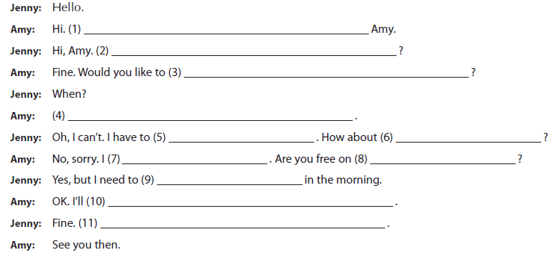
Unit (2) Big moments Lesson 3

- Complete the paragraph with a preposition from the box and put the verbs in parentheses in the correct form:

(1)____________________ (leave) school, today, I had a nice surprise. (2) _______________ (go) home, and (3)
________________ (walk) along the street, I met my cousin. I hadn’t seen him for ages, so we had a long chat.
(4) ________________ (say) goodbye to him, I continued on my way home. My dad was worried about me because I was late.

- Complete the conversation with the information in the box.
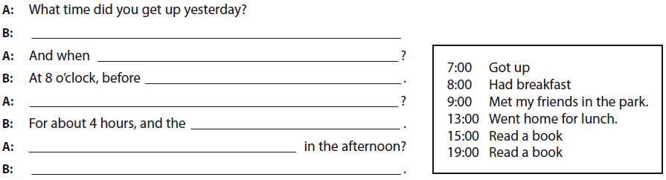
3. Read the text and look carefully at each line. Some of the lines are correct and others have a word which should not be there. Check (✔) the correct lines or write the words which should not be there.
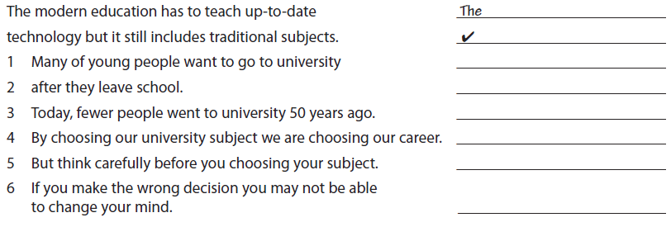4. Complete the sentences, using the correct preposition in each case:
1. My brother’s getting married _____________ Saturday morning.
2. My father graduated _____________ 1984.
3. Khalid’s coming to visit us _____________ October 13th.
4.10 In the U.S.A., schools are on vacation ________ July and August.

Unit (3) Crossing cultures Lesson 1

1. This is an interview with a man who lives and works in the U.S.A. Read the answers and write the questions.
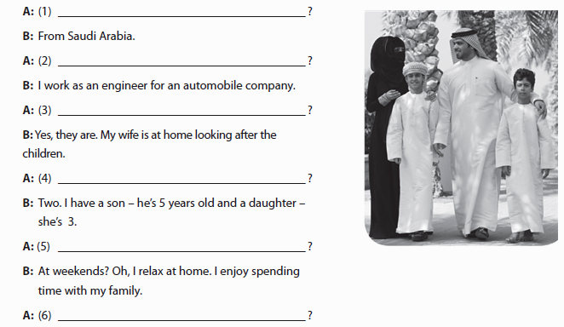

2. Which jobs do you think of as being done by man or woman?

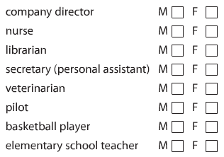

Unit (3) Crossing cultures Lesson 2

1. Match the phrases that go together.
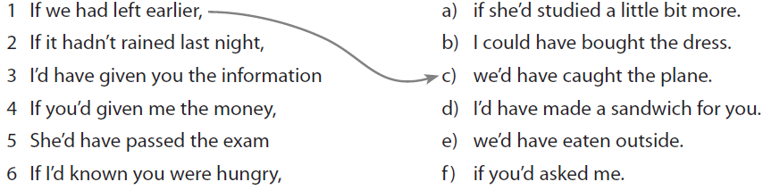
2-Complete the paragraph with the correct forms of the verbs in parentheses.

What an awful day I’ve had! If I (1) _____________ (know) what was going to happen,
I (2) _______________ (stay) at home. I decided to visit my parents. It was a beautiful
morning and I decided to take the back roads. And that was where my car broke down.
If I (3) _______________ (go) on the highway, someone (4) ______________ (stop and help)
me. And, of course, if I (5) _____________ (not forget) my cell phone I (6) ______________ (call)
for help. I waited for hours before someone came along—and I never did get to see my parents!
3-Make third conditional sentences using the information in parentheses.

1 If you’d come to work that day, you (see / the director / get angry) __________________________________________

2 If he (work / harder / be / promoted) ___________________________________________________________________________
3 If they (arrive / on time), we (meet / them) _____________________________________________________________________
4 We (go / horseback riding) yesterday if it (not / rain) ___________________________________________________________

5 I (finish / my project) on time if my computer (not / break down) ______________________________________________

6-If I’d got up earlier, (I / not / miss / the bus)
______________________________________________

Unit (3) Crossing cultures Lesson 3

1*Circle the word that is different from the others in the group.

1 jacket / socks / whistle / trousers
2 darker / colder/ heavy / higher
3 cell phone / whistle / alarm / first aid kit
4 tourist / doctor / traveler / walker
5 dark / fog / rain / wind
6 walk / stroll / stay / climb

2*Complete the sentences with the correct forms of the verbs in parentheses.

(1) _________________ (not get) up this morning. I wish I
(2) _________________ (not miss) the bus and I wish
(3) _________________ (get) to school on time. I wish my
teacher (4) _________________ (not get) angry. I wish I
(5) _________________ (not forget) to bring my homework. I
wish I (6) _________________ (not read) the wrong chapter
of my history book. I wish I (7) _________________ (not
write) so horribly on the test. I wish I (8) _________________
(not leave) my keys in my room. I wish I (9) ______________
(not try) to climb through the window to get into the house.
I wish I (10) _________ (not fall) because now I'm here in the hospital with a broken arm!

3*Rewrite the sentence using I wish + the past perfect.
1 I didn’t call you.
……………………………………………………………………..
2 My brother lost his job.
……………………………………………………………………..
3 The teacher was late.
……………………………………………………………………..
4 The cake burned.
……………………………………………………………………..
5 I didn’t have breakfast.
……………………………………………………………………..

Unit (4) Life’s a journey Lesson 1

1*Read the first paragraph of this news story. What headline would you give it?
The Jackson family of Midvale had a fright last evening when they got back from shopping. Mr. and Mrs. Jackson and their four children returned from the mall at around 8:00 p.m. last night, but when they opened the door to their apartment the lights were on and they heard a noise coming from the living room. Mrs. Jackson also smelled cooking. Mr. Jackson opened the door to the living room and there was a man, a complete stranger, asleep in front of the TV, with a half-eaten plate of eggs and French fries on the table.

b )Read the paragraph again. Complete the table.

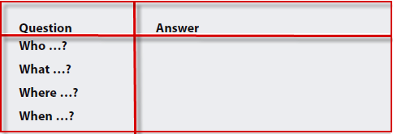
C) Answer the questions about the news story:
1 Why did the Jacksons suspect something was wrong?
______________________________________________________________________________________
2 Why did Robert seem confused when Mr. Jackson attacked him?
______________________________________________________________________________________
3 Why didn’t Robert ask for directions at reception?
______________________________________________________________________________________
4 Why didn’t he finish his meal?
______________________________________________________________________________________
5 If his cousin had lived in apartment 8, would Robert have made the same mistake?
______________________________________________________________________________________
2- Imagine that you are the police officer interviewing Robert. First of all, prepare a list of at least five questions you would like to ask him. Remember, you are especially interested in finding out: who, what, where, when, and why in the interview.
Questions
…………………………………………………………………………………………………………………………………………………………………………………………………………………………………………………………………………………………………………………………………………………………………………………………………………………………………………………………………………………………………………………………………………………………………………………………………………………………………………………………….

Unit (4) Life’s a journey Lesson 2

1*Write a sentence with should(n’t) have.
1 John wore his new shoes to the park. It was very muddy.
He …………………………………………………………………………………………………………………………………………..
2 We went to Rome in winter. It was very cold.
…………………………………………………………………………………………………………………………………………..
3 Mariam spent all her money. She can’t come to the mall.
…………………………………………………………………………………………………………………………………………..
4 George pushed Teddy. Teddy fell over.
…………………………………………………………………………………………………………………………………………..
5 I ran for the bus. I hurt my leg.
…………………………………………………………………………………………………………………………………………..
2*Steven stayed in on Saturday. Write five sentences using could have.
1 …………………………………………………………………………………………………………………………………………..
“We ate Caesar salad. And there were fantastic desserts too.”
2…………………………………………………………………………………………………………………………………………..
“After dinner we went for a walk in the mall and bought some books.”
3 …………………………………………………………………………………………………………………………………………..
“After that we met George for coffee.”
3*Max and Neil are twins. They look the same but they are very different in personality. Compare Max to Neil using would have and the words in parentheses.
1 Max brought a box of sweets for the family. (Neil / nothing)
…………………………………………………………………………………………………………………………………………..
2 Max didn't eat a lot. (Neil / eat more)
…………………………………………………………………………………………………………………………………………..
3 Max made very interesting conversation. (Neil / say very little)
…………………………………………………………………………………………………………………………………………..
4 Max left soon after dinner. (Neil / stay late)
…………………………………………………………………………………………………………………………………………..
5 Max sent my parents a nice “thank you” card. (Neil / send an e-mail.)
…………………………………………………………………………………………………………………………………………..

Unit (4) Life’s a journey Lesson 3

1*Circle the correct modals.
1 James is never late. He can have had / must have had an accident.
…………………………………………………………………………………………………………………………………………..
2 Maybe Harriet took it. She may have needed / can’t have needed it.
…………………………………………………………………………………………………………………………………………..
3 They said they’d been to London, but they’re back already. They couldn’t have been / might have been there long.
…………………………………………………………………………………………………………………………………………..
4 Bob went back to work the next day. He may have been / can’t have been very ill.
…………………………………………………………………………………………………………………………………………..
5 Mr. Lawrence hasn’t called. I wonder if he might have lost / must have lost the phone number.
…………………………………………………………………………………………………………………………………………..
6 Look, there’s Jenny’s book. She might have forgotten / must have forgotten it.
…………………………………………………………………………………………………………………………………………..
2*Complete the conversation with the correct forms of the modals and verbs in parentheses.
A: Where’s your brother?
B: I don’t know. He said he’d get here early. Something (1) _________________________ (must happen) to him.
A: Oh, I don’t know. He's usually late. His watch (2) __________________________ (might stop) or his car
(3) ____________________ (may break down).
B: Oh, I don’t know. I’m sure something horrible has happened. He (4) ____________________ (must go) to the
hospital. He (5) _______________________ (might lose) my telephone number and no one there can contact
me. He (6) ______________________ (could hurt) his head and he can’t talk.
A: Oh, relax. Nothing that bad (7) ______________________ (could happen). There has to be a logical reason.
He (8) _____________________(could not have) an accident. He's a good driver.
C: Hi, everyone. Am I late?

Unit (4) Life’s a journey Lesson 3

1*Read the text.
Mary Celeste
On 7th November 1872 a ship called the Mary Celeste left New York for Italy. The captain, Mr Briggs, and his experienced crew were never seen alive again. About a month later the captain of another ship spotted the Mary Celeste in the middle of the Atlantic Ocean. No one responded when the sailors shouted, so they eventually boarded the Mary Celeste and searched for any sign of life. There was none. Below deck, things were very strange. A meal had been prepared in the kitchen. In the crew’s quarters clothes were neatly laid out and laundry was hung on lines, and in one cabin there was a chart showing the ship’s position on November 24th. More interesting was the fact that some navigation items were missing from the ship. Also missing was the Celeste’s small boat.
Why did the crew abandon ship? There was no sign of damage, or any other factors which could explain why the crew had left. Were they perhaps taken by pirates, or was there a storm and they thought the ship was sinking? We will never know. What took place on board the Mary Celeste has remained a mystery until this day.

a) Check (✔) the statements true (T) or false (F).
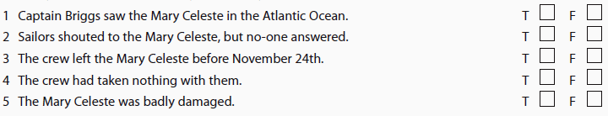
b) Using the text, complete the sentences with must, might, could, or couldn’t.

1 At first, the sailors on the other ship _____________ have known that there was no-one on board the Mary
Celeste.
2 Someone on the Mary Celeste _____________ have been alive on November 24th.
3 The crew _____________ have sailed away in the small boat, though no-one’s sure.
4 They _____________ have thought that the ship was sinking.
c)Complete the sentences with must, might, could or couldn’t using the information in the text in the above exercise:
1 Perhaps she had a headache. ______________________________________________________
2 I’m sure she didn’t see you. _______________________________________________________
3 Maybe they left early. _______________________________________________________
4 I’m certain the bag was blue. _______________________________________________________
5 Perhaps he was angry. ______________________________________________________
6 I’m positive I gave it to him. _____________________________________________________
7 Maybe they had an accident. ______________________________________________________
8 I’m sure he didn’t phone me. ________________________________
Unit (5) Stages of life Lesson 1

1) Match the names and approximate ages.
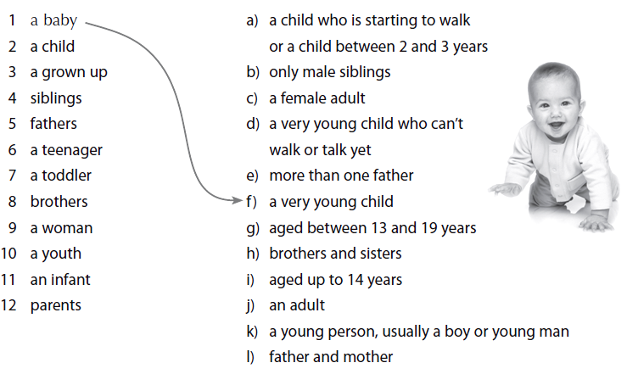
2) check (✔) the factors you think cause childhood obesity.
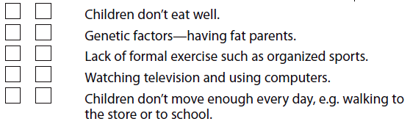
3) Circle the correct answers.
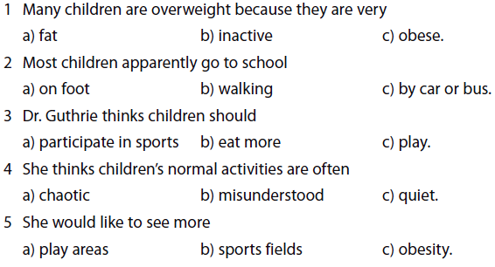

Unit (5) Stages of life Lesson 2
1) Correct the errors in these sentences.
1 When I’m 60, I’ll be retire in Florida.
_______________________________________
2 I hope Robert will be coming to work early tomorrow morning.

_______________________________________
3 By the end of next year, I’ll travel in Europe.
_______________________________________
4 Sally will getting her degree as soon as possible.
_______________________________________
5 My mother will cook dinner by the time I get home.

_______________________________________
6 The painters will be painting the house first thing tomorrow morning.

_______________________________________

2) Put the conversation in the correct order.
1 You’re wrong there. I’ve already gotten one job offer. I don’t know if I’ll take it, though. ………………………………………………………………………………………………………………………………………
2 Well, the pay isn’t very good and I don’t think I’m ready to move away yet.
………………………………………………………………………………………………………………………………………
3 I guess I’ll be working at a big law firm in New York.
………………………………………………………………………………………………………………………………………
4 Why wouldn’t you?
………………………………………………………………………………………………………………………………………
5 You’re optimistic. I bet you’ll still be living here.
………………………………………………………………………………………………………………………………………
6 We’ll be graduating in one month. What do you think you’ll be doing this time next year? ………………………………………………………………………………………………………………………………………
7 I don’t know. I haven’t thought about it yet. What about you?
………………………………………………………………………………………………………………………………………

3) Complete the conversation.
A: What do you think you’ll be doing at this time next year?
You: (1) ______________________________________________________________________________________
A: Really? Tell me more.
You: (2) ______________________________________________________________________________________
A: And then what will you do?
You: (3) ______________________________________________________________________________________
A: How long do you think you’ll be doing this?
You: (4) ______________________________________________________________________________________
A: It sounds really interesting.
Unit (5) Stages of life Lesson 3

1)Put the actions in the most logical order
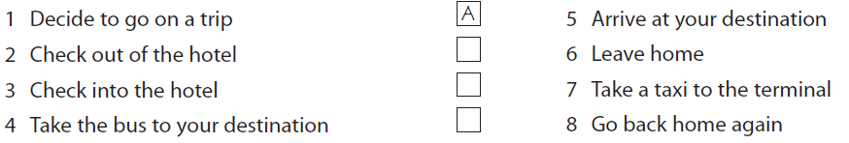
2) Join the sentences using but, however, so, or therefore.
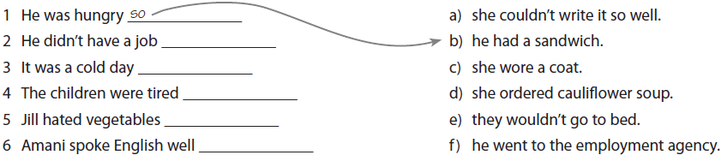

3) Rewrite the sentences to express the same meaning, using so or because.

1 The child cried because the toy broke. _____________________________________________
2 The boys were bored so they played football. _____________________________________________
3 I came here because I wanted to see you. _____________________________________________
4 Joe went to the market because he needed vegetables. _____________________________________________
5 They were tired so they went home.
_____________________________________________
6 It was hot so he took off his sweater

Unit (6) The future Lesson 1
1) Match the words with similar meaning.
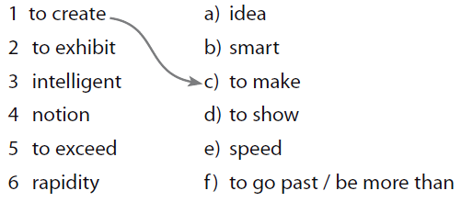
2) More and more drivers use sat-nav (satellite navigation) to get from one place to another. But is it always reliable? Read the questions and answers carefully, and choose the correct answers.
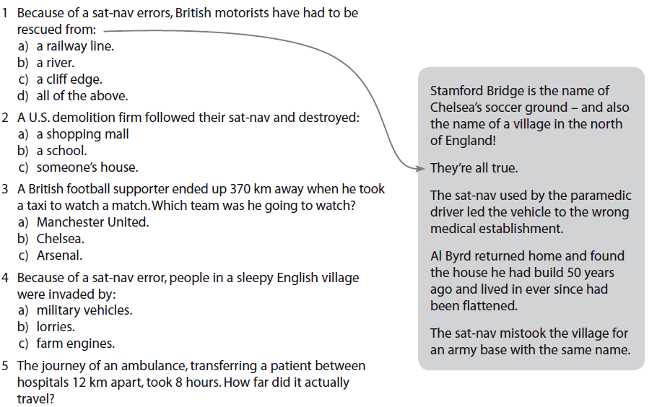

Unit (6) The future Lesson 2

1) Match the words and definitions. One example has been done for you.
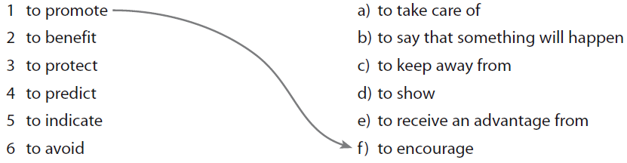
2) Complete the interview with the correct forms of the verbs in parentheses.
Reporter: Professor Sanchez, tell me what (1) _____________________ (happen) in 30 years?
Dr. Sanchez: In 30 years, we (2) _______________________ (land) on Mars and we
(3) _______________________ (build) colonies there.
Reporter: What about in medicine? (4) __________ we _______________(find) a cure for cancer?
Dr. Sanchez: I believe so, but we (5) _______________________ (discover) more dangerous diseases.
Reporter: (6) _________________ we __________________ (invent) time travel?
Dr. Sanchez: I don’t think so.
3) Read the text and answer the questions:
Tomorrow’s people
Dr. Craig Venter, Celera Genomics, Maryland
Sometime this century, when parents leave the hospital with a new baby, they will take with them a genetic printout. It will include predictions of high-risk diseases, suggestions about the chemicals and foods in the environment that the child should avoid, and the kind of lifestyle that will promote their child’s health and longevity. At the same time, the parents must be sure that there will be laws that protect the baby’s genetic code from ever being used against him or her, so that the knowledge will only benefit his life. They also need to understand that genes hardly ever predict a disease with absolute certainty; they can only give an indication of risk. Our research is teaching us that genetic determinism simply doesn’t work. There are many factors—in our food, the environment, our social lives—that can take our genes in lots of different directions. So our genetic make-up shouldn’t be viewed as a limitation but instead as potential for achieving a healthier and disease-free future.
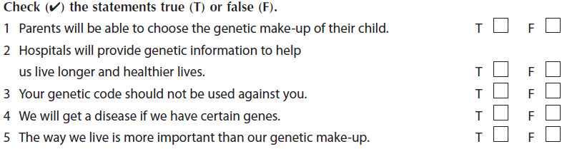

Unit (6) The future Lesson 3
1) Circle the correct future form: will or present simple.
1 The Chicago Bears win / will win the Super Bowl this year.
2 Georgia has / will have a French class on Saturday.
3 Don’t worry. The meeting is / will be a great success.
4 Do you think Mary passes / will pass the exam?
5 The next course starts / will start on May 14th so
you should sign up now.
6 The plane leaves / will leave at 7:00 p.m.

2) Circle the correct form of the verb: will, future progressive, or future perfect.

1 This is Kevin—you’ll have worked / be working with
him in accounting.
2 Just imagine, in a few months I’ll live / be living
in Dubai!
3 By the time I’m 70 I will have retired / will be retiring.
4 I feel confident you’ll get / be getting the job.
5 Come by at 8:00 p.m., we’ll have eaten / be eating
by then and we can leave right away.
6 In June I’ll be / have been in this job for a year.

3) Put the conversation in the correct order.

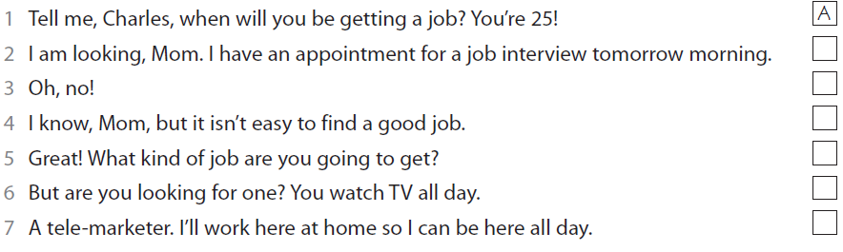
Unit (7) The 20th Century Lesson 1

1) Complete the interview with the words in the box.
Journalist: What would you (1) _______________ to be the most important
invention in the 20th century.
Inventor: That’s difficult to say. But I guess the invention of the computer was
one of the greatest (2) _______________ on the way we live and work,
in at least two ways. First is the speed with which we can now
(3) _______________ without the need, really, to leave our home or
office. The second is the way this technology has made information
(4) _______________ to almost anyone.
Journalist: Yes, you're right. Before the development of IT it was much harder
for people to (5) _______________ information , unless they had the
relevant books or went to a library.
Inventor: Exactly. The 20th Century brought information into the home through the (6) _______________ .
This has made life incredibly easier for everyone, from school children doing their homework to
professionals conducting (7) _______________ . Computer technology really had an
(8) _______________ on all our lives.

2)Look at the sentences and underline the stressed syllable in the pairs of words.
1 a) They are making good progress with their English.
b) This piece of work is progressing well.
2 a) Have you almost finished that project?
b) These are the projected figures for next year.
3 a) The cameras were exported.
b) These cars are for export only.
4 a) You should be careful about personal insults.
b) The advertisement insulted our intelligence.
5 a) Our company imports clothing from the Far East.
b) The level of imports into the country has risen.
3)
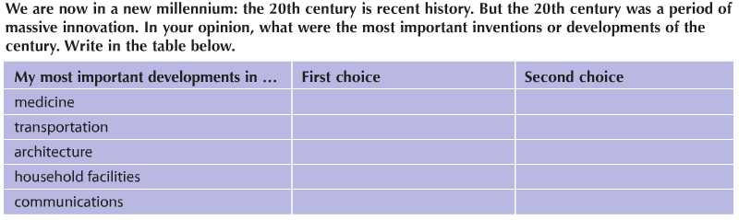

1)Look at how the following connectors are used and match them with the correct meaning.
Unit (7) The 20th Century Lesson 2
Be careful: there are two connectors for one of the meanings!
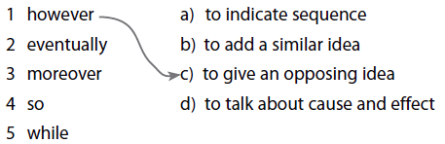
2) Rewrite the sentences using although or however.
1 Although the human race has reached the moon, we seem unable to prevent wars.
_______________________________________________________________ ______________________________________________
2 Many people in the west are worried about their diet. However, obesity is an increasing problem.
_______________________________________________________________ ______________________________________________
3 Governments are trying to limit carbon emissions. However, the world’s climate continues to get warmer.
_______________________________________________________________ ______________________________________________
4 Although we have made huge technological progress, many of the world’s people are still hungry.
_______________________________________________________________ ______________________________________________
3) Read the sentences and then put them in the correct order to form a paragraph.
1 This was largely because most buildings in ____
Seattle were very solidly built with special
protection against earthquakes.
2 There were then a number of aftershocks. ____
3 Early in the year 2001, there was an ____
earthquake in Seattle, Washington state, U.S.
4 The residents of Seattle believe that ____
eventually there could be a much bigger
earthquake, which might even destroy
their city.
5 Although it measured over seven on the ____
Richter scale, very few people
were killed.
6 A great deal of damage was done, ____
however, and people were extremely
frightened since the initial earthquake
lasted over 40 seconds.
Unit (7) The 20th Century Lesson 3

1) Join the two sentences in each pair, using while, when, or after.

1 He had established the family business. He opened the first branch in Makkah.
…………………………………………………………………………………………………………………………
2 He was becoming successful in business. He developed an interest in philanthropy.
…………………………………………………………………………………………………………………………
3 He gave support to orphans. He had made enough money.
…………………………………………………………………………………………………………………………

4 He developed an interest in business. He was still growing up.
…………………………………………………………………………………………………………………………
2) Complete the text with a suitable connector in the box.
In the 20th Century, the world made huge advances, especially in science, medicine, and technology.
____________ , there were still enormous problems. Much of the world’s population was still starving.
(1)___________________ , environmental problems were increasing, largely (2)___________________ of
pollution caused by growth in industry. (3)___________________ , a number of countries were living under the constant threat of disaster and war. (4)___________________ we have made great progress, it seems we are unable to live together in harmony and protect our environment. (5)___________________ , if we are not careful, our planet may not survive.

Unit (8) People and technology Lesson 1
1) Make notes about the advantages and disadvantages of e-mail and / or text messages, under these headings.
………………………………………………………………………………………………………………………………………………………………………………………………………………………………………………………………………………………………..………………………………………………………………………………………………………………………………………………………………………………………………………………………………………………………………………………………………..
2) Match the multi-word verbs in the sentences with the definitions on the right.
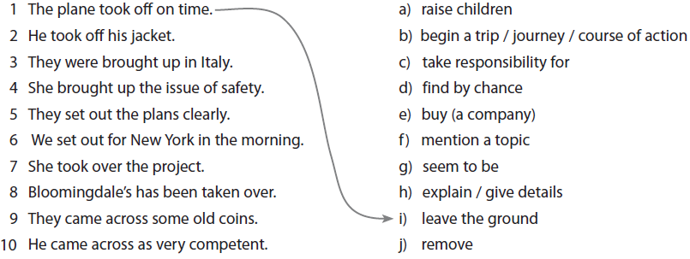
3) Rewrite each sentence with one of the multi-word:
1 They left early for the islands.
…………………………………………………………………………………………………………
2 He found some archeological remains by chance.
…………………………………………………………………………………………………………
3 He took responsibility for the company when his father retired.
…………………………………………………………………………………………………………
4 The plane left after a two-hour delay on the runway.
…………………………………………………………………………………………………………

1) Look at these words and phrases about modern biology and climate change. Complete the table.
Unit (8) People and technology Lesson 2
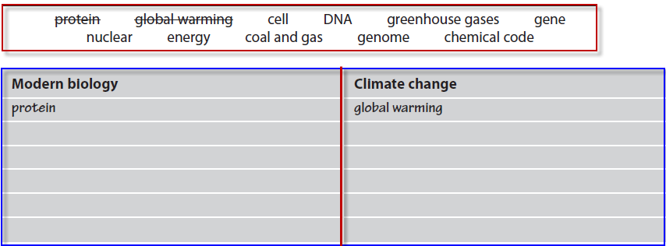
2) Read the questionnaire and check (✔) the most appropriate answer, according to your opinion.
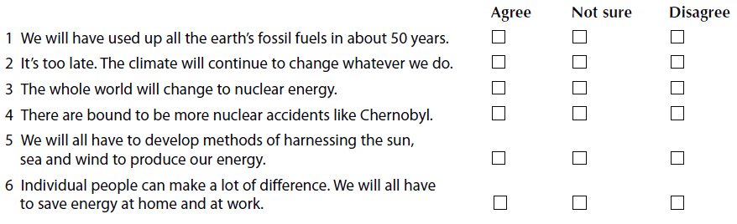
3) Match the beginnings of the sentences on the left with the endings on the right.

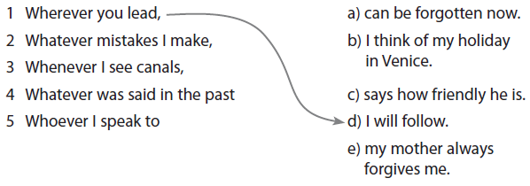
Unit (8) People and technology Lesson 3

1)Match each pair of examples of multi-word verbs and their objects to one of the rules a–c below.
1 Turn down the radio, Michael! Can’t you hear me? I said turn it down!
What? Wait, I can’t hear you. Let me turn the radio down first.
2 Yesterday I ran into Mr. Morgan at the grocery store at 9:00 a.m.
Then later I ran into him again at the gas station.
3 Make sure you turn off the coffee maker when you leave the house.
If you forget to turn it off, it could start a fire.
a) The objects (noun or pronoun) of non-separable verbs always go after the multi-word verb. ______
b) Noun objects of separable verbs can go after the multi-word verb or in the middle of it. ______
c) Pronoun objects of separable verbs always go in the middle of the multi-word verb. ______
2) Cross out the incorrect one.
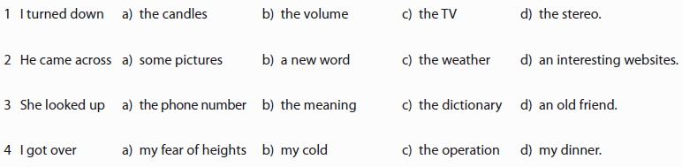
3) Put the words in the correct order to make sentences.

1 reactions / out / Jack / planning / carry / research / is / to / chemical / on
_____________________________________________________________________________________
2 for / president / decided / the / to / office / stand / again / has
_____________________________________________________________________________________
3 the / looking / I / is / words / dictionary / think / fun / up / in
_____________________________________________________________________________________
4 the / him / wrap / salesman / it / helped / up
_____________________________________________________________________________________
5 put / hat / I / on / it / took / the / and
____________________________________________________________________________________
Unit (9) People and technology Lesson 1

1) Look at the words about truth and falsehood. Complete the table and write the part of speech. Include one or two words that can go with them.

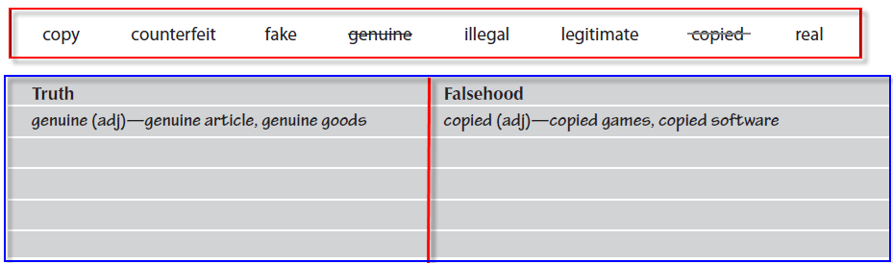

2) Say the words to yourself, then complete the table according to the vowel sound (underlined in words of more than one syllable).

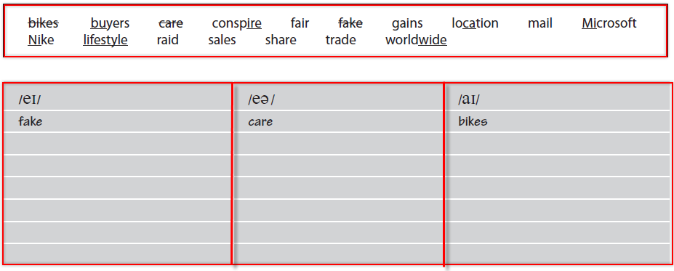
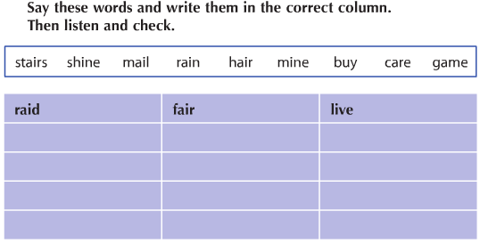
Unit (9) People and technology Lesson 2

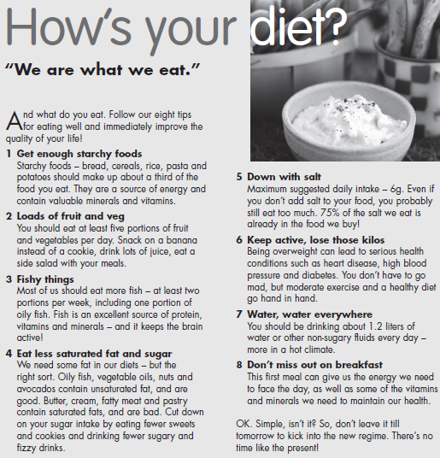
-Circle the correct answer.

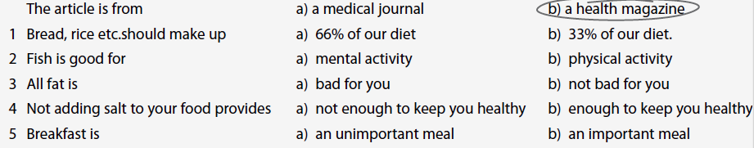
-Find words in the article which mean the same or something similar to the words in the list below.
1 eat between meals _____________________
2 how much you eat _____________________
3 bubbly _____________________
4 liquids _____________________
5 start _____________________
6 set of rules _____________________
Unit (9) People and technology Lesson 3

1) Complete the e-mail with indefinite pronouns.
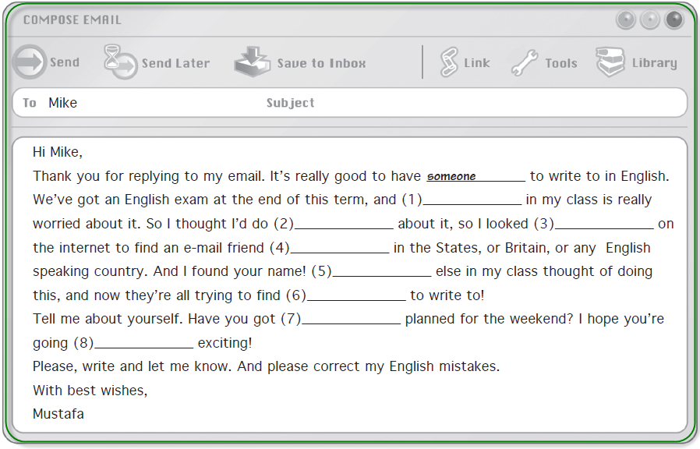
2)


