
بسم الله الرحمن الرحيم
المملكة العربية السعودية
وزارة التربية والتعليم
ادارة التربية والتعليم بمحافظة رجال المع

Unit 1 (Food)

Listen and circle :*
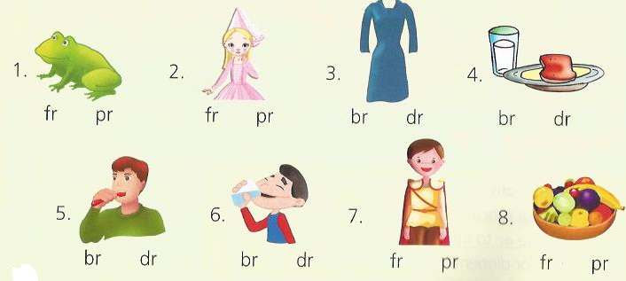

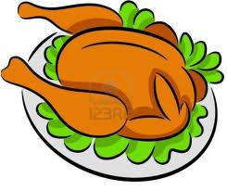
**Answer the following :
Do you want a chicken ?

……………………………………………………

What do you have for dinner ?

.......................................................................................

*choose the correct answers:
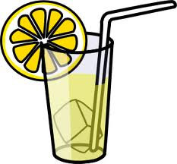
1-Do you like lemonade? Yes,………….. (I,do_I don't)
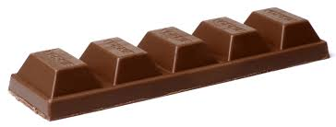
2- Do you like chocolate? No,…………….( I,do_I don't)
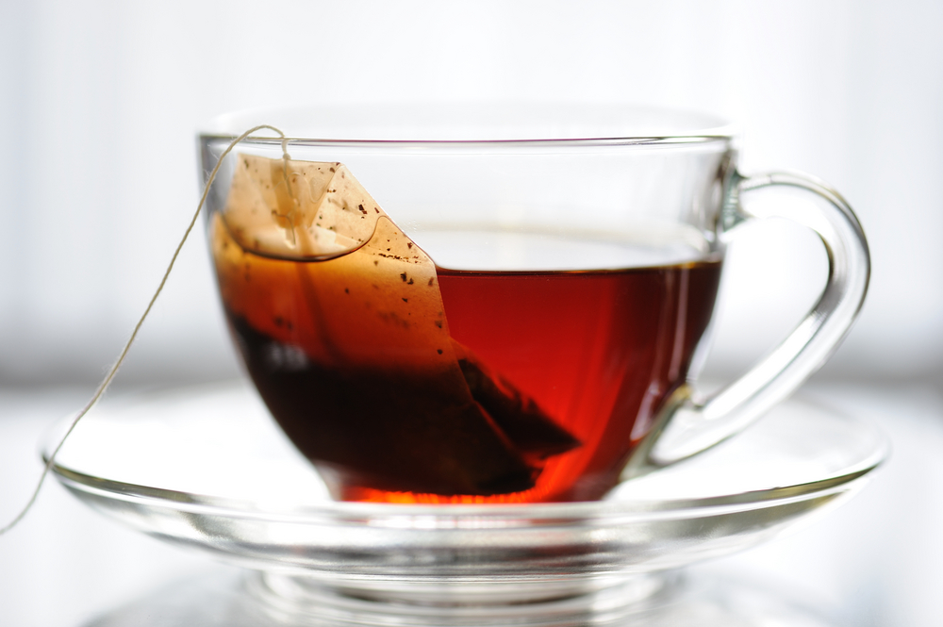
3- I don't like tea. It's ……………………… (sweet_ hot)
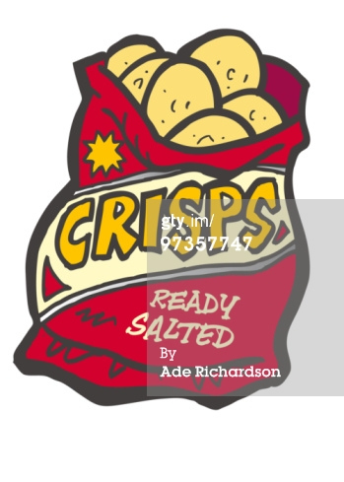
4- I like crisps. It's………………………….. (cold_ salty)


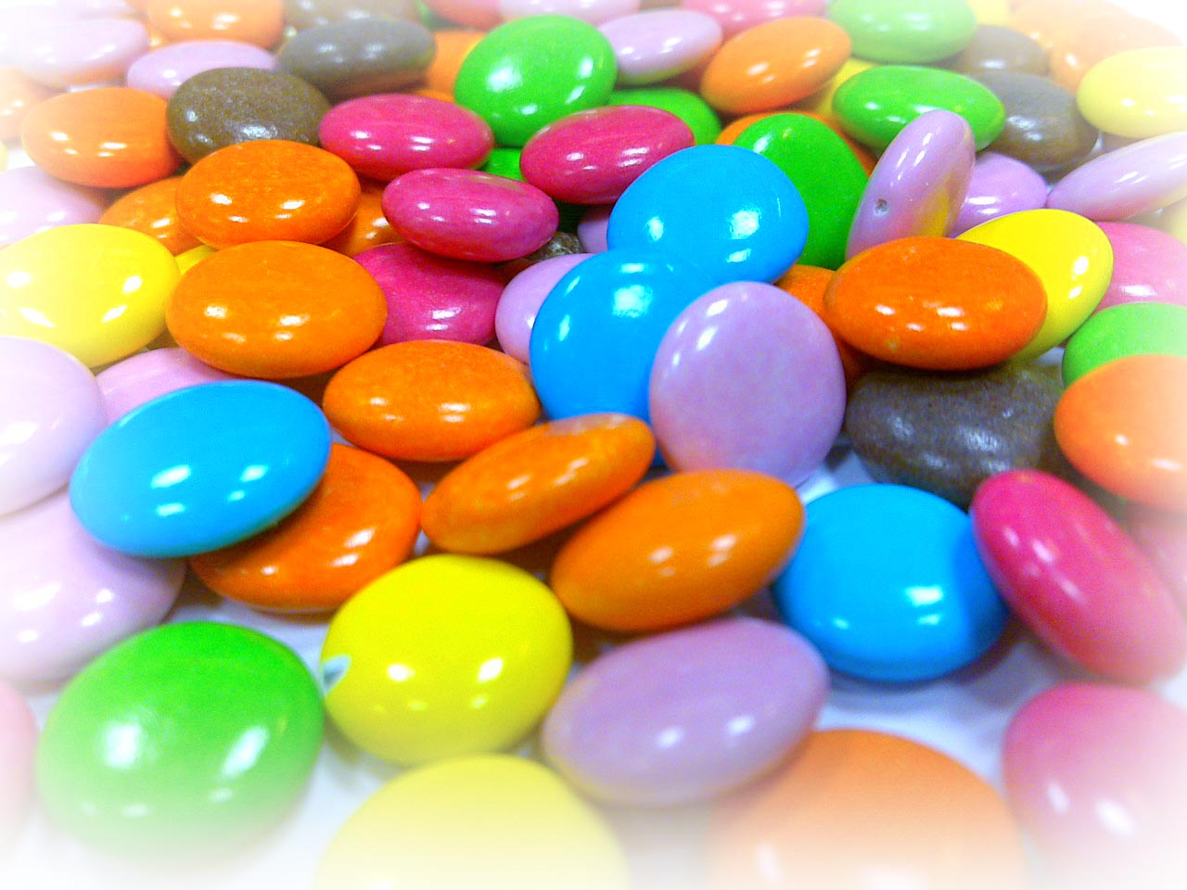
5-Sweets are ……………… ( good for you_ bad for you)
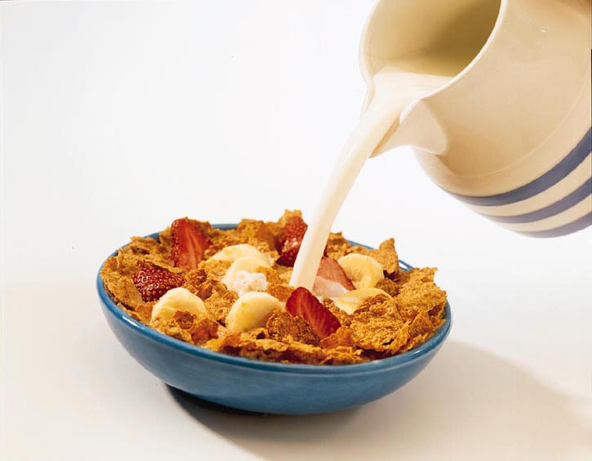
6-Cereal with milk are ….( good for you_ bad for you)

*Match the words to the pictures:
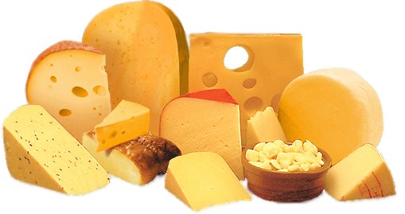
1-Vegetables
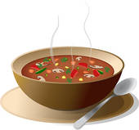
2- Lunch
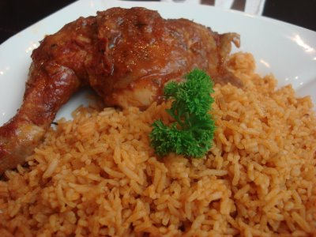
3- Cheese
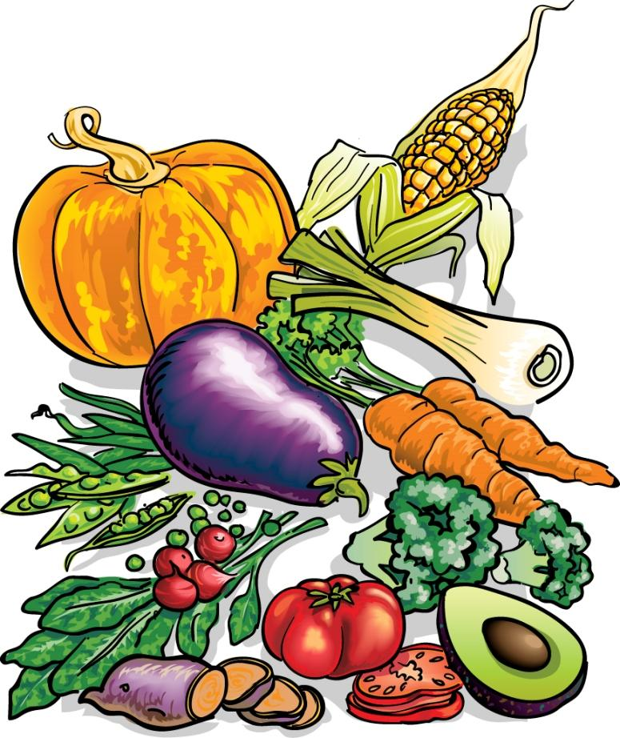
4- Soup

*Change the following nouns into " plural " form:
1 tomato 3 ………. 1 sandwich 10 ………...

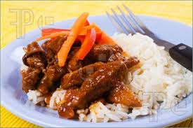
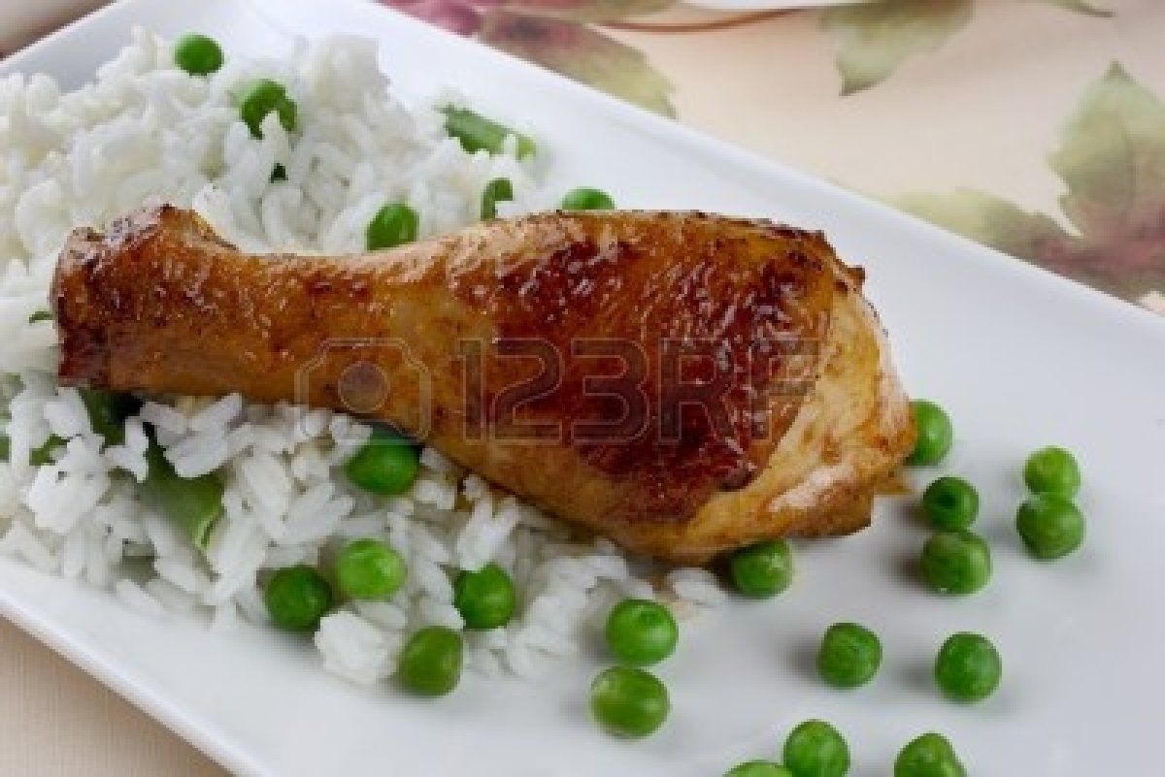
**complete with ( and - or )
for lunch I have chicken with rice ........ meat with rice*

*for dinner I have sandwich …….milk



