Name......................................................... 1st Module 1+2
Q1)Grammar
A – Circle the correct answer:_
1- Did you ( use to – used to )send a lot of e-mails?.
2- Susan 's graduation is ( at – in ) June.
3- would you like ( some – any ) milk?.
4-There are (little – few ) chairs in the living room.
5- I ( was – were ) watching TV when my sister ( walk – walked) into the house.
6- Tom( has - have ) opened the bottle with his teeth.
7- I have ( see – seen ) him do it many times before.
8- Roger has ( just – since ) come back from the supermarket.
B: Do as shown in the brackets;-
1-Maram cooked dinner last night . {Negative}.
…………………………………………………………………………..
2- I was watching TV at 7 o'clock yesterday evening. { Make Yes/No Question }
…………………………………………………………………………
Q2: Vocabulary:
A- Circle the correct word :
1-I get very ( honest – angry ) when people lie to me.
2- I ( won - beat ) my brother at tennis yesterday.
3-We left early because the lecture was ( bored – boring ).
4- can you ( cut – bite ) this rope with that knife.
5- lemons taste ( sweet – sour )
Call:……………….. have: ………….. ( give the past form) End of the Questions.

B: Match the word with it picture :
4-sunny | 3- snowing | 2- mop the floor | 1-chef
8-bellboy | 7-car park | 6- drawer | 5-fridge
12-raining | 11- washing-machine | 10- library | 9- reporter

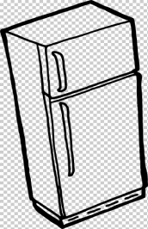 |  |  | 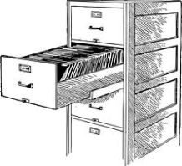
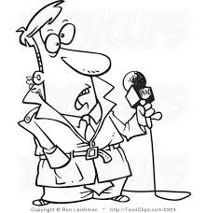 |  | 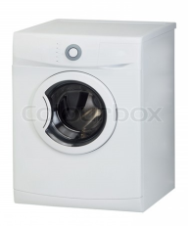 | 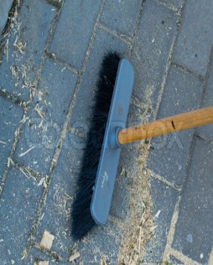
 |  | 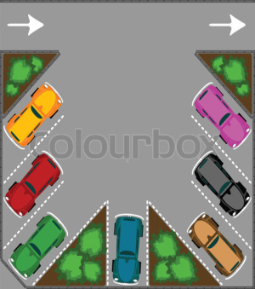

End of the Questions .

