Phonics
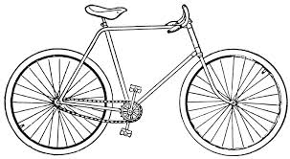
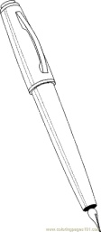
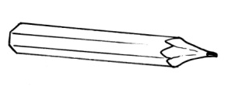
Pencil- book

pencil pink pen book bike
pencil pink pen book bike

Date: ……\…………\……..
Presents
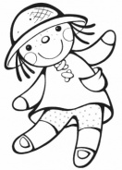
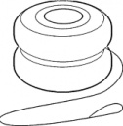
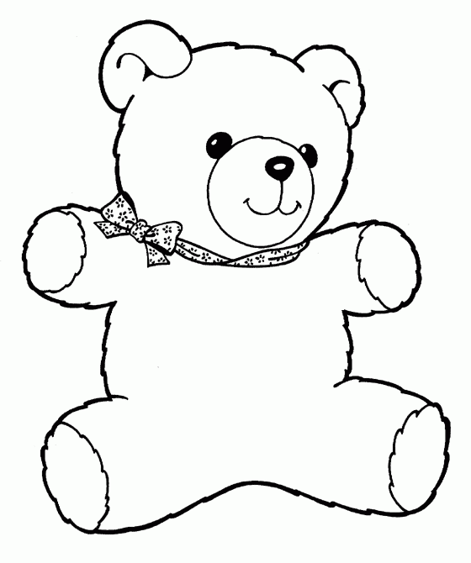
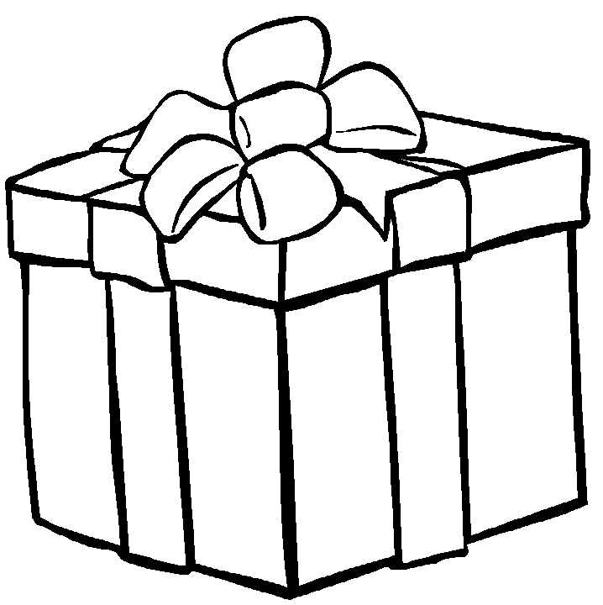
A chant

present doll yo-yo teddy bear
present doll yo-yo teddy bear

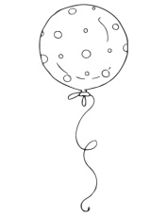
balloon
balloon

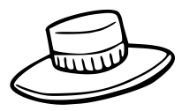
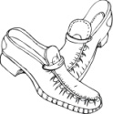
Smart kids

shirt shoes hat thobe
shirt shoes hat thobe

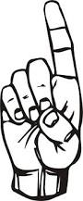
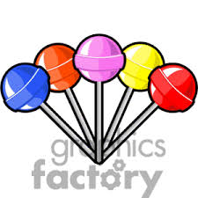
What are these? They're lollipops.
What are these? They're lollipops.
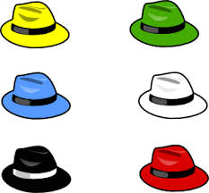
What're those? Those are hats.
What're those? Those are hats.

They're = they are
They're = they are
Comic

orange pink brown black white
orange pink brown black white

date:………….\..............\............
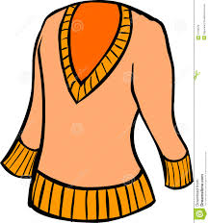
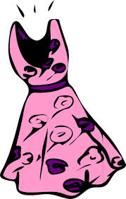
Let's play

jumper dress trousers
jumper dress trousers

Are they trousers?
Yes, they are \ No, they are not.
Yes, they are \ No, they are not.

Phonics
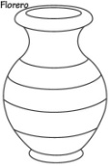
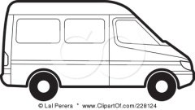
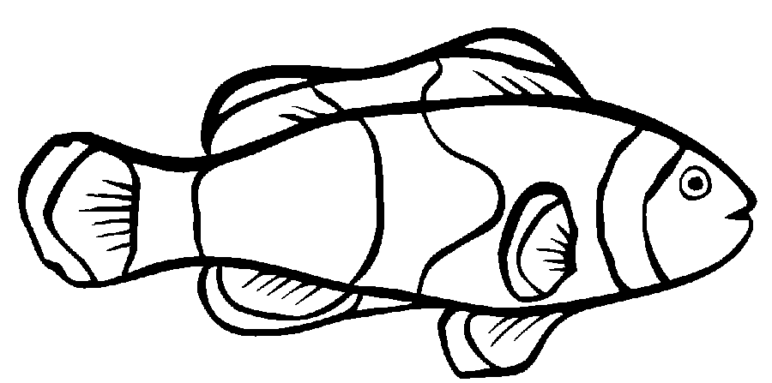
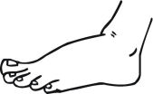
Feet - van

feet fish van vase
feet fish van vase

date:………..\...........\.........
story time
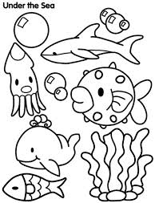
Smart time 1
Traditional clothes
Draw a traditional costume from your country and write:

Date:………\...........\...........
Phonics
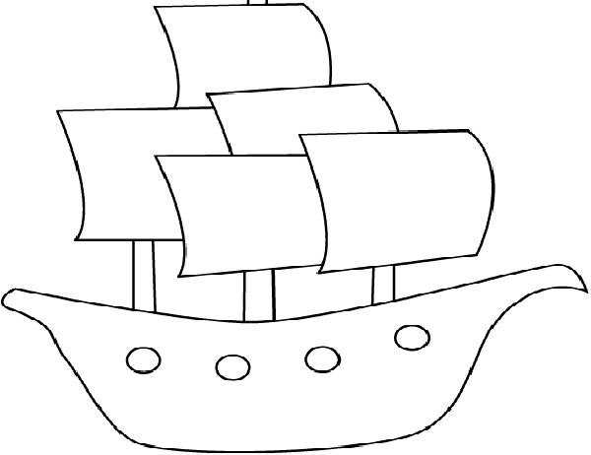
Chair - Fish

teacher peach ship short
teacher peach ship short

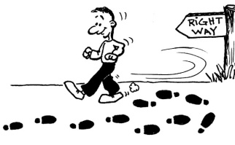
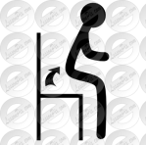
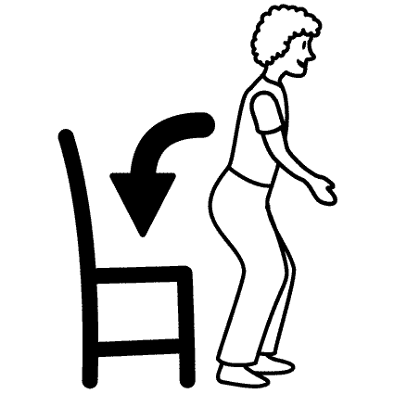
toys and games-a chant

stand up sit down turn around
stand up sit down turn around
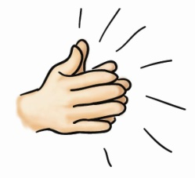
clap your hand
clap your hand

date:………..\...........\.........
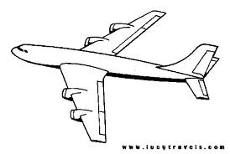
smart kids
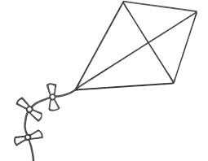
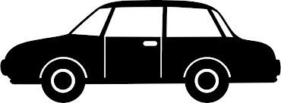
bike kite plane car
bike kite plane car

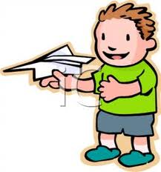
I have got a plane.
I have got a plane.

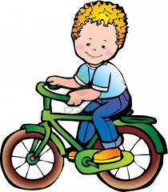
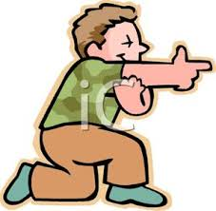
You have got a bike.
You have got a bike.

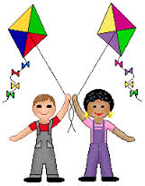
We have got a kites.
We have got a kites.
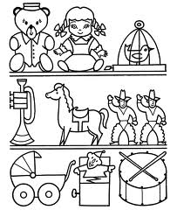

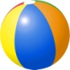
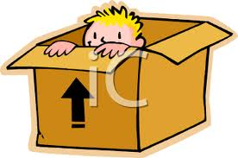
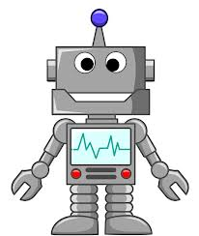
Comic
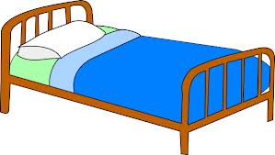
on in box robot bed
on in box robot bed

Where is the ball?
It's on the bed.
It's on the bed.
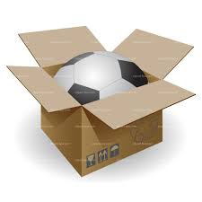
It's in the box.
It's in the box.

Let's play
Have you got a bike?
Yes, I have.
Yes, I have.

No, I haven't.
No, I haven't.

Date:……..\........\.........
Phonics
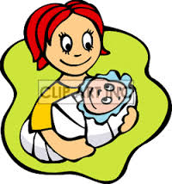
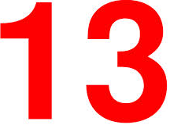
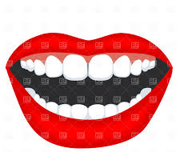
Mouth - This

mouth thirteen this mother
mouth thirteen this mother

phonics
cat - fin
cat hat fat fin tin fish
cat hat fat fin tin fish

date:…………\.........\.........
my body
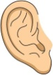
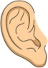
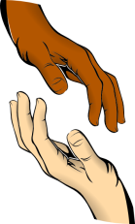
a chant

touch ears eyes nose
touch ears eyes nose

touch your mouth
touch your mouth
don't touch your eyes.
don't touch your eyes.
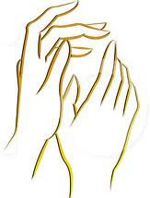
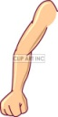
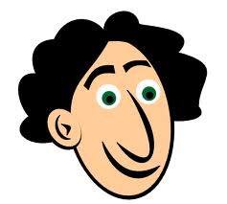
Smart kids

head arms legs hands long
head arms legs hands long

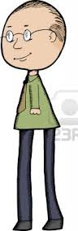
He has got long legs.
He has got long legs.

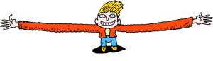
She has got long arms.
She has got long arms.
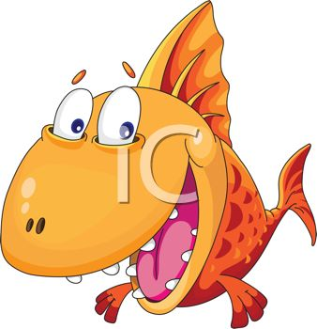
It has got big mouth.
It has got big mouth.

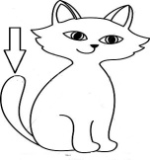
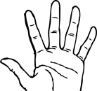
Comic + let's play
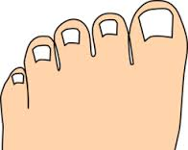
fingers toes teeth tail
fingers toes teeth tail

It hasn't got big feet.
It hasn't got big feet.
It hasn't got long fingers.
It hasn't got long fingers.
It hasn't got a tail.
It hasn't got a tail.
Has it got a long tail?
Yes, it has.
Yes, it has.
No, it hasn't.
No, it hasn't.
Smart time 3
Animals

Draw and write about an animal:

D
Date:…………\.......\..........
Phonics
Kite - nose
kite bike nine nose rose bone
kite bike nine nose rose bone

Food
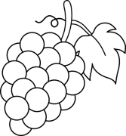
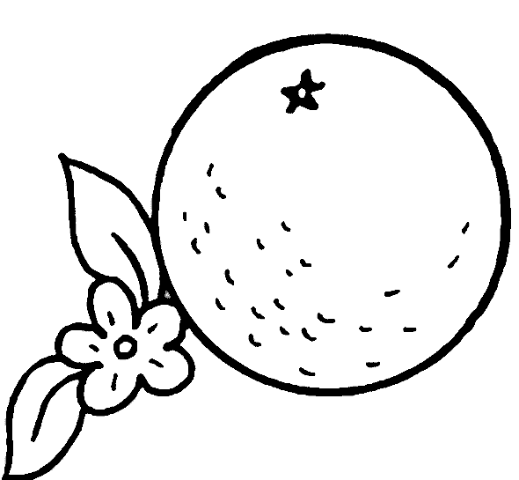
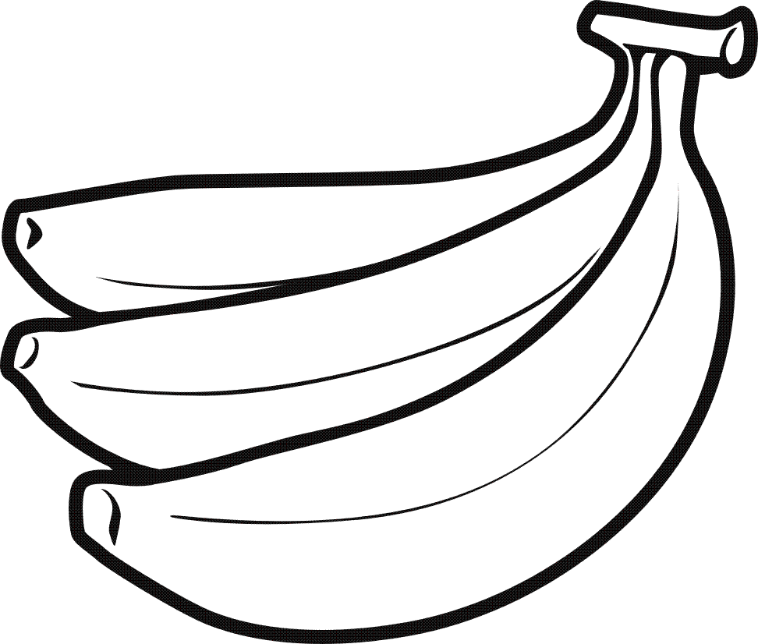
A chant

bananas grapes dates oranges
bananas grapes dates oranges
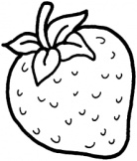
strawberries
strawberries

date:………..\..........\..........
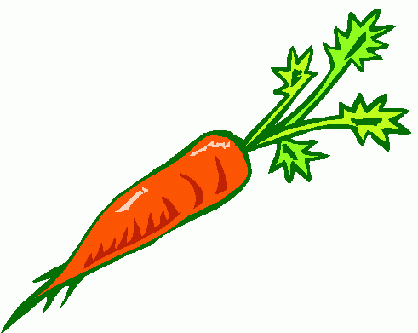
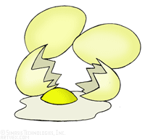
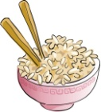
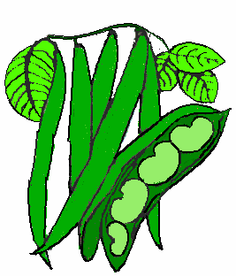
Smart kids

carrots rice eggs beans
carrots rice eggs beans

Do you like rice?
Yes, I do.
Yes, I do.

No, I don't.
No, I don't.

Date:………\........\............
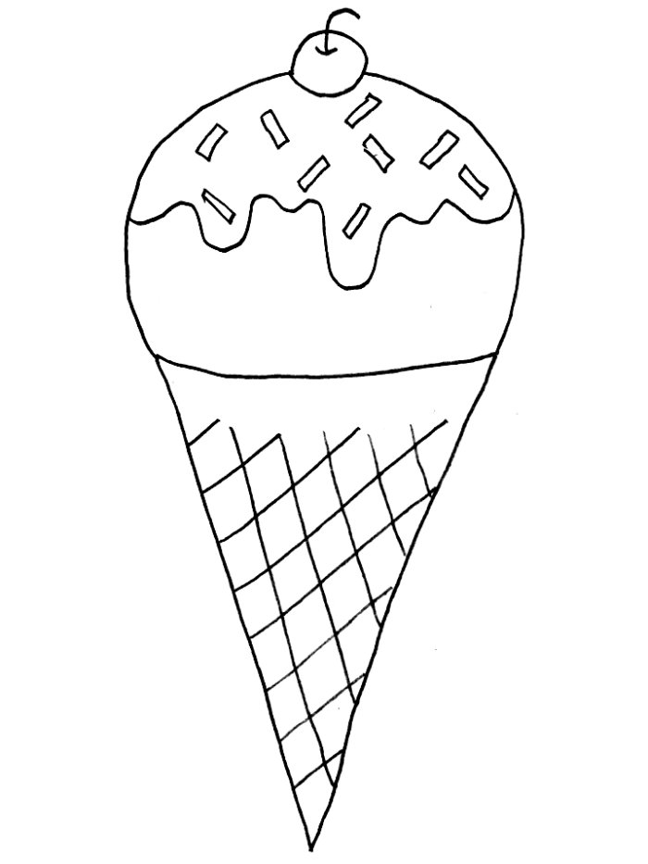
Our world
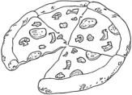
pizza ice-cream pasta
pizza ice-cream pasta

What's your favourite food?
Pasta.
Pasta.

Date:……………..\............\............
Let's play
16 17 18
sixteen seventeen eighteen
sixteen seventeen eighteen

19 20 30 40
nineteen twenty thirty forty
nineteen twenty thirty forty

50 60 70 80 90
fifty sixty seventy eighty ninety
fifty sixty seventy eighty ninety

100
a hundred
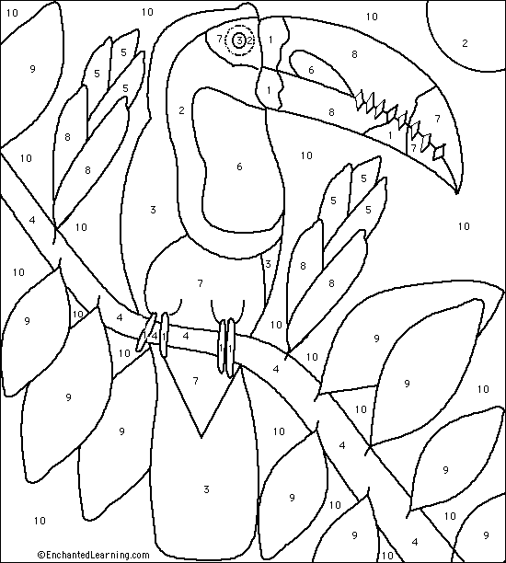
a hundred

Here you are
Here you are

Story time
Please don't touch the food.
Please don't touch the food.

Date:…………\............\............
Smart time 4
Food
kabsa noodles meat pie
kabsa noodles meat pie

