Out and about
A chant
Vocabulary:

Answer the questions:
Where is your school?

How do I get there?

Draw
The
Map

Smart kids
Vocabulary:

Write numbers in figures:
One hundred = two hundred=
three hundred= four hundred=
five hundred= six hundred =
seven hundred= eight hundred=
nine hundred= one thousand=
Answer the question:
What do you collect?

How many have you got?

Our world
Rules
Vocabulary:

Make some rules:
1. in class:

2. in library:

3. in hospital:

4. in mosque:

5. in plane:

Let's play + phonics
Vocabulary:

Draw the time:
It's half past four
It's quarter past nine
It's four thirty

Where were you yesterday?
A chant
Vocabulary:

Answer the questions?
Where was she yesterday?

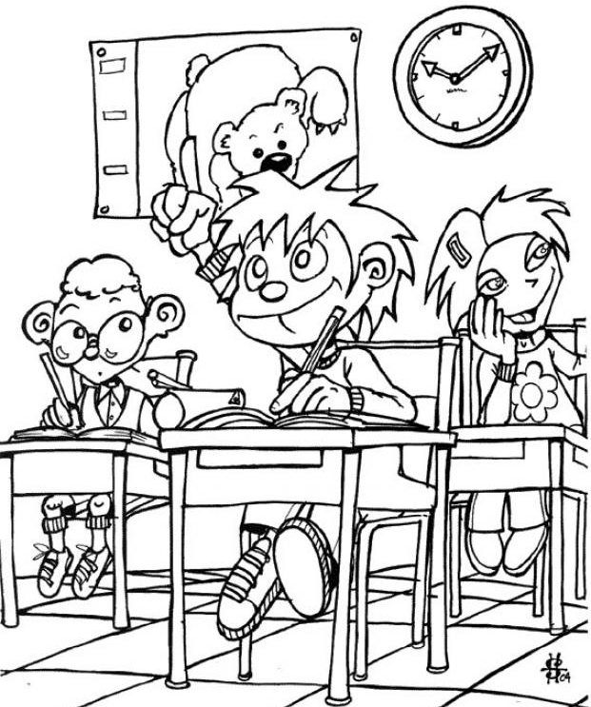
Where were they yesterday?

Smart kids
Vocabulary:

Answer the questions:
How was school today?

Was the weather nice yesterday?

How was the cake?

Our world
Vocabulary:

Complete the sentences with words from the list:
was- wasn't – were – weren't
In the past, there …………… any cars. There ……….. camels and donkeys. There …………. one souq and there…………..a school.
HHH HHH HHH HHH HHH HHH HHH
Date:…………………..\.............\...............
On holiday
A chant
Vocabulary:

Give past form of the verb:
1)play: 2)watch:
Smart kids
Vocabulary:

Give past form of the verb:
go : take:
see: eat:
HHH HHH HHH HHH HHH HHH HHH
Date:…………………..\.............\...............
Our world
Vocabulary:

Make negative:
1. They ate the cake.

Lets play \ phonics
Vocabulary:

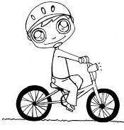
Answer the questions:

1. Did he swim?

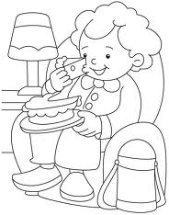

2. Did she eat?

3. Did they walk?

The world around us
A chant
Vocabulary:

Give the comparative form:
strong: fat:
short: big:
HHH HHH HHH HHH HHH HHH HHH
Date:…………………..\.............\...............
Smart kids
Vocabulary:

Give the comparative form:
good: angry:
scary: heavy:

our world
vocabulary:

Give the superlative form:
far : good:
tall: small:

HHH HHH HHH HHH HHH HHH HHH

Date:…………………..\.............\...............

Let's play- phonics
Vocabulary:

Answer the question:
1. Where are you going to travel?

2. Where are you going to do on Sunday?

Smart time4
phonics

Vocabulary:

