DATE:…………….\............\............
Phonics
Friend – prince
frog fruit princess pretty

DATE:…………….\............\............
My favourite food
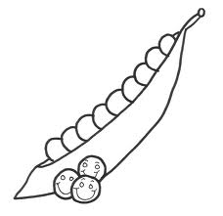
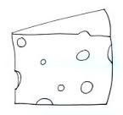
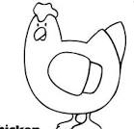
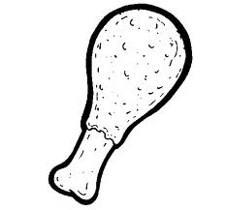
A chant

meat chicken cheese peas

tomato + s = tomatoes

sandwich + s = sandwiches

I like rice .

I don't like meat.

DATE:…………….\............\............
Smart kids

crisps soup tea beans milk

orange juice salty sweet cold hot

Do you like milk?

Yes, I do. \ No, I don't.

DATE:…………….\............\............
Comic
Good for you

Chocolate vegetables sweets

Lemonade salad

Do you want a salad?
Yes, I do. \ Yes, please.

No, I don't. \ No, thanks.

Do + not = don't

Date:………….\............\............
Let's play

breakfast lunch dinner

cereal pancake omelette bread

What do you have for dinner?
I have chicken with bread.

Date:………….\............\............
Phonics
Bread - dress
brush drink bedroom dress

date:…………..\..........\............
Story time
Good for you vs. Bad for you
cafeteria classroom home

good bad pizza

Date:………….\............\...........
Smart time 1
My breakfast
Fill in words in correct spaces:
name - from - eggs - jam - Arabic - dates - favourite

My …………………………is Ahmed. I'm ……………………KSA. For breakfast I have ………………… , bread with ……………… , and …………………… coffee. I sometimes have ……………………, too! It's my ……………………… breakfast.

Date:………………\.............\.............
Phonics
Crisps - grapes
crocodile crab green grey

Date:…………….\...........\.........
On time
A chant
Saturday Sunday Monday Tuesday

Wednesday Thursday Friday

What day is it today?
It's
What's your favourite day?

Date:………….\..........\..........
Smart kids

morning afternoon evening

night
What's the time?
It's nine o'clock.

Date:………..\.........\..........
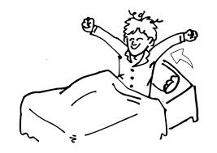
Our world

get up do my homework

go to school go home

What time do you get up?
I get up at eight o'clock.
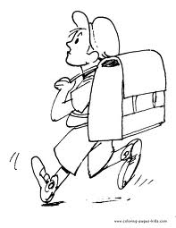
I get up at ten o'clock.
What time do you go to school?
I go to school at six o'clock.
What time do you go to bed?
I go to bed at nine o'clock.

Date:…………\...........\..............
Let's play
First = 1st second= 2nd third=3rd

Fourth=4th fifth=5th sixth=6th

Seventh=7th eighth=8th ninth=9th
Tenth=10th eleventh=11th

Twelfth=12th

January February March April
May June July August
September October November
December

Date:………\..........\...........
Phonics
Star - tree
stop sticker train tractor

Date:………………\...........\..........
Story time
What's the time?
What time Ameer go to school?

Date:………….\...........\..........
Smart time2
Festivals
arts and crafts camel race

ice fishing ice sledding snowman

Date:…………\...........\..........
Phonics
Spoon - Snake
Spider space snack snow
Date:………………\.............\........
At work
A chant
Police officer teacher waiter

doctor work

I work in a school.

He works in school.

She works in hospital.

They work in police station.

Date:…………..\........\........
Smart kids
farmer feed the animals

wash cook chef

Do you cook every day?
Yes, I do \ No, I don't
Does she work?
Yes, she does. \ No, she doesn't.

Date:………….\...........\.......
Comic

mechanic fix car taxi driver drive

I don't drive a taxi.

He doesn't fix cars.

They don't cook.

Date:………….\...........\...........
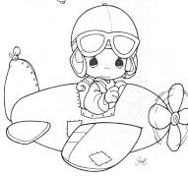
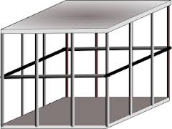
Let's play

zookeeper clean cage pilot

airport

1)Ahmed goes to school at 7o'clock.
2) She cooks dinner every night.
Date:………………\.......\.........
Phonics
Small --- Swim
smile smell sweets swan

Date:…………..\.........\..........
Story time
Where is the monkey?
tail meat fruit climb

Date:…………….\.............\..........
Phonics
Fly - - sleep
flag flower sled slippers

date:…………..\........\......
People
A chant
He's playing basketball.

He's playing football.

He's playing tennis.

He's playing volleyball.

I am playing a board game.

He + is = he's she + is=
They + are= I + am=
Date:………….\..........\.........
Smart kids

wear trainers glasses

jeans gloves scarf jacket

Answer the following:
Are you wearing gloves?

Is he wearing glasses?

Are they wearing jackets?

Date:…………\........\............
Our world
They're playing table tennis.

They're playing tag.

They're playing hide and seek.

He isn't playing tennis

You aren't reading.

They aren't playing football.

Date:……..\..........\...........
Let's play

coat socks pyjamas

abaya sandals

Whose abaya is this?
It's Fatima's.
Whose sandals are these?
They're Ahmed's.

Date:…………..\........\...........
Phonics
Blue – igloo
black blanket glasses gloves

date:………..\......\..........
story time
I don't like sports
Sport poor catch come on

Date:……..\.......\.........
Project
Friends
Write about your friend

