Name:………………………………………………………………… class:………………………………………..
Recognize short and long a-i-o-e-oo-u : اتقنت لم تتقن
Match:
Sound | words
a | rice
i | date
o | food
oo | rose
u | duck

Recognize some English digraphs ch-sh-ph-wh اتقنت لم تتقن
Match:
wh | photo
ph | white
sh | chair
ch | sheep

Recognize and differentiate between the ending of plural nouns s – es اتقنت لم تتقن
Change to plural:
book \ ……………. pen\.................... ruler\.....................

class\.................. dress\...................... fox\........................

فتره الاولى والثانيه
Ask questions using what- where - write a short answer to a written questions ;
اتقنت لم تتقن
What is your name ?
My name is ………………………………..
Where are you from ?
I am from ……………………………………
Identify items in house ; اتقنت لم تتقن
Match:
1- window 2- TV 3- sofa 4- lamp 5- book 6-Wardrobe 7- bed
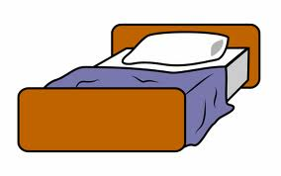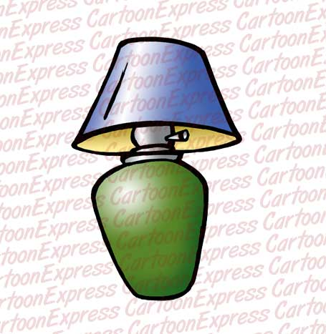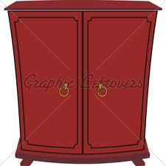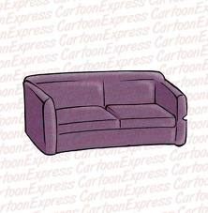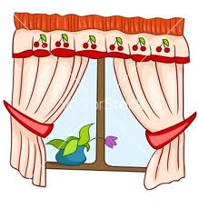
----- ----- ----- ----- ----- ----- -----
Describe physical appearance اتقنت لم تتقن
Match every animal with its body part:
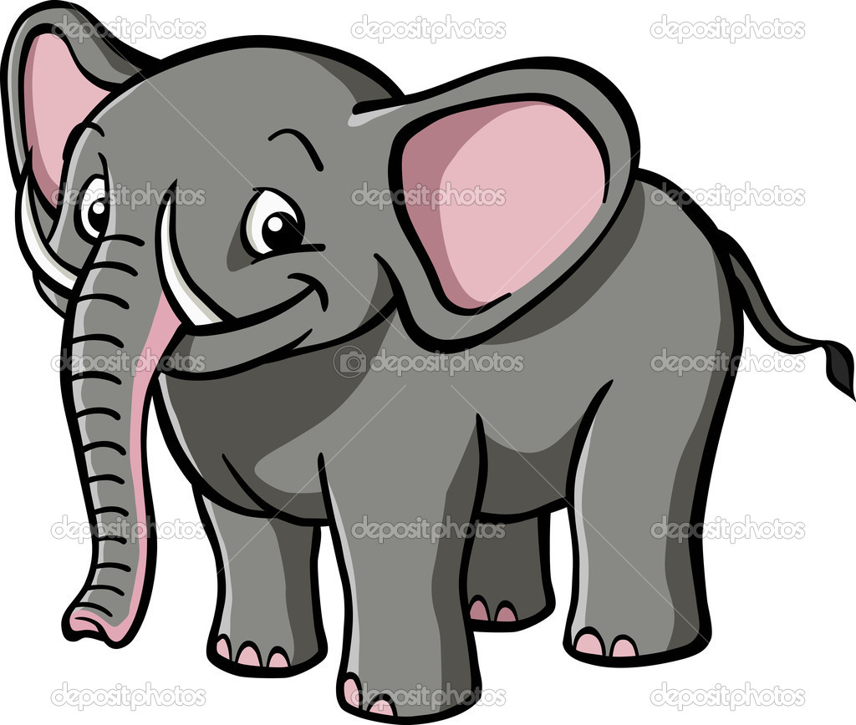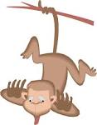

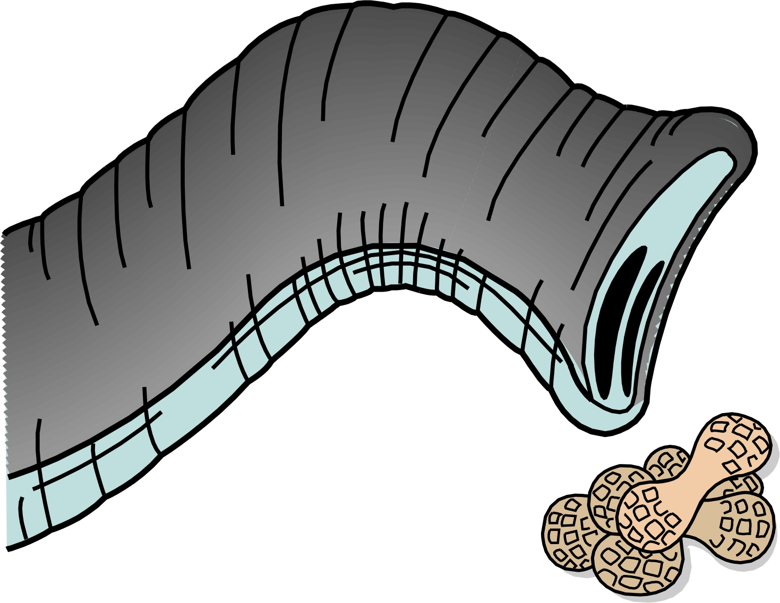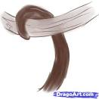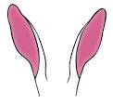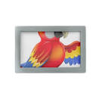
Elephant trunk Monkey tail Rabbit ears Parrot wings

Identify toys, games and classroom obeject; اتقنت لم تتقن
Match the following:
1- computer games 2- doll 3- puzzle 4- ruler 5- chair
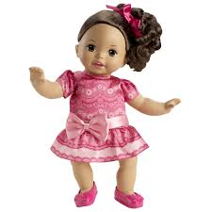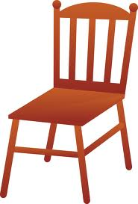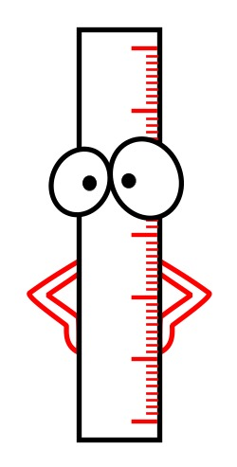
--------- --------- --------- --------- ---------
Identify irregular plural nouns اتقنت لم تتقن
Write the plural form:
man……………...... women…………….……
child ………………..
Recognize some consonant blends اتقنت لم تتقن
Match every word with the suitable sound;

Pl | Plane
 | clam
cl | plan
 | clap

Use the intensifier very اتقنت لم تتقن
Use very in the following sentences:
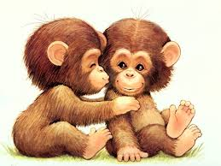 Monkeys are cute.
……………………………………………………………

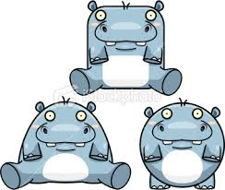 Hippos are fat.
……………………………………………………………….
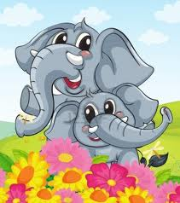 Elephants are big.
……………………………………………………………………

Ask about number using how many: اتقنت لم تتقن
How many toys do you have? 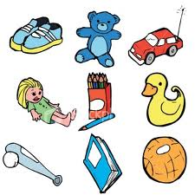
....................................................
---------------------------------------------------------------------------------------------------------------------
Identify the weather: اتقنت لم تتقن

Hot
Clod
Rainy
snowy
Match:
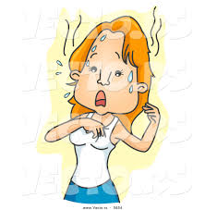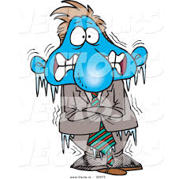

Using possessive adjective –its their اتقنت لم تتقن
Match:

Its
trunk

Their
wings

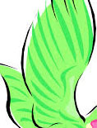
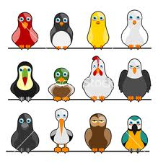

Using possessive pronounce اتقنت لم تتقن
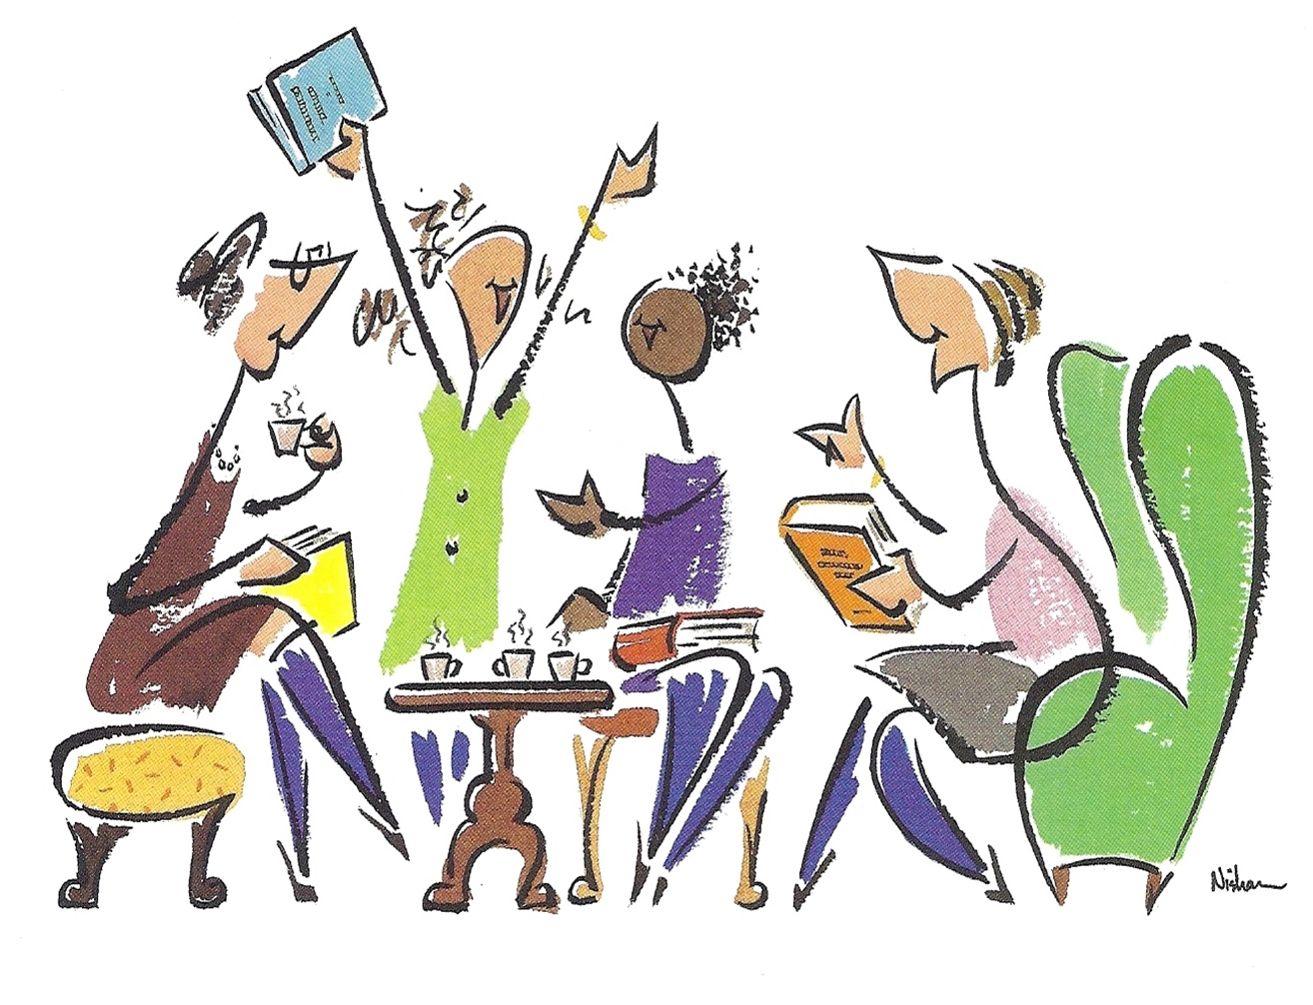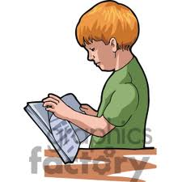
Match:

His book

Her book

Our book

Link idea with but اتقنت لم تتقن
I see animals like: monkey , camel , bird don’t see snake.

Write short simple words and sentence اتقنت لم تتقن

bag | cake | bathroom

--------------------------------------------------------------------------------------------------------------------

My friend .

--------------------------------------------------------------------------------------------------------------------

