Name : ………………………………………………………………… class : 3/S
Q1- Choose the correct alternative :
- Take Umbrella . It ( are going – is going – go ) to rain.
- I think humans ( is going – will - would ) land on the moon .
- I was about ( going – would – to ) leave the house when my mum called .
- Ali is ( big – biggest – bigger ) than Ahmad .
- They worked as ( hard harder – hardest ) as other group .
- Ahmad's car is ( more beautiful – beautifuler - the most beautiful ) in the park .
______________________________________________
Q2 - Add the correct prefix to these words :
il - post - dis- ir - inter – im -

- Appeared ………………… f- 1990 ……………………..
- Possible …………………. E- national …………………..
_______________________________________________
Q3 - Complete the sentence with (journey – trip – voyage )
- We went on a school …………………………………. To Najran .
- It will be difficult for humans to make the long ……………………………..to Mars .
_______________________________________________
Q4- Choose the correct word under each picture :
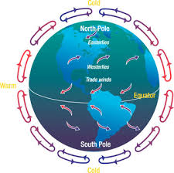
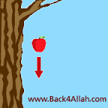

1-( telescope – orbit ) 2-( atmosphere – astronaut) 3- ( space shuttle – planet) 4- ( crew – gravity )
_________________________________________________
Q5 – Match the word with its opposite :
- Clever # ( ) tactless
- Gifted # ( ) stupid
- Patient # ( ) impatient
- Tactful # ( )slow

