Abdul RahmanFakeah Model Schools. (The Intermediate Stage)
Name: ………………………………
Unit 1Test  B  I - Comprehension  Read the following passage then, answer the questions:  My name is Asil. I’m a new school student at the intermediate stage. I love my new school. The students are very friendly. I meet lots of friends everyday and I play in the football team every Sunday. At school I study interesting subjects. I study history, geography, math, Arabic, English and computer. I’m very good at all these subjects, but I’m not very good at math. The teachers are nice. They don’t give us much homework, but they give us lots of exams.  A- Answer the following questions:  1- Is Asil at the intermediate stage?  ……………………………………………………………………………………  2- What does he play every Sunday?  ……………………………………………………………………………………  B- Choose the correct words:  1- He meets lots of [doctors - professors – students] at his new school.  2-He is not very good at [computer – math - Arabic].  3- The school subjects are [interesting - boring – unexciting].  C- Put ( ) or ( ):  1- He isn't very good at English subject. { }  2- Asil’s teachers give him lots of exams. { } | Class: 1 / …….  II – General Information Questions  A - Answer the following question:-  1- Where are you from?  ………………………………………………  B- Choose the correct response:  1- Hi, Ahmed  a- Goodbye teacher b- Fine, teacher c- Hi, teacher  2- My phone number is  a- 1, 2, 3, 4……. b-2- 10 – 2007 c- 055427019  A- choose the correct words :  1- A………….teaches in a school .  a- Farmer b- doctor c- driver d- teacher  2- My father 's……………is Ahmed .  a- age b- name c- job d- sister  D- Count and write the number:  3 + 1= ……. 5 + 2 =……  6 + 2 =……. 1 + 9 =………  III- Spelling  Write the correct word under each picture:  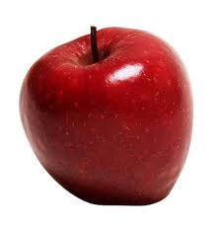  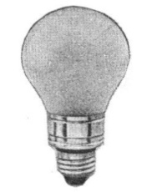  ………………. ……………. ………….. ………………

Best wishes,
Mr. Ahmed M. Ibrahim.

