Quiz M(1) 2nd grade
That's me!

Name: ....................................................... Class: 2/..........

A:Information questions:

Q1- What is your favourite school subject?

--------------------------------------------------------------------------

Q2- What do you like to do in your free time ?

---------------------------------------------------------------------------

B:Vocabulary :

1-Match the words with the pictures below:

Gym / History / Hoover / ICT / Jumper

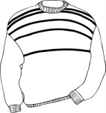

.......................

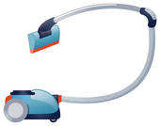

.......................

.......................

.......................

2-Match the opposites of the following adjectives:

- Chubby 1-beautiful
- Lazy 2-short
- Shy 3-slim
- Tall 4-active
5-outgoing

C:Grammar:

1-Put the words in order to make correct sentence

washes / on Thursdays /Ryan / his car
.......................................................................................

2-Choose the correct word:

a-Tom ( read / reads / reading) magazines everyday.

b-Paul watches TV ( in / on / at) night.

c-I am ( tidy / tidies / tidying ) my room today.

e-I'd like ( surf / to surf / surfing ) the Net.

D:fill in the missing letter :

Bi___logy / i__on / spo__ge / ear__ings

E.Copy this sentence once

She always cooks with her mother.

Do your best my little girls
T. ^-^

