Name :………………………………………….. Class:………………………………………
Comprehension
Captain James cook was a famous explorer . he was born in England in 1728 , he went on his first voyage to the south seas on 19th April , he reached and explored the east coast of Australia . cook named the place he reached first point Hicks .

2
Answer the following question :
1-When was captain cook born ?
………………………………………………………………………………………………….

B-Put { T } or { F }
1-Captain James cook was a famous doctor { }
2-he explored the east coast of Australia { }
Information questions

2
A-answer the following questions :

1-What do you do in your free time ? { just one )
………………………………………………………………………………………………………………
2-What are the means of transport ? { just one }
……………………………………………………………………………………………………………..

B-Complete the sentences with the words in the box
Junk food desert curly ugly

1-I don't like this dress it's …………………
2-Ahmed saw a camel in the …………………
3-Reem has got long ……………………. Hair
4-don't eat …………………………. It makes you fat.

2
Grammar
A-Do as shown between brackets:
1-{ she } is talking to you listen to …………….. { complete with object pronoun }
2-They are drawing picture { make yes , No questions }
…………………………………………………………………………………………………………
3-she { is } sick yesterday . { correct }
………………………………………………………………………………………………
4-is / a / beautiful / he / baby { Reorder }
B-Choose the correct answer
1-Ahmed { drink - drinks - drinking } milk.
2- { when - what - who } do you sleep
3-he { should - couldn't - could } draw two years ago , but now he can
4-I would like { cooking - to cook } an Italian food
Vocabulary

2
A-Circle the odd word
1-north - apple - south - east
2-shirt - abaya - skirt - math

B-write the correct word under its picture :
{ hoover - hat - junk food - lazy }
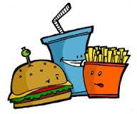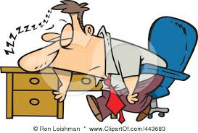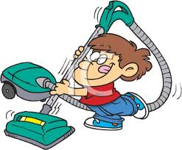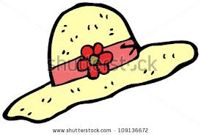
……………………….. ………………………. ……………………….. ……………………….

1
Dictation
A-Choose the correct word :
1-Land - danl - londe 3-skle - slake - silk
2-spange - sponge - speenge 4- carpet - catop - carbat

2

Hand writing

I never say No to my mother
------------------------------------------------------------------------------------------------------------------------------------------------------------------------------------------------------------------------------------------------------------------------------------------------------------------------------------------------------------------------------------------------

