General Summary on U3 Sports and Activities

1- Answer:

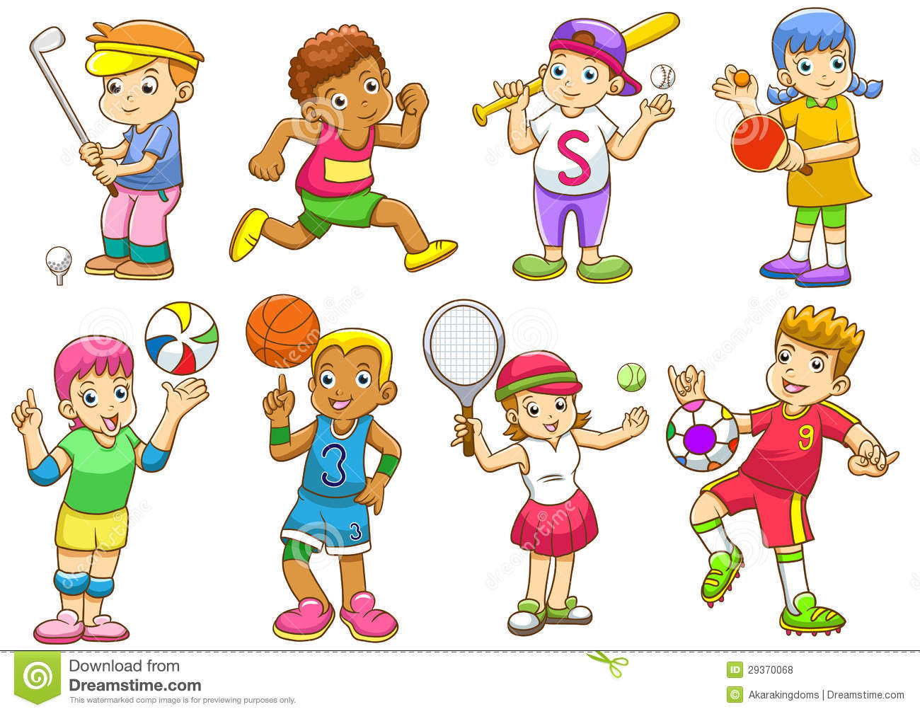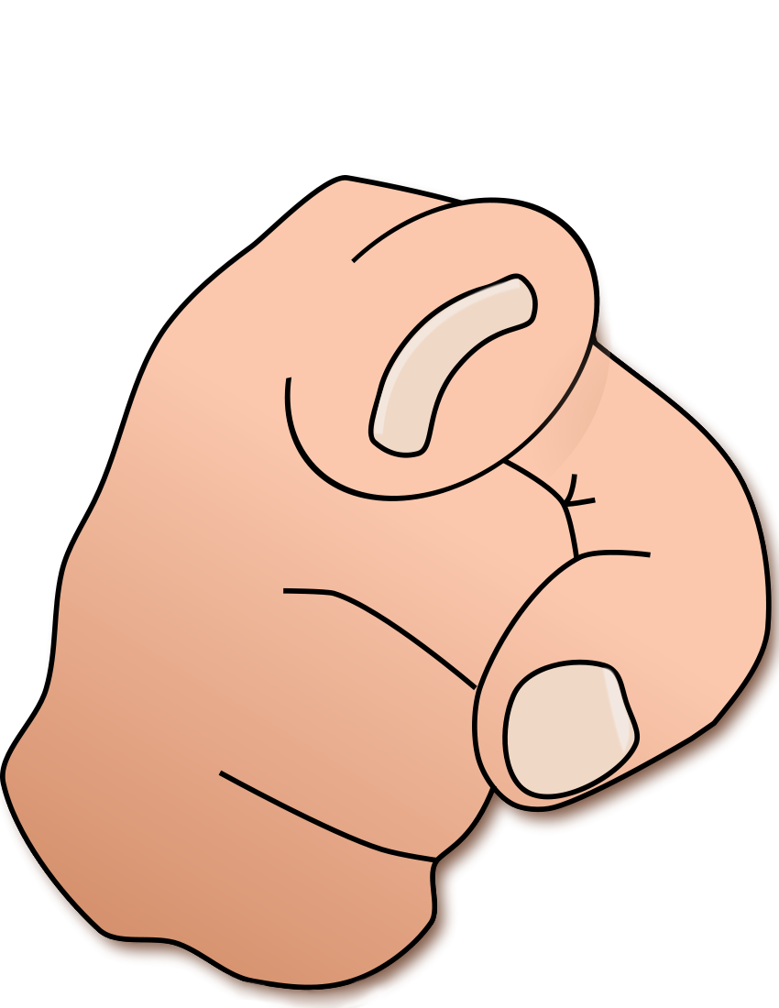

1- What sport or activity do you like?

………………………………………………………

2- What sport or activity do you want to try ?

………………………………………………………

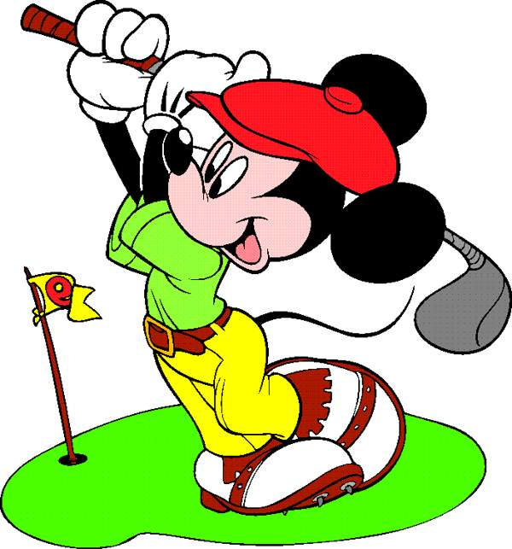

3- Do you play golf ?

……………………………………………………….

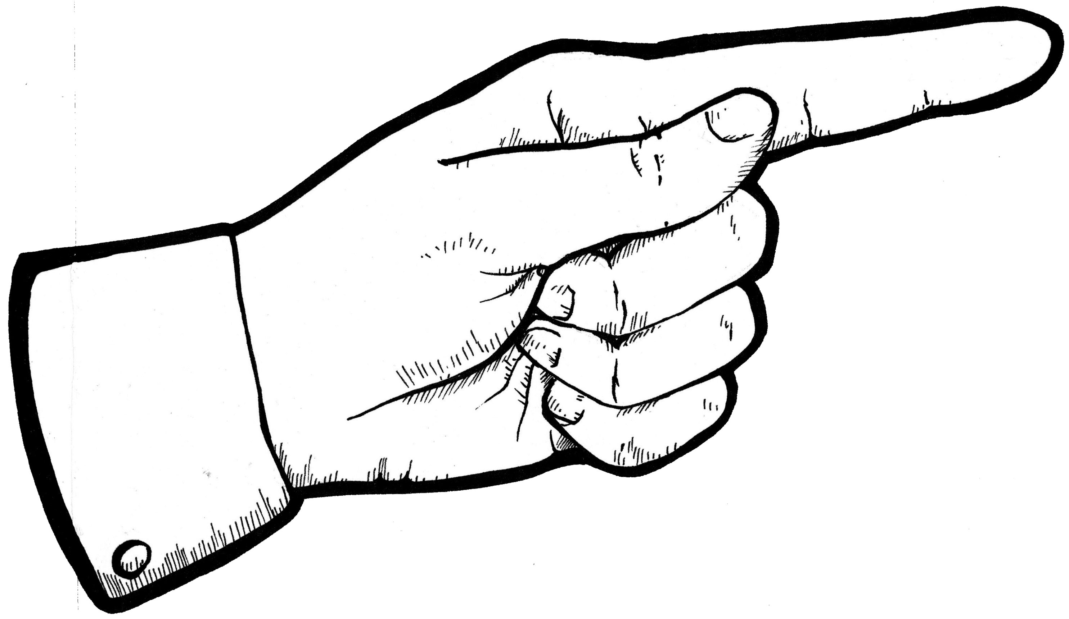

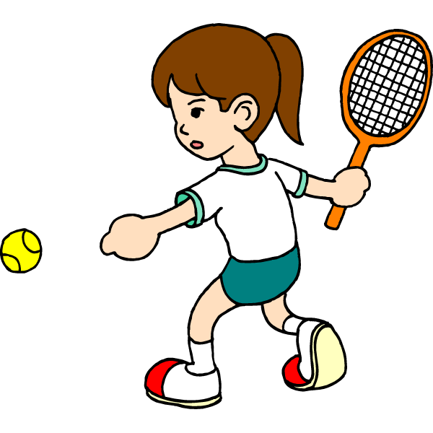

4- Does she play tennis ?

……………………………………………………..

2- Choose :

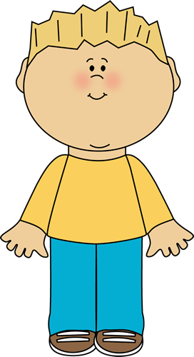

1- He likes football.

a- What sport does your brother like ?

b- Where do you live ?

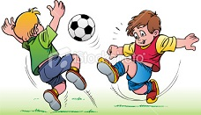

2- Do they play football ?

a- Yes, they do. b- No, they don't.

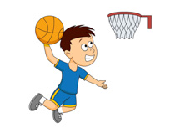

3- Does he ski ?

a- Yes, he does. b- No, he doesn't.

3- Write the following pronouns correctly :

* He- They - It - You I WeShe

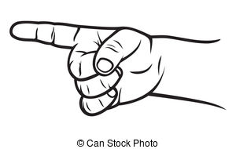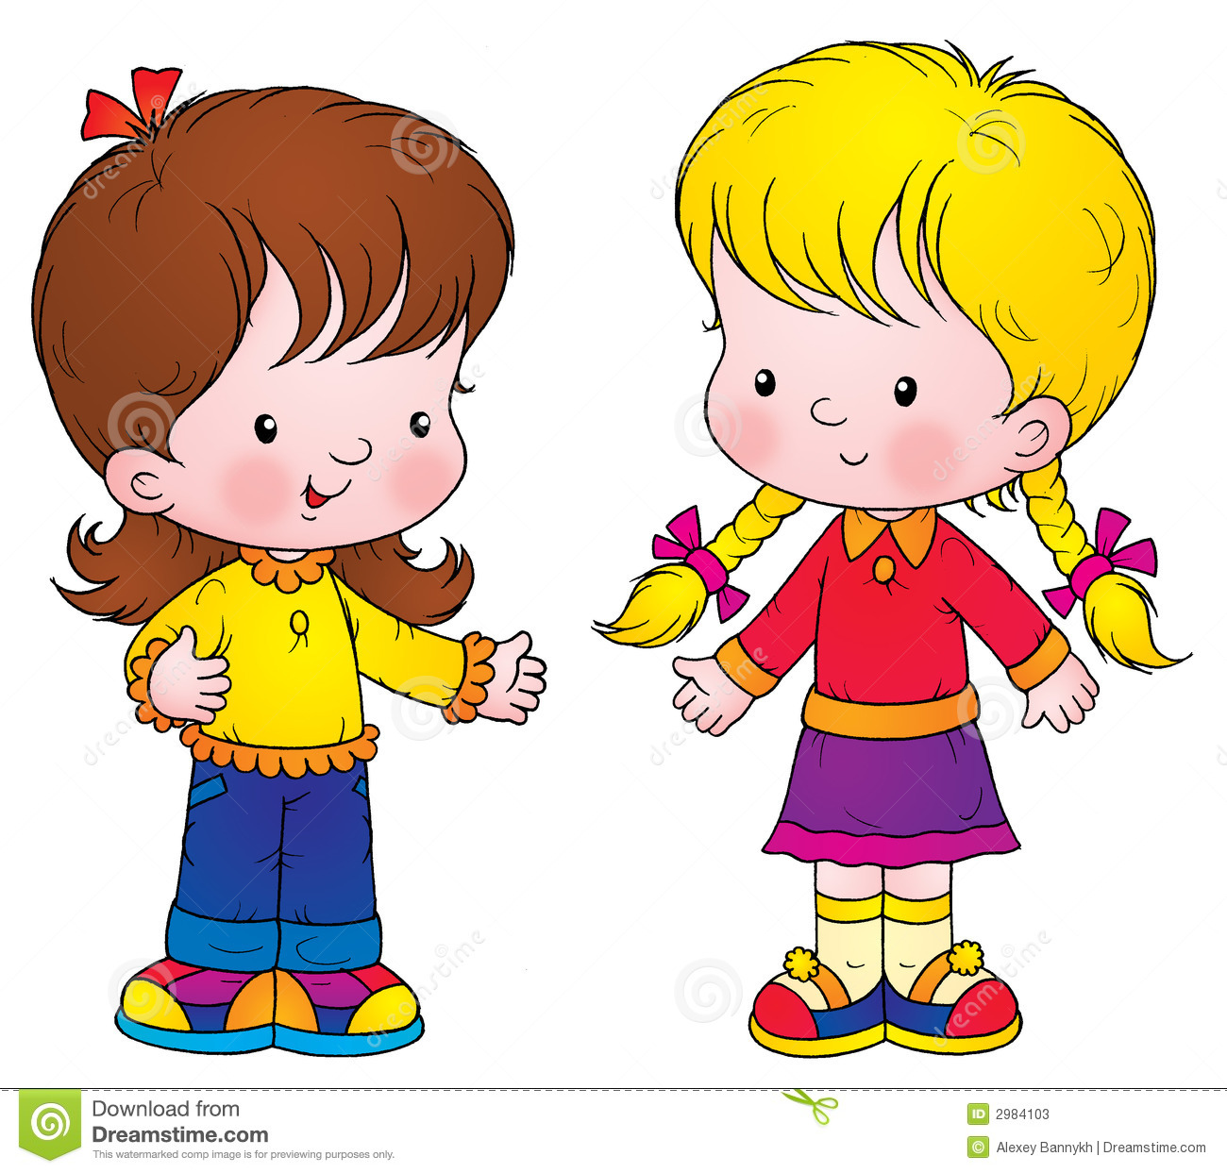









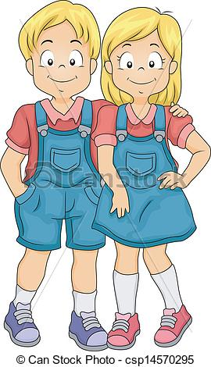



4- Write the following correctly :

Tennis - Football - Pottery - Painting - Ride a horse - Ski - Basketball - Snowboard - Word games - Volleyball - Jog - Computer gamesلاشمم - word games - volley nting - Ride a horse - Golf - Basketball - snowboard - word games - volley

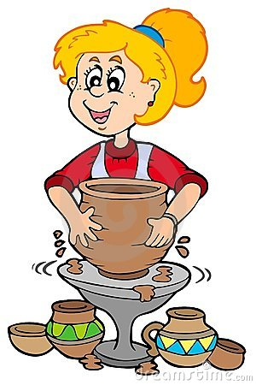



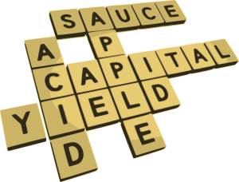

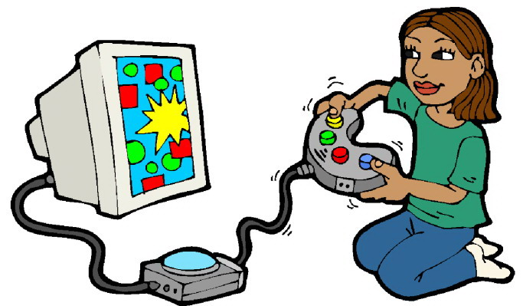



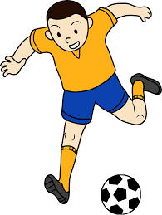

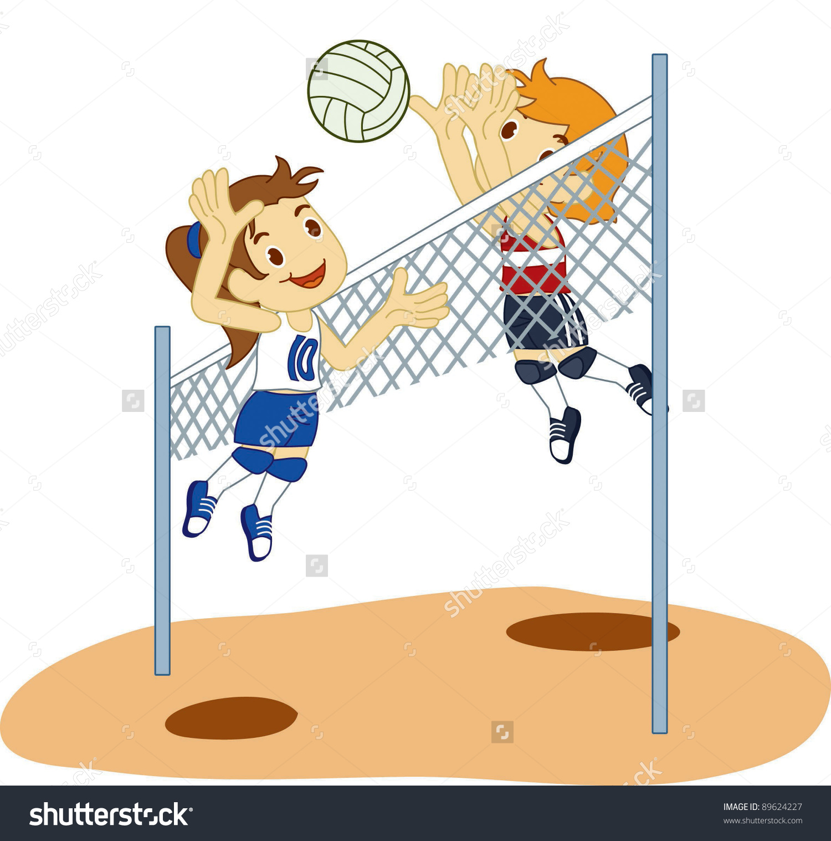



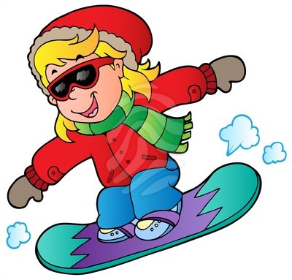

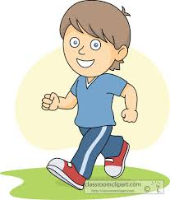



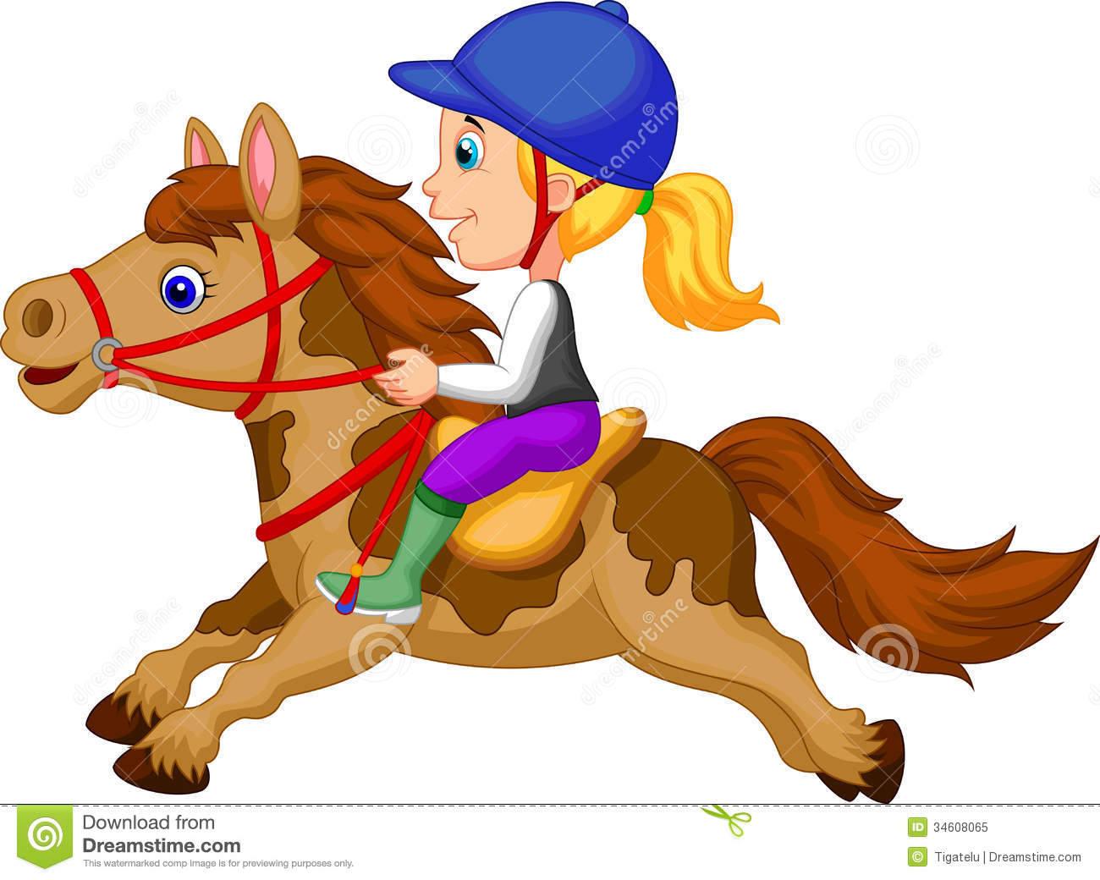

5- Choose then complete the table correctly :



1- Horse riding is ( more exciting - exciting )

than football.

2- Rock climbing is ( more dangerous – the most dangerous )

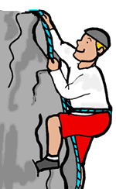

than jogging .

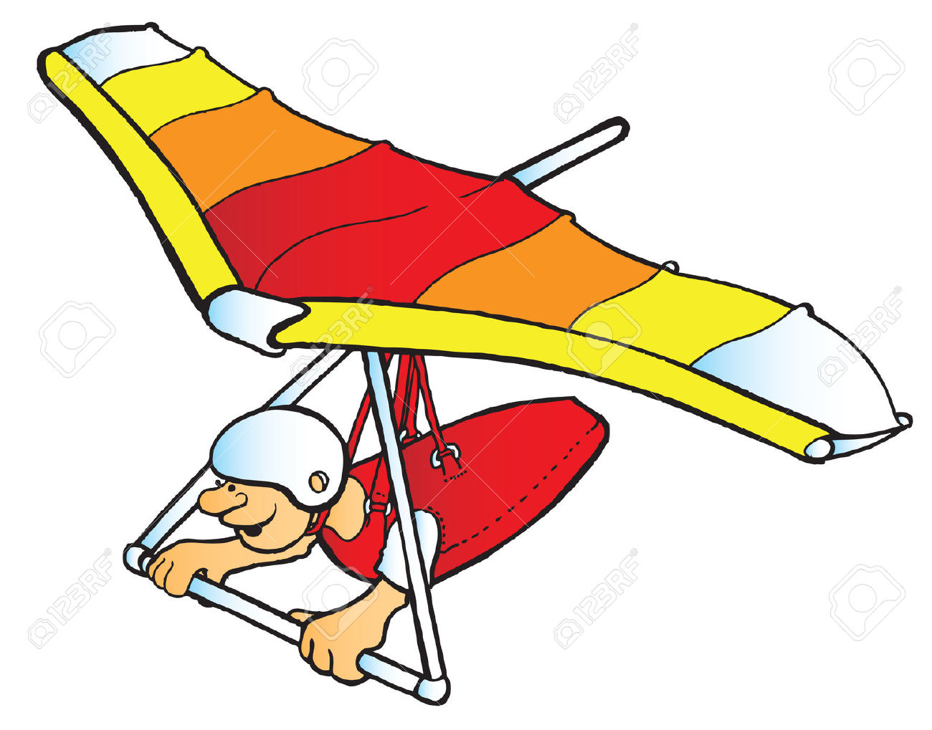

3- Hang gliding is ( the most dangerous - more dangerous ).

|  |  |  |
| --- | --- | --- |
|  |  | Fast |
|  |  | Boring |
|  |  | Cute |
|  |  | Difficult |

6- Match then Number :

1- I'd like to play tennis, but I have no horse.

2- I'd like to try riding, but I don't know.

3- I'd like to try cooking, but I have no racket.



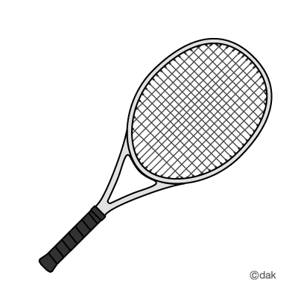

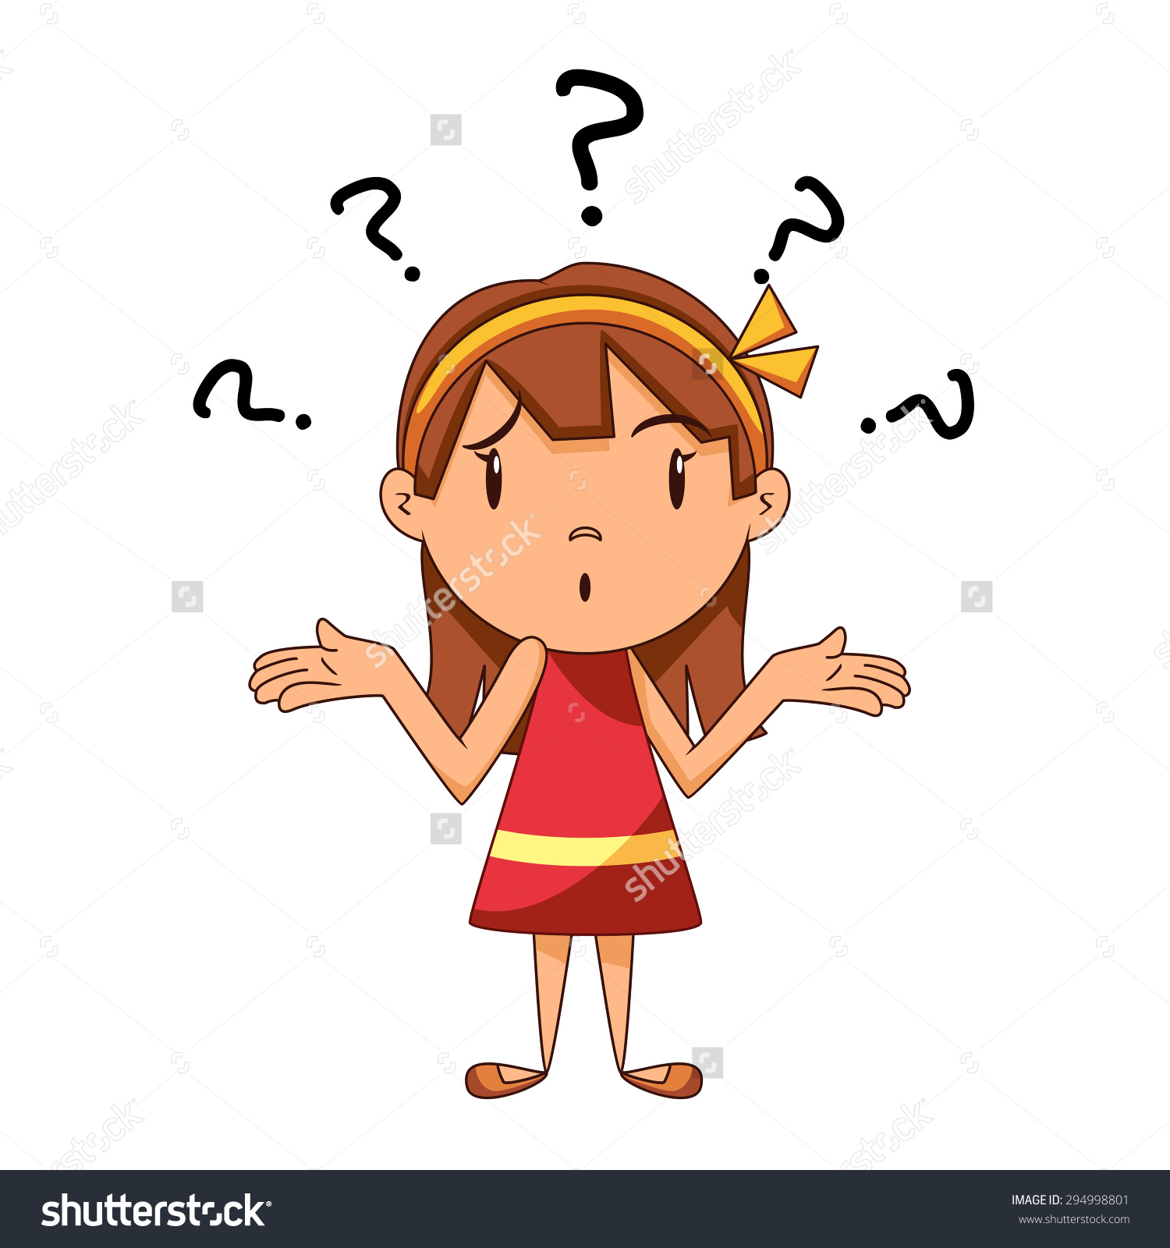

7- Listen then choose :

|  |
| --- |
|  |

|  |
| --- |
|  |

|  |  |  |  |
| --- | --- | --- | --- |
| boil | Boy | toy | C:\Users\gardenia\Pictures\صور للمنهج\مجلد جديد ‫‬\boy.png |
| flower | Clover | lower | C:\Users\gardenia\Pictures\flower.png |
| mount | House | mouse | http://www.cartooncritters.com/clipartpics/cliparta93.gif |
| coin | pin | point | C:\Users\gardenia\Pictures\coin.jpg |

8- Listen then Write :

Cr - Cl

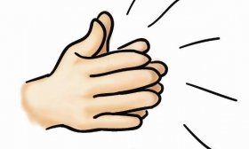

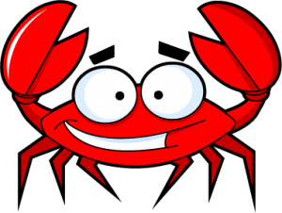

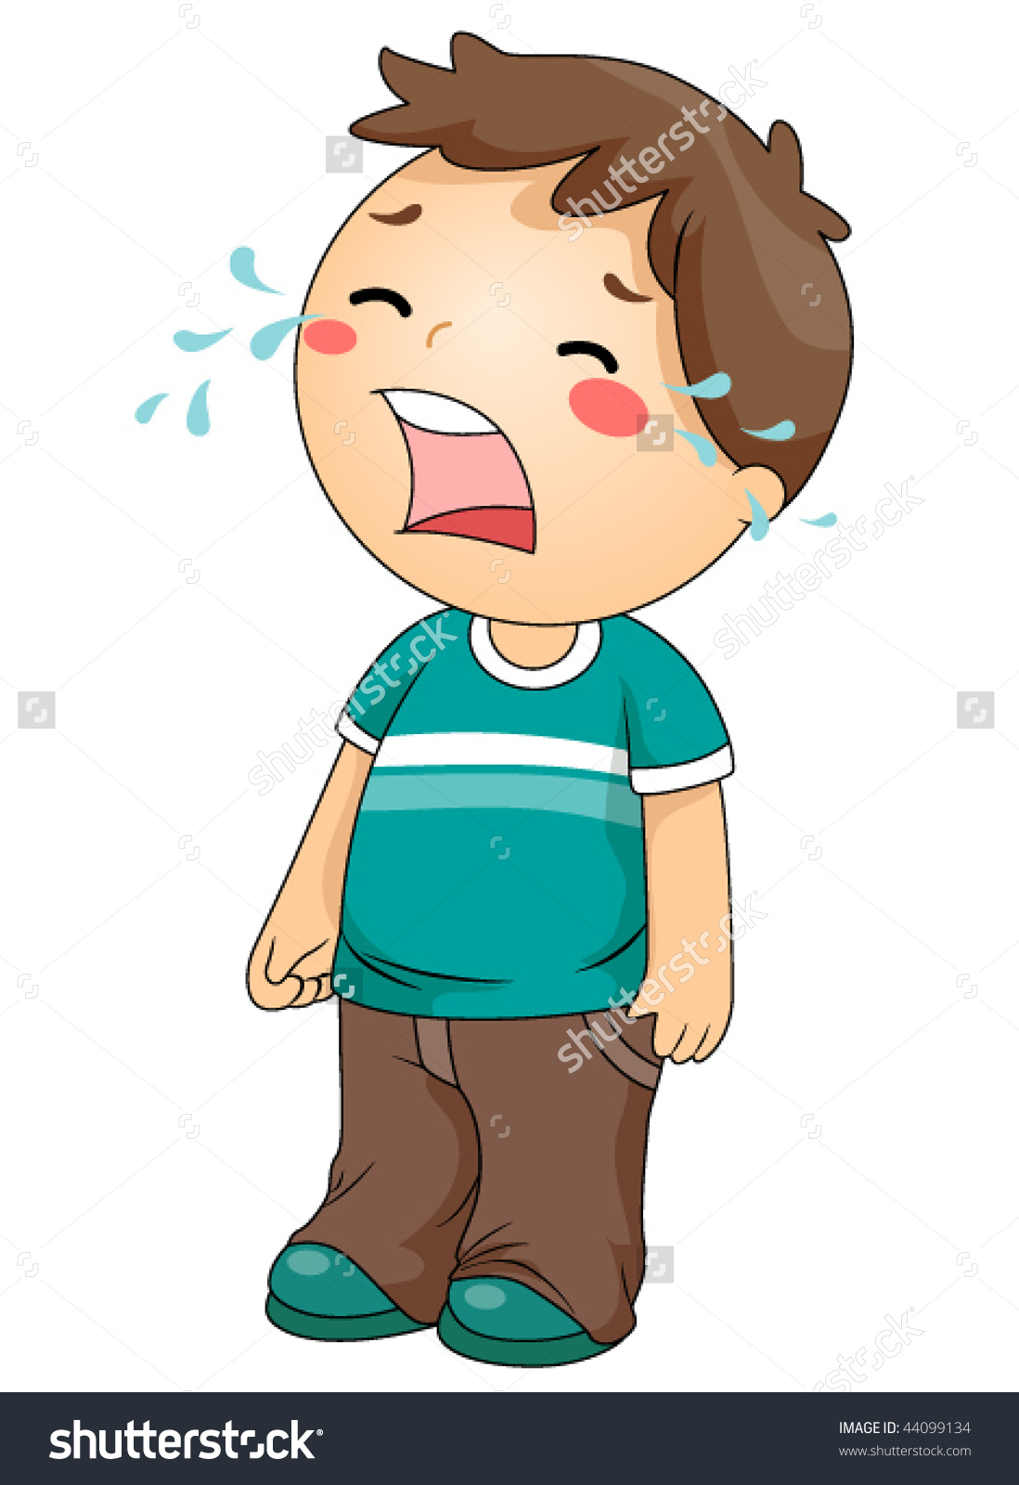



_ _ oud _ _ y _ _ab _ _ap

ere - air - ear

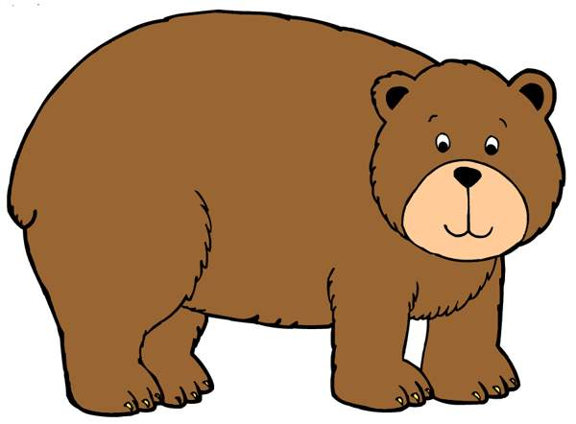



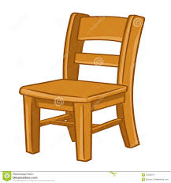

b _ _ _ wh _ _ _ ch _ _ _