Kingdom of Saudi Arabia
Ministry of Education Educational Directorate In Hail
Mujahid Intermediate

The Final Exam for 2st Grade
First Term
1433 - 1434 AH
Time: Two Hours

 |  | Corrected by
30 | Thirty marks | Total marks

Name: ………………………………………………………………………………………………………… Class: ...........

قال: رسول -صلى الله عليه و سلم-” من غشنا فليس منا"… استعن بالله ثم أجب

Q.1 –
Read the passage and answer the questions below:
The Last Prophet Mohammad (PBUH)
Prophet Mohammad (PBUH) was born in Makkah in Monday of the Year of the Elephant. His Father, died before he was born. His mother, died when he was a child of six. He lived with his grandfather.
Mohammad (PBUH) worked as a shepherd. He was always honest and people called him “alSadiq AlAmeen “. He started spreading the message of Islam in Makkah. After fourteen years from the massage Allah ordered him to move to Al Madinah. The people of Al Madinah supported him a lot. He died in the year 11 of AL Hijra in Al Madinah.

5
A- Choose the correct answer:
1- Prophet Muhammad (peace be upon him) was born in...............
a- Makkah c- Riyadh d- Madinah
2- A shepherd is a person .................
a- who teach a children b– who looks after a sheep c- who drive a cars
3- His mother, died when he wa
a. 10 years old. b. 12 years old. c. 6 years old.
B. Put ( √ ) or ( X ) for each statement:
1- The people of Al Madinah supported Muhammad (PBUH) ( )
2- He died in the year 15 of Al Hijra in Al Madinah ( )

Q.2-
A- B. Do as shown between the brackets:
1. ……………….. you like reading? (Add "do" or "does")
2- 1. speak / can / I / English / . /
…………………………………………………………………… ( Rearrange the sentence)
3- study -........................ go - .................... ( Write the past tense)
4- He …………… at home last night. (write suitable past tense of “Be” )
5- This is …………… house. ( write suitable possessive adjective)
6- I …………………………… get up at 7.30 in the morning ( write suitable adverb )

9
B- Complete the sentences by choosing the correct words:
1. Sami (is - was - were) a football player last year.
2- ( His - Her ) name is Saud

Q.3:
A - What time is it ? 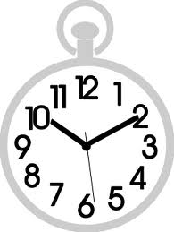

6
2
It is …… (ten o'clock - quarter to ten - ten past ten )
B - Match the suitable words under each picture:
– Reading – shepherd - air port – fishing – school crossing -

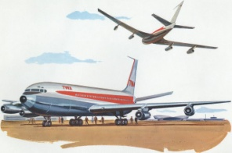
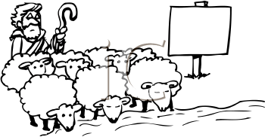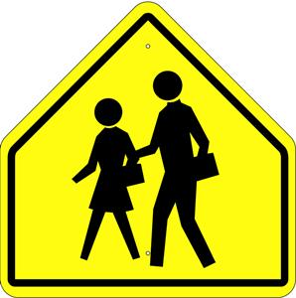

(………………………………) (………………………………) (………………………………) (………………………………)

Q.4-
A-Choose the correct letters:
Look a__ter |  |  |  | Favo__ite
k | f | g |  | z | o | r

Do__s
e | i | n

10

B- Complete the web about yourself Use the information in the web to write a paragraph about yourself: ( abilities, hobbies, favorite, likes, dislikes )

Name……………………………
Age…………………………………

Me
………………………………………………………………………………………………………………………

………………………………………………………………………………………………………………………

...My name is …….…………………………………………………………………….
………………………………………………………………………………………….
………………………………………………………………………………………….
………………………………………………………………………………………….
………………………………………………………………………………………….

3

انتهت الأسئلة
With My Best Wishes .T……….

