Kingdom of Saudi Arabia English Language
Ministry of Education Third Grade
…….intermediate school Date: /8/1438H
Time : 2 hours
Final Exam 2nd term – 1st session ( 1437 / 1438 H )
اختبار مادة اللغة الإنجليزية للفصل الدراسي الثاني _ الدور الأول _ عام 1437 - 1438 هـ للصف الثالث متوسط .
Student's Name:……………….……………… Seat No:……..…… Class…..…..

Q. No. | I | II | III |  | IV | V | Oral  evaluation | Total
Mark N.
Mark L.
Corrected by: |  |  |  | Revised by: |  | Checked by:

عزيزتي الطالبة : 1- استعيني بالله ثم أجيبي على كل الأسئلة .
2- تأكدي أن عدد الأوراق ( 4 ) .
3- الاختبار سهل واضح و بسيط .

5
I :Composition:

Which is better , running outside in the park or running at home on a treadmill? Give your opinion in a short paragraph .
Use the following words : ( opinion – running – treadmill – better than – comfortable – depend on – weather – exercise – view – easier )
………………………………………………………………………………………………………………………………………………………………………………………………………………………………………………………………………………………………………………………………………………………………………………………………………………………………………………………………………………………………………………………………………………………………………………………………………………………………………………………………………………………………………………………………………………………………………………………………………………………………………………………………………
(1)

5
II:Comprehension:

Read the following passage then answer the questions correctly:

Many animals in the world today are in danger. For many of them, the biggest danger is humans . People always kill animals for their meat or their skin . Others are killed because they eat crops or animals which belongs to farmers . Certain animals such as tigers and elephants , used to live in great numbers in countries like India. People have hunted them so much that there aren't many left alive . However , there are now laws to stop this .
In South America , many different birds and animals have lost their natural homes in the forests because thousands of trees have been cut down or burnt . People then use the land for farming or for building roads and towns . We are too late to save some animals . A few are now extinct. There are none left anywhere in the world. Others are only alive in the zoos or special parks . Zoos are important because they can help some animals to live . It is also possible to care for animals and learn more about them in zoos.
Questions :
- Why do people kill animals ?
………………………………………………………………………………………………………………….
2- Are animals in danger ?
…………………………………………………………………………………..

Complete the sentence :
1- People use the land for ………………..….or for …………………….. roads and towns .

Put {√ } or {X}:
1- We are too late to save some animals ( )
2- Zoos are not important ( )

Choose the correct answer :
1- The opposite of big is……………
a- large b- thin c- small

2- The underlined word them refer to :
a- Tigers and elephants b- people c- birds
P.T.O
(2)

5
III:Grammar

A – Choose the right words :-

1- Jeff goes to work early in ( a – the – an ) morning.
2- Tom was happy to ( give – giving – gives ) Brain a lift home .
3- ( Exercising – Exercise – Exercises ) is good for your health .
4- We finished the project by ( myself – himself – ourselves ) .
5- It was ( so – such – too ) a big cake that we couldn't eat it all .

B ) {correct the verb}:

1- This TV programme ………… ( watch ) by millions of people .
………………………………………………………….
{ Change into negative .} c)
2- You should eat a lot of sweets .They're bad for you .
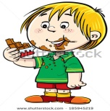
…………………………………………………………………………..

{ Rewrite the sentence using reported speech} D)
3- " Answer the quiz "
Tell : ……………………………………………………………………

5
Vocabulary: IV:

1- Write the word under the picture :
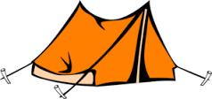
( lanterns - shake hands - smile - camping - nodded )

............................. ……………..………………. ……………………………. ………………..…………….

P.T.O
(3)
2- Form the opposites of the words in the box.

( agree - happy - possible - like )
Un + adjective | dis + adjective | im + adjective

3- Match :
1- patient a- very difficult
2- make b- a person who is getting medical treatment
c- a cake

V: Orthography:

1- Match A with B :

2
A B

1- Fire less
2- Help lift
works

2- Complete the missing letters :
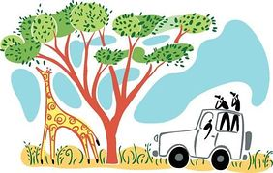
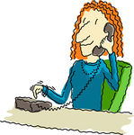

…..ob hu…. dia…… sa….ari

3- Choose the correct spelling under the pictures :

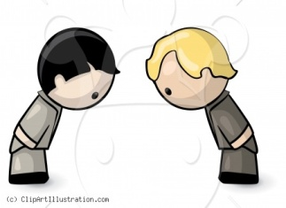
candle - candel
bwo - bow

Your teacher :………….
(4)

