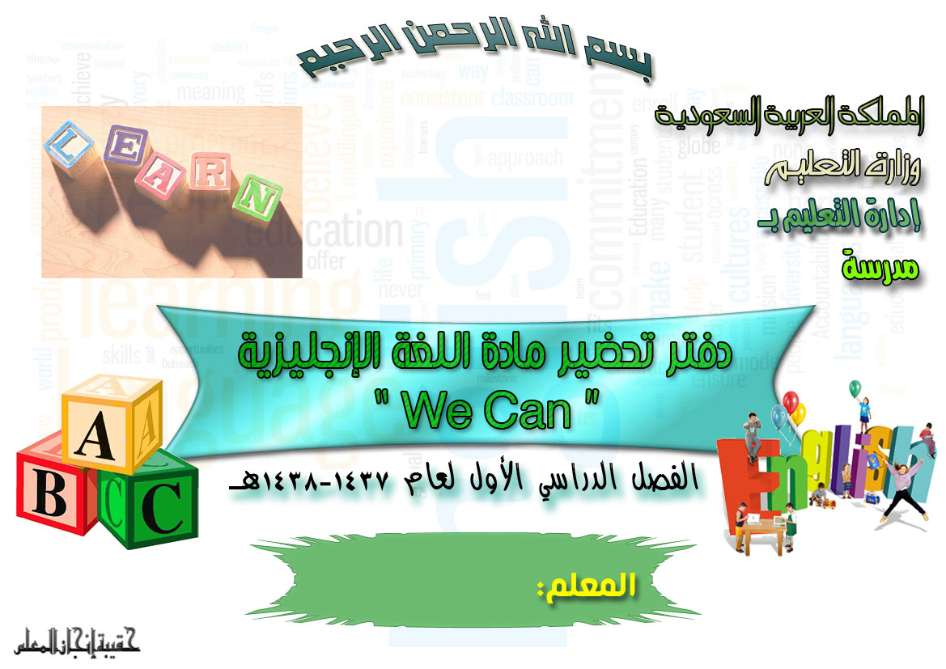

- To contribute to student’s intellectual, personal and professional growth.
- To enable student to acquire basic language skills (listening, speaking, reading and writing).
- To develop student’s awareness of the importance of English as a means of international communication.
- To develop student’s positive attitude towards learning English.
- To enable student to acquire the necessary linguistic competence required in various life situations.
- To enable student to acquire the linguistic competence required in different professions.
- To develop student awareness about the cultural, economic, and social issues of his society and prepare him to participate in their solutions.
- To develop the linguistic competence that enables student – in future - to present and explain Islamic concepts and issues, and participate in spreading Islam.
- To enable student linguistically to present the culture and civilization of his nation.
- To enable student linguistically to benefit from English-speaking nations, that would enhance the concepts of international cooperation that would develop understanding and respect of the cultural differences between nations.
- To provide student with the linguistic basis that would enable him to participate in transforming other nation’s scientific and technological advances that can enhance the progress of his nation.
English Supervisor: School Principal:
Signature: Signature:
Date: / / 143 H Date: / / 143 H



By the end of the Elementary Stage and within the assigned structures and vocabulary for this stage:
Students should be able to . . .
- Learn the basics of the English language that would form the foundation for its mastery in the future.
- Use the basic structures of English sentences.
- Learn the core vocabulary assigned for this stage.
- Listen to and understand simple English.
- Express themselves orally using simple English.
- Read and understand simple written English materials.
- Write simple guided sentences in English.
- Develop an awareness of the importance of the English language as an international mean of communication in order to be able to introduce Islam, the Islamic nation’s culture and the cultural achievements of Muslims to other nations.
- Develop an awareness of the importance of the English language as an international mean of communication in order to benefit from the achievements of other cultures in accordance to the precepts of Islam.
English Supervisor: School Principal:
Signature: Signature:
Date: / / 143 H Date: / / 143 H

By the end of the Intermediate Stage and according to the overall syllabus for the three years of the intermediate stage the general aims are:
- To produce an individual who is able to speak, read, and listen with understanding to simple current English and to write a connected passage of up to half a page about a simple subject or incident.
- To give pupils who finish three formal education levels enough knowledge of the language to help them in their vacation.
- To give pupils who precede to the secondary stage a sound foundation on which to build their future studies.
- To lay the foundation of knowledge of English so that they acquire sufficient grasp of the language to enable them preach their religion to English speakers and to refute the errors of the enemies of Islam.

English Supervisor: School Principal:
Signature: Signature:
Date: / / 143 H Date: / / 143 H

By the end of the Secondary Stage and according to the overall syllabus for the three years of the secondary stage the general aims are:
- To afford the secondary school pupil a window on the world.
- To give the secondary school pupil an experience of delight through reading samples of English that have a universal appeal both in arts and sciences.
- To cultivate the pupil’s critical thinking as a useful adjunct to intelligent reading of English texts.
- To give play to the pupil’s imagination by means of imagery in poetry and visualization of character.
- To provide the pupil who intends to join the university or other higher institutes with an adequate knowledge of English to help him in his future studies.
- To give the pupil who finishes his formal education in the third year of secondary education sufficient knowledge of the language to help him in his vocation.

English Supervisor: School Principal:
Signature: Signature:
Date: / / 143 H Date: / / 143 H

Islamic Goals of Teaching
English as a Foreign Language in Saudi Arabia

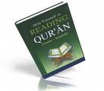
- To feel the greatness of the creator in the great differences between the tongues and the languages of different people all over the world.
- To acquire the linguistic basis that enables the learners to advocate Islamic and explain the Islamic concepts and Issues.
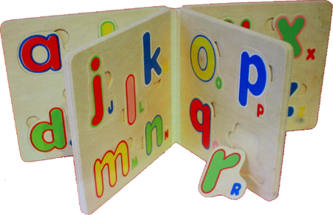
- To spread the Instructions of the true Islamic religion through convincing the other of those who are not Muslims all over the world.
- To benefit from being an International language that spread all over the world by developing attitude towards spreading the Islamic Instructions.
- To appreciate the important of English as an International language of communication – to benefit from the achievements of the other cultures in accordance with the Islamic teachings.

English Supervisor: School Principal:
Signature: Signature:
Date: / / 143 H Date: / / 143 H

Goals of Teaching English as a Foreign Language in the Kingdom of Saudi Arabia
Students should be able to:
- Enhance their intellectual, personal and professional abilities.
- Acquire the language skills (listening, speaking, reading and writing) in order to communicate with English speaking people.
- Acquire the linguistic competence necessarily required to use English in various life situations.
- Develop awareness of the importance of English in the local job market.
- Develop awareness of the important of English as a means of International communication.
- Develop the linguistic competence that enables them to understand the cultural, economic and social issues of their society in order to participate in their solution.
- Develop the linguistic competences that enable them, in the future, to participate in spreading Islam.
- Acquire the linguistic basis that enables them to advocate Islam and explain the Islamic concepts and issues.
- Enhance understanding and respect of cultural differences among nations.
- Appreciate the importance of English – as an International language of communication – to present their culture, and civilization to others.
- Appreciate the important of English – as an International language of communication – to benefit from the achievements of other cultures in accordance with the Islamic teachings.
- Develop positive towards learning English.

English Supervisor: School Principal:
Signature: Signature:
Date: / / 143 H Date: / / 143 H

The General Objectives of English Language in Saudi Arabia:

Students should be able to:
- Develop their intellectual, personal and professional abilities.
- Acquire basic language skills (listening, speaking, reading and writing) in order to
- Communicate with speakers of English language.
- Acquire the linguistic competence necessarily required in various life situations.
- Acquire the linguistic competence required in different professions.
- Develop their awareness of the importance of English as a means of international communication.
- Develop positive attitudes towards learning English.
- Develop the linguistic competence that enables them to be aware of the cultural, economical and social issues of their society in order to contribute in giving solutions.
- Develop the linguistic competence that enables them, in the future, to present and explain the Islamic concepts and issues, and participate in spreading Islam.
- Develop the linguistic competence that enables them, in the future, to present the cultural and civilization of their nation.
- Benefit from English – speaking nations, in order to enhance the concepts of international cooperation of their nation.
- Acquire the linguistic bases that enable them to participate in transferring the scientific and technological advances of their nations to their nation.
- Acquire their linguistic bases that enable them to present and explain Islamic concepts and issues, and participate in the programme of Islam.

English Supervisor: School Principal:
Signature: Signature:
Date: / / 143 H Date: / / 143 H
General Recommendations
It is recommended, also, that a teacher should know about the objectives of teaching English in details:
First: Objectives of Teaching Writing in the Elementary stage
By the end of this stage and within the framework of the assigned structures and vocabulary: students should be able to . . .
- Practice the system of spacing between letters and words.
- Match capital letters with small letters.
- Recognize (and correctly write and pronounce) the letter-sound relationship.
- Recognize and apply the directionality of English writing.
- Recognize and apply the position of letters in relation to the ruled lines.
- Recognize and apply the formation of individual letters and numbers through coloring and tracing.
- Copy letters, words, numbers and simple sentences assigned for this grade using cursive script.
- Spell the assigned vocabulary correctly.
- Write guided answers to written questions.
- Do controlled writing exercises such as supplying missing letters or words.
- Recognize and correctly use punctuation and capitalization assigned for this grade.
- Show willingness to write words, numbers and simple sentences.

Second: Objectives of Teaching Listening and Speaking in The Elementary Stage:

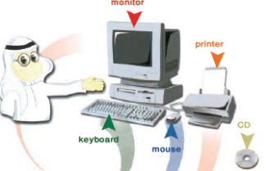
By the end of the Elementary Stage pupils should be able to do the following within the framework of the assigned structure and vocabulary for this stage:
- Recognize and produce the English alphabet.
- Understand and respond to simple verbal and physical requests.
- Participate in simple short activities such as greetings, receiving commands, conversations, role play, etc.
- Ask and respond to simple interrogative sentences about people and things in general such as yes/no questions and WH questions.
- Describe and participate in simple short events and activities taking place in continuous forms.
- Distinguish and pronounce different sounds using different techniques.
- Show willingness to take different parts in classroom activities such as songs, role plays, games, etc .
- Show willingness to listen carefully to listen to short prepared recorded materials.

Third: Objectives of Teaching Reading in the Elementary Stage:

By the end of the Elementary Stage pupils should be able to
- Recognize and produce the English alphabet.
- Recognize and apply directionality in reading English alphabet and words.
- Recognize the relationship between sounds and letters.
- Distinguish and read words containing symbols of English alphabet such as (ch, th, ph)
- Read correctly and comprehend simple words and short sentences and paragraphs.
- Comprehend the meaning of the following English punctuation and capitalization (period, comma, colon, semicolon, question mark, exclamation mark, slash, hyphen, an apostrophe)
- Be willing to read words phrases and sentences.
- Be willing to read simplified illustrated (drawn / pictured) students short stories.

English Supervisor: School Principal:
Signature: Signature:
Date: / / 143 H Date: / / 143 H
It is recommended to introduce some songs or rhymes to help in delivering the subject
The characteristics of acceptable rhymes:
Rhymes and songs are very useful. One should know what makes a song or a rhyme Suitable for a beginner age group and interests and the learners level of English. A song or a rhyme should be in simple modern language, short, easy to be repeated and it serves a purpose, i.e. relates to the topic understudy. And it should not have too many new items of vocabulary and grammar. A rhyme should be culturally acceptable, i.e. it does not contradict the culture of the native language.
Why rhymes should be taught?
    - They help pupils to speak the language fluently.

    - Young learners enjoy singing and playing.
    - Rhymes reinforce the target language.
    - The stressed syllables are taught correctly.
    - The simple grammatical structures are reinforced.
    - The language patterns, which are commonly used, are taught successfully.
How a rhyme is taught?
- Sing or simply say the rhyme once or twice to the pupils accompanied with suitable actions.
- Try to know that the pupils have understood what the rhyme is about.
- If they cannot understand the meaning, try to explain the rhyme in a very simple language. Use any needed visual aids.
- Say the rhyme again more than once, and let them repeat after you.
- Keep repeating each rhyme during regular lessons, revision lessons, and any other chances.
- As an assignment, ask pupils to find other rhymes, and choose the simple ones to be repeated with the class, if they are relevant to the syllabus.

English Supervisor: School Principal:
Signature: Signature:
Date: / / 143 H Date: / / 143 H

A Brief Display of Some Known Methods of Teaching English as a Foreign Language

  - The Grammar Translation Method:
- It places significant emphasis on reading. It makes an extensive use of the native language of the learner to explain and discuss the target language.
- It also concentrates on direct instruction of grammatical rules and memorization of isolated words. Translation from and to native language is a major practice in this method.

  - The Direct Method:
- The direct method emphasizes the use of the target language in the classroom.
- The native language is not used at all. The target language is dominating.

  - The Audio – Lingual Method: (Aural – Oral)
- It is a reaction to the Grammar Translation Method which concentrates on reading and writing skills. The Audio-lingual method views language as a set of habits formation through repeated exposure to specific forms.

  - The Suggestopedia (Suggestology):
- The instructional objective of this method is defined in semantic and communicative term. Students initiate the foreign language learning with the assistance of their language teacher.

  - The Total Physical Response Method:
- It is not an actual method. Rather, it is a technique. It attaches great importance and emphasis on listening and comprehension skills.

  - The Communicative Approach:
- It is known as Functional National Approach. The primary goal of Communicative approach is to enable Foreign Language learners to communicate on the target language fluently and freely.

  - Cognitive Approach:
- It pays great attention to conscious instruction drills rather than to mechanical ones. Rules of grammar are taught dialogues and are presented in a sequential basis.

  - Natural Approach:
- It views language as a means of inter personal communications.
- There is no one method for all situations. Teachers should be aware of these methods and approaches in order to choose from them to build their own method of teaching. Each instructional situation is unique. To be effective, the teacher should be eutectic.

Dear colleague, remember before writing your objectives, they should be:
  - Clear.
  - Limited.
  - Attainable.
  - Measurable.
  - Stated in behavioral terms.

English Supervisor: School Principal:
Signature: Signature:
Date: / / 143 H Date: / / 143 H
Behavioral Terms
By the end of the lesson the pupil is able to:
- Pronounce (the letter …….) correctly. 2- Write down capital …………… small.
- Identify letters capital/small letters… 4- Apply ……… rules of certain structure.
- Put…… certain words in sentences. 6- Change from active into passive.
- Report certain sentences. 8- Compare between two things/more.
- Read a text at (80% - 90%) of fluency. 10- Answer some given questions.
- Use a model composition for writing another. 12- Match words which…..
- Distinguish elements. 14- List things, names ……………… etc.
- Classify ……………………… 16- Select ……………….
- Contrast ……………………… 18- Discuss ………………
- Relate ……………………….. 20- Combine …………….
- Organize ……………………. 22- Discover ……………..
- Differentiate ……………….. 24- Rewrite ………………

English Supervisor: School Principal:
Signature: Signature:
Date: / / 143 H Date: / / 143 H

School year: 1437/1438 H
Topic | Hijri calendar | Christian calendar
Beginning of the first semester | Sunday 17/12/1437 H | 18/9/2016 AD
National day holiday | Thursday 21/12/1437 H | 22/9/2016 AD
Beginning of the mid-first semester vacation | Thursday 10/2/1438 H | 10/11/2016 AD
Beginning of the study after mid-first semester vacation | Sunday 20/2/1438 H | 20/11/2016 AD
Beginning of the first semester tests | Sunday 17/4/1438 H | 15/1/2017 AD
Beginning of mid-year vacation | Thursday 28/4/1438 H | 26/1/2017 AD
Beginning of the study for the second semester | Sunday 8/5/1438 H | 5/2/2017 AD
Beginning of the mid-second semester vacation | Thursday 2/7/1438 H | 30/3/2017 AD
Beginning of the study after mid-second semester vacation | Sunday 12/7/1438 H | 9/4/2017 AD
Beginning of the second semester tests | Sunday 9/91438 H | 4/6/2017 AD
Beginning of the summer vacation | Thursday 20/9/1438 H | 15/6/2017 AD
Beginning of school year 1438/1439 H. | Sunday 19/12/1438 H | 10/9/2017 AD
Number of school weeks of the first semester | (18) weeks (include school weeks and the two weeks of tests)
Number of school weeks of the second semester | (18) weeks (include school weeks and the two weeks of tests)
Actual number of school days for the two semesters | (179) days (include school days and days of tests)
The number of vacations during the school year | (5) vacations
The number of days for mid-first semester vacation | (11) days
The number of days for mid-year vacation | (9) days
The number of days for mid-second semester vacation | (8) days


The distribution of the syllabus We Can3 for 5th Elementary grade First semester (1437 – 1438H)
The 1st week | The 2nd week | The 3rd week | The 4th week | The 5th week
17/12 - 20/12 (Naional day holiday 21/12) | 24/12 - 28/12 | 1/1 - 5/1 | 8/1 - 12/1 | 15/1 - 19/1
Introduction P. 2 & 3 | Unit 1: L 1 - P. 4 & 5  Unit 1: L 2 - P. 6 & 7 | Unit 1: L 3 - P. 8 & 9  Unit 1: L 4 - P. 10 & 11 | WB & Revision | Unit 2: L 1 - P. 12 & 13  Unit 2: L 2 - P. 14 & 15
The 6th week | The 7th week | The 8th week | the 9th week | The 10th week
22/1 - 26/1 | 29/1 - 3/2 | 6/2 - 10/2 | 20/2 - 24/2 | 27/2 - 2/3
Unit 2: L 3 - P. 16 & 17  Unit 2: L 4 - P. 18 & 19 | WB & Revision | Unit 3: L 1 - P. 20 & 21  Unit 3: L 2 - P. 22 & 23 | Unit 3: L 3 - P. 24 & 25  Unit 3: L 4 - P. 26 & 27 | WB & Revision
The 11th week | The 12th week | The 15th week | The 14th week | The 15th week
5/3 - 9/3 | 12/3 - 16/3 | 19/3 - 23/3 | 26/3 - 30/3 | 3/4 - 7/4
Unit 4: L 1 - P. 28 & 29  Unit 4: L 2 - P. 30 & 31 | Unit 4: L 3 - P. 32 & 33  Unit 4: L 4 - P. 34 & 35 | WB & Revision | Unit 5: L 1 - P. 36 & 37  Unit 5: L 2 - P. 38 & 39 | Unit 5: L 3 - P. 40 & 41  Unit 5: L 4 - P. 42 & 43
The 16th week | The 17th week | The 18th week | Beginning of the vacation by the end of the week.
10/4 - 14/4 | 17/4 - 21/4 | 24/4 - 28/4 | 28/4/1438 H
WB & Revision | General Revision |  | Beginning of the vacation

Subject teacher Supervisor Headmaster
Name: Name: Name:
Signature Signature Signature

Feelings |  |  |  |  |  | Title | 1  1 |  | Unit  Lesson |  |  | English 5th G. |  |  | Subject
 |  |  |  |  |  | Date |  |  |  |  |  |  |  |  | Chapter - Class
Great – fine- thanks- meet- first- second- third- fourth- fifth |  |  |  |  |  |  |  |  |  |  |  |  |  |  | Vocabulary
Verification |  |  | Procedure |  |  |  |  |  |  | Aids |  |  |  |  | Objectives
Evaluation:  - “How are you?”  - Greet your teacher.  - Complete: "I'm ...." |  |  | - I greet the students and say "Hello".  - I write the date and the title on the board.  - Page 4:  1 -  - I play the CD and listen to a short simple dialogue.  - I ask the students:"How are you?"  - Get the students to respond.  - I ask the students to open their books and play the CD twice.  - I walk around the class to make sure that the students are finding the correct pictures.  2 -  - I ask the students to play the dialogue in pairs, then play the CD twice.  3-  - I write the dialogue on the board, and ask students to act out the talk in pairs.  - Page 5:  4-  - I ask the students to stand in a line.  - I ask the students to listen, then play the CD twice.  - I write the new words on the board.  - They read them, and say "I'm first, second, …….. |  |  |  |  |  |  | - Student's book  - Workbook  - Poster (s)  - Flashcards  - Word cards  - CD   |  |  |  |  | - To ask;"How are you?"  - To greet their teacher  - To say, "I'm first, second, ………
I ask the students to turn to their W.B. I read the instructions and explain the tasks. The students start to do the exercises in the class and then, I assign the rest for homework. |  |  |  |  |  |  |  |  |  |  |  |  |  |  | Homework

Feelings |  |  |  |  |  | Title | 1  2 |  | Unit  Lesson |  |  | English 5th G. |  |  | Subject
 |  |  |  |  |  | Date |  |  |  |  |  |  |  |  | Chapter - Class
Happy- know-hand- show- cap- clap- lock- clock- sixth- seventh- eighth- ninth- tenth |  |  |  |  |  |  |  |  |  |  |  |  |  |  | Vocabulary
Verification |  |  | Procedure |  |  |  |  |  |  | Aids |  |  |  |  | Objectives
Evaluation:  - Chant the if you're happy and you know it chant on P.6 in pairs.  - Play the confusion game in pairs.  - Is [H] the sixth letter of the alphabet? |  |  | - I greet the students and ask one of them, "How are you?" and get the answer.  - I write the date and the title on the board.  - I check the homework.  - Page 6:  1-  - I ask the students to listen, then play the CD.  - I ask the students to chant the song chorally.  2-  - I play the CD twice, and ask students to listen carefully to notice the sounds.  - They match the words with the correct pictures.  - Page 7:  3-  - I write the new vocabulary on the board.  - I ask them to read it one by one loudly.  - I ask them to play the confusion game in pairs. |  |  |  |  |  |  | - Student's book  - Workbook  - Poster (s)  - Flashcards  - Word cards  - CD  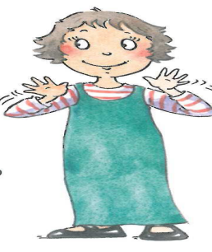 |  |  |  |  | - To chant an  educational chant with a partner  - To play the confusion game with a partner  - To say ''sixth, seventh, eighth, …."
I ask the students to turn to their W.B. I read the instructions and explain the tasks. The students start to do the exercises in the class and then, I assign the rest for homework. |  |  |  |  |  |  |  |  |  |  |  |  |  |  | Homework

Fellings |  |  |  |  |  | Title | 1  3 |  | Unit  Lesson |  |  | English 5th G. |  |  | Subject
 |  |  |  |  |  | Date |  |  |  |  |  |  |  |  | Chapter - Class
Matter- thirsty- hungry- hot – cold- sleepy- scared |  |  |  |  |  |  |  |  |  |  |  |  |  |  | Vocabulary
Verification |  |  | Procedure |  |  |  |  |  |  | Aids |  |  |  |  | Objectives
Evaluation:  - "What's the matter?"  - Act out that you are hungry.  - Say your feeling:  I'm… |  |  | - I greet the students.  - I revise the previous lesson and check the homework.  - I write the date and the title on the board.  - Page 8:  1-  - I hold up the Student’s Book, point to the pictures and ask them to read loudly.  - I play the CD twice.  2,3-  - I play the CD twice.  - I ask the students to listen and act.  - I go round the class to check that they find the correct pictures.  - They ask in pairs, " What's the matter?", and another one replies.  - Page 9:  4-  - I ask one student to be the leader.  - I ask the rest to do the same action as the leader.  - They do the different feelings. |  |  |  |  |  |  | - Student's book  - Workbook  - Poster (s)  - Flashcards  - Word cards  - CD  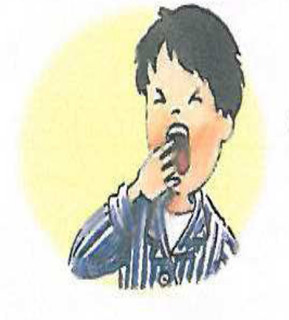 |  |  |  |  | - To ask: "What's the matter?"  - To act out three feelings  - To answer, "This is….."
I ask the students to turn to their W.B. I read the instructions and explain the tasks. The students start to do the exercises in the class and then, I assign the rest for homework. |  |  |  |  |  |  |  |  |  |  |  |  |  |  | Homework

Feelings |  |  |  |  |  | Title | 1  4 |  | Unit  Lesson |  |  | English 5th G. |  |  | Subject
 |  |  |  |  |  | Date |  |  |  |  |  |  |  |  | Chapter – Class
Ink-iron- pin- pine- time |  |  |  |  |  |  |  |  |  |  |  |  |  |  | Vocabulary
Verification |  |  | Procedure |  |  |  |  |  |  | Aids |  |  |  |  | Objectives
Evaluation:  - Look at P.10 and point to the right pictures and words.  - Practice the sounds /a/ and /i/. |  |  | - I greet the students.  - I revise the previous lesson and I check the homework.  - I write the date and the title on the board.  - Page 10:  1-  - I ask the students to open their books and play the CD twice.  - I ask the students to repeat after me.  - They point to the right pictures and words.  2-  - I play the CD twice, and write the words on the board.  - I ask the students to number the words with the correct sound.  - I go around the class to check that they number the pictures correctly.  3-  - I play the CD twice and ask them to say the words. Ask them to match the pictures while they are listening to the words.  - I go around the class to make sure that they are matching the correct pictures.  - Page 11:  4-  - I play the CD twice, and ask the students to mime and say in pairs.  - The students mime other sounds. |  |  |  |  |  |  | - Student's book  - Workbook  - Poster (s)  - Flashcards  - Word cards  - CD   |  |  |  |  | - To listen and point to the right pictures and words  - To say, read, and I write the sounds for a, I by themselves
I ask the students to turn to their W.B. I read the instructions and explain the tasks. The students start to do the exercises in the class and then, I assign the rest for homework. |  |  |  |  |  |  |  |  |  |  |  |  |  |  | Homework

Things we wear |  |  |  |  |  | Title | 2  1 |  | Unit  Lesson |  |  | English 5th G. |  |  | Subject
 |  |  |  |  |  | Date |  |  |  |  |  |  |  |  | Chapter - Class
Hat- mine- thank –welcome –whose –who-what-white |  |  |  |  |  |  |  |  |  |  |  |  |  |  | Vocabulary
Verification |  |  | Procedure |  |  |  |  |  |  | Aids |  |  |  |  | Objectives
Evaluation:  - Complete:……car is this? - "it's mine"  - Answer, "Whose book is this?"  - Put on order: hat/like/your/i |  |  | - I greet the students.  - I revise the previous lesson and check the homework.  - I write the date and the title on the board.  - Page 12:  1 -  - I play the CD and listen to a short simple dialogue.  - I ask the students:"Whose book is this?"  - I ask the students to open their books and I play the CD twice.  2 -  - I ask the students to act out the dialogue in pairs.  3-  - I play the CD twice, and write the words on the board.  - I ask the students to number the words with the correct sound.  - I go around the class to check that they number the pictures correctly.  - Page 13:  4-  - I explain the task.    - I ask them to ask and answer about their belongings in pairs. |  |  |  |  |  |  | - Student's book  - Workbook  - Poster (s)  - Flashcards  - Word cards  - CD   |  |  |  |  | - To ask, "Whose…is this?"  - To reply, "it's mine"  - To meet someone and say,"I like your…."
I ask the students to turn to their W.B. I read the instructions and explain the tasks. The students start to do the exercises in the class and then, I assign the rest for homework. |  |  |  |  |  |  |  |  |  |  |  |  |  |  | Homework

Things we wear |  |  |  |  |  | Title | 2  2 |  | Unit  Lesson |  |  | English 5th G. |  |  | Subject
 |  |  |  |  |  | Date |  |  |  |  |  |  |  |  | Chapter - Class
Wear- green-me-today-look- who- grass- see- ass- blue |  |  |  |  |  |  |  |  |  |  |  |  |  |  | Vocabulary
Verification |  |  | Procedure |  |  |  |  |  |  | Aids |  |  |  |  | Objectives
Evaluation:  - Chant the Who is wearing green? Chant chorally.  - Write three colors that they are wearing. |  |  | - I greet the students.  - I revise the previous lesson and I check the homework.  - I write the date and the title on the board.  - Page 14:  1-  - I ask the students to listen, then play the CD.  - I ask the students to chant the song chorally.  2-  - I play the CD twice, and ask the students to listen carefully to notice the sounds.  - They write the missing letters.  - Page15:  3-  - I explain the task.    - I ask them to play the colors the classmates are wearing  EX:  - Who's wearing green today?  - I ask them to play one by one. |  |  |  |  |  |  | - Student's book  - Workbook  - Poster (s)  - Flashcards  - Word cards  - CD  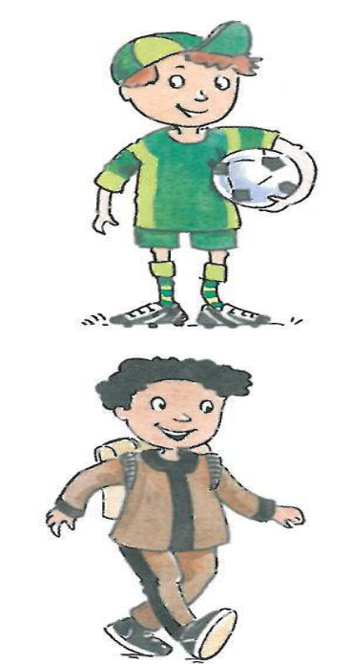 |  |  |  |  | - To chant the Who is wearing green? Chant  - To say three colors that they are wearing
I ask the students to turn to their W.B. I read the instructions and explain the tasks. The students start to do the exercises in the class and then, I assign the rest for homework. |  |  |  |  |  |  |  |  |  |  |  |  |  |  | Homework

Things we wear |  |  |  |  |  | Title | 2  3 |  | Unit  Lesson |  |  | English 5th G. |  |  | Subject
 |  |  |  |  |  | Date |  |  |  |  |  |  |  |  | Chapter - Class
Sunglasses- T-shirt- a jacket-blouse- sweater- skirt- jeans- shoes |  |  |  |  |  |  |  |  |  |  |  |  |  |  | Vocabulary
Verification |  |  | Procedure |  |  |  |  |  |  | Aids |  |  |  |  | Objectives
Evaluation:  - I write the names of five things that you can wear.  - " I'm wearing………,…,…….,…….today? |  |  | - I greet the students.  - I revise the previous lesson and check the homework.  - I write the date and the title on the board.  - Page 16:  1-  - I write the new vocabulary on the board.  - I hold up the Student’s Book, point to the picture and ask them to read loudly.  - I play the CD twice.  - I hold up the flashcards of clothes. They point and say the words.  2-  - I say the chant, ask them to repeat after me.  - I ask them to say the chant chorally.  - Page 17:  3-  - I ask students to name the pictures.  - I ask them one by one to touch the pictures that I say it.  - Do it again with other pictures. |  |  |  |  |  |  | - Student's book  - Workbook  - Poster (s)  - Flashcards  - Word cards  - CD   |  |  |  |  | - To say the names of five things that they can wear  - To name two things he/she wearing, saying,"I'm wearing…. and…..today."
I ask the students to turn to their W.B. I read the instructions and explain the tasks. The students start to do the exercises in the class and then, I assign the rest for homework. |  |  |  |  |  |  |  |  |  |  |  |  |  |  | Homework

Things we wear |  |  |  |  |  | Title | 2  4 |  | Unit  Lesson |  |  | English 5th G. |  |  | Subject
 |  |  |  |  |  | Date |  |  |  |  |  |  |  |  | Chapter - Class
Parrot-pen-panda-bear-bed-banana-plane-black-blue-tissue-mouth |  |  |  |  |  |  |  |  |  |  |  |  |  |  | Vocabulary
Verification |  |  | Procedure |  |  |  |  |  |  | Aids |  |  |  |  | Objectives
Evaluation:  - Say if these words start with p or b (ball-bat-pin-pine)  - Give two words that start with p and b.  - Play Does it move? In group   |  |  | - I greet the students.  - I revise the previous lesson and check the homework.  - I write the date and the title on the board.  - Page 18:  1-  - I ask the students to open their books and play the CD twice.  - I ask them to listen carefully.  - They read and say it one by one and then chorally.  2-  - I play the CD twice.  - I ask the students to say the words then they match the words with the correct pictures.  - They write the missing letters to complete the sentence.  - Page 19:  3-  - I play the CD twice  - I ask them to repeat.  - Then, I give everyone a tissue to hold it in front of his/her mouth to say the words.  - I'll be sure that they say the words correctly. |  |  |  |  |  |  | - Student's book  - Workbook  - Poster (s)  - Flashcards  - Word cards  - CD  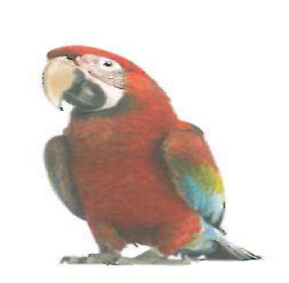 |  |  |  |  | - To tell if the words start with p or b  - To say two words that begin with p and b  - To play Does it move? in group
I ask the students to turn to their W.B. I read the instructions and explain the tasks. The students start to do the exercises in the class and then, I assign the rest for homework. |  |  |  |  |  |  |  |  |  |  |  |  |  |  | Homework

Things we do |  |  |  |  |  | Title | 3  1 |  | Unit  Lesson |  |  | English 5th G. |  | Subject
 |  |  |  |  |  | Date |  |  |  |  |  |  |  | Chapter - Class
Homework-watch-phonics-photo-phone-elephant- snacks |  |  |  |  |  |  |  |  |  |  |  |  |  | Vocabulary
Verification |  |  | Procedure |  |  |  |  |  |  | Aids |  |  |  | Objectives
Evaluation:  - Act out the telephone talks on P.21 in pairs.  - Make up a telephone conversation in English.  - Practice the sound of /ph/.  - Put the sentence in order :( playing-he-football-is)   |  |  | - I greet the students.  - Revise the previous lesson and I check the homework.  - I write the date and the title on the board.  - Page 20:  1-  - I play the CD twice, and ask students to listen carefully.  - I ask the students to read the conversation.  2-  - They act out the conversation in pairs.  - I ask them to change the verb as: reading a book, listening to music, ……etc.  3-  - I play the CD twice, and ask them to say the words.  - I ask them to match the pictures.  - They complete the missing letters to make correct sentence.  - Page 21:  4-  - I play the CD, and ask the students to listen carefully.  - They act out the telephone call in pairs to ask what he or she is doing.  - I check that they have understood what’s required. |  |  |  |  |  |  | - Student's book  - Workbook  - Poster (s)  - Flashcards  - Word cards  - CD   |  |  |  | - To act out the telephone talks with a partner  - To have a telephone conversation in English  - To practice the sounds of /ph/  - To use present continuous to talk about what they are doing at the moment
I ask the students to turn to their W.B. I read the instructions and explain the tasks. The students start to do the exercises in the class and then, I assign the rest for homework. |  |  |  |  |  |  |  |  |  |  |  |  |  | Homework

Things we do |  |  |  |  |  | Title | 3  2 |  | Unit  Lesson |  |  | English 5th G. |  |  | Subject
 |  |  |  |  |  | Date |  |  |  |  |  |  |  |  | Chapter - Class
Karate-football |  |  |  |  |  |  |  |  |  |  |  |  |  |  | Vocabulary
Verification |  |  | Procedure |  |  |  |  |  |  | Aids |  |  |  |  | Objectives
Evaluation:  - Chant the What are you doing? Chant chorally.  - Play the True or False Action Game in pairs.   |  |  | - I greet the students.  - I revise the previous lesson and check the homework.  - I write the date and the title on the board.  - Page 22:  1-  - I ask the students to listen, then play the CD.  - I write the new vocabulary on the board and ask them to read it loudly.  - I ask the students to chant the song chorally.  2-  - I play the CD twice.  - I ask the students to read the song loudly.  - Page23:  3-  - I ask them to play [True or False Action Game] in groups.  - I ask them to run to the T or F when I do the action. |  |  |  |  |  |  | - Student's book  - Workbook  - Poster (s)  - Flashcards  - Word cards  - CD  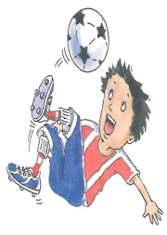 |  |  |  |  | - To chant the What are you doing? Chant  - To play the True or False Action Game with a friend
I ask the students to turn to their W.B. I read the instructions and explain the tasks. The students start to do the exercises in the class and then, I assign the rest for homework. |  |  |  |  |  |  |  |  |  |  |  |  |  |  | Homework

Things we do |  |  |  |  |  | Title | 3  3 |  | Unit  Lesson |  |  | English 5th G. |  |  | Subject
 |  |  |  |  |  | Date |  |  |  |  |  |  |  |  | Chapter - Class
Computer games- gring-ring-rink-wink-giwn- wing-speak-peaking |  |  |  |  |  |  |  |  |  |  |  |  |  |  | Vocabulary
Verification |  |  | Procedure |  |  |  |  |  |  | Aids |  |  |  |  | Objectives
Evaluation:  - Play the Card Snap Game in-group.  - What are you doing?  - Put the sentence in order (reading/he/a/is/book/.)  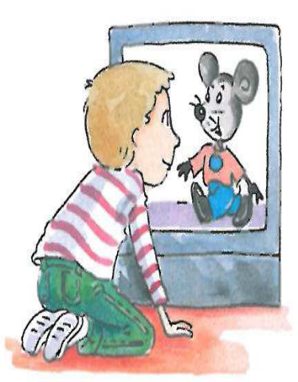 |  |  | - I greet the students.  - I revise the previous lesson and check the homework.  - I write the date and the title on the board.  - Page 24:  1-  - I explain the task. I play the CD twice and ask students to listen.  - I write the new vocabulary on the board.  - I ask them to point to the actions on the book.  - I go around the class to check that they find the correct exercise.  2-  - I play the CD twice, and ask the students to listen carefully.  - They say the words, then to read and circle.  - Page25:  3-  - I play the CD twice.  - I ask the student to hit the card when the I say the sentence.  - I check that students have understood what’s required. |  |  |  |  |  |  | - Student's book  - Workbook  - Poster (s)  - Flashcards  - Word cards  - CD  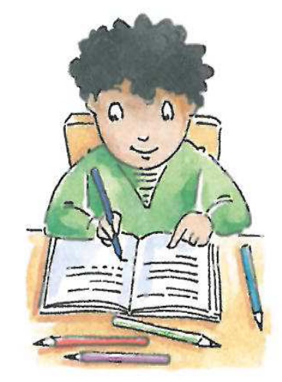 |  |  |  |  | - To play the Card Snap Game with friends  - To say two things when asked "What are you doing?"  - To put the sentences in order
I ask the students to turn to their W.B. I read the instructions and explain the tasks. The students start to do the exercises in the class and then, I assign the rest for homework. |  |  |  |  |  |  |  |  |  |  |  |  |  |  | Homework

Things we do |  |  |  |  |  | Title | 3  4 |  | Unit  Lesson |  |  | English 5th G. |  |  | Subject
 |  |  |  |  |  | Date |  |  |  |  |  |  |  |  | Chapter - Class
Tiger- tomato-telephone-door-doll-duck |  |  |  |  |  |  |  |  |  |  |  |  |  |  | Vocabulary
Verification |  |  | Procedure |  |  |  |  |  |  | Aids |  |  |  |  | Objectives
Evaluation:  - Say if these words start with t or d (dog-tea-tiger-doll)  - Write two words that start with t and d.  - Name this animal   |  |  | - I greet the students.  - I revise the previous lesson and check the homework.  - I write the date and the title on the board.  - Page26:  1-  - I ask the students to open their books and play the CD twice.  - I ask them to listen carefully.  - They read and say it one by one and then chorally.  2-  - I play the CD twice.  - I ask the students to say the words then they number the pictures.  - They write the missing letters to complete the words.  - Page 27:  3-  - I play the CD twice  - I ask the students to name the pictures.  - I ask them to touch the pictures that I say it one by one.  - I do it again with other pictures.  - I'll be sure that they say the words correctly. |  |  |  |  |  |  | - Student's book  - Workbook  - Poster (s)  - Flashcards  - Word cards  - CD  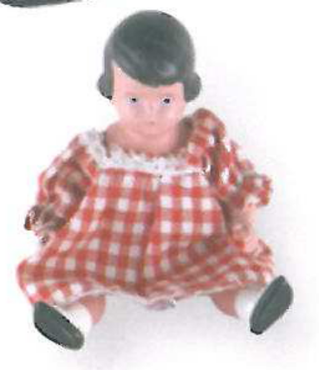 |  |  |  |  | - To tell if the words start with t or d  - To say two words that begin with t or d  - To name objects
I ask the students to turn to their W.B. I read the instructions and explain the tasks. The students start to do the exercises in the class and then, I assign the rest for homework. |  |  |  |  |  |  |  |  |  |  |  |  |  |  | Homework

Beautiful nature |  |  |  |  |  | Title | 4  1 |  | Unit  Lesson |  |  | English 5th G. |  |  | Subject
 |  |  |  |  |  | Date |  |  |  |  |  |  |  |  | Chapter - Class
Snake- bat-short-long-beautiful- ugly- shake-snow-show |  |  |  |  |  |  |  |  |  |  |  |  |  |  | Vocabulary
Verification |  |  | Procedure |  |  |  |  |  |  | Aids |  |  |  |  | Objectives
Evaluation:  - Act out a talk about nature in pairs.  - Find out something beautiful or ugly around you.  - Describe the tiger. |  |  | - I greet the students.  - I revise the previous lesson and check the homework.  - I write the date and the title on the board.  - Page 28:  1-  - I play the CD twice, and ask the students to listen carefully.  - I ask the students to read the conversation.  2-  - I ask them to act out the conversation in pairs.  - They talk about about other beautiful and ugly things.  3-  - I play the CD twice, and ask them to say the words.  - I ask them to complete the missing letters to make correct words.  - Page 29 :  4-  - I play the CD, and ask them to listen carefully to the conversation.  - They look around and find a beautiful or an ugly object.  - I check that students have understood what’s required. |  |  |  |  |  |  | - Student's book  - Workbook  - Poster (s)  - Flashcards  - Word cards  - CD  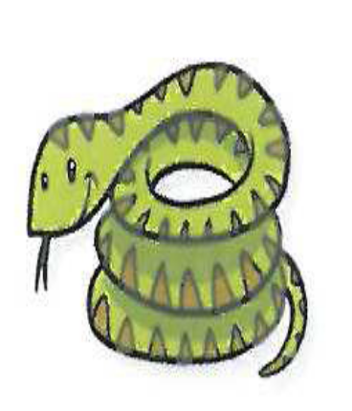 |  |  |  |  | - To act out one of the talks about nature  - To find something beautiful or ugly and say" look! It's a ….! It's beautiful (or ugly)."  - To describe objects
I ask the students to turn to their W.B. I read the instructions and explain the tasks. The students start to do the exercises in the class and then, I assign the rest for homework. |  |  |  |  |  |  |  |  |  |  |  |  |  |  | Homework

Beautiful nature |  |  |  |  |  | Title | 4  2 |  | Unit  Lesson |  |  | English 5th G. |  |  | Subject
 |  |  |  |  |  | Date |  |  |  |  |  |  |  |  | Chapter - Class
Spring-winter-summer-fall- mountain-rolling hills-campfire- stars |  |  |  |  |  |  |  |  |  |  |  |  |  |  | Vocabulary
Verification |  |  | Procedure |  |  |  |  |  |  | Aids |  |  |  |  | Objectives
Evaluation:  - Chant the I love the mountains chant chorally.  - Say the months and the seasons of the year.  - Number the pictures on P.30 |  |  | - I greet the students.  - I revise the previous lesson and check the homework.  - I write the date and the title on the board.  - Page 30:  1-  - I ask students to listen, then play the CD.  - I ask the students to chant the song chorally.  2-  - I play the CD twice, and ask students to listen carefully to notice the sounds.  - They number the words, then read it in groups.  - Page 31:  3-  - I write the new vocabulary on the board.  - I play the CD twice, and ask them to listen carefully.  - I ask them to read it one by one.  - I ask them to match it with the correct pictures. |  |  |  |  |  |  | - Student's book  - Workbook  - Poster (s)  - Flashcards  - Word cards  - CD   |  |  |  |  | - To chant the I love the mountains chant  - To name seasons and months  - To number the pictures correctly
I ask the students to turn to their W.B. I read the instructions and explain the tasks. The students start to do the exercises in the class and then, I assign the rest for homework. |  |  |  |  |  |  |  |  |  |  |  |  |  |  | Homework

Beautiful nature |  |  |  |  |  | Title | 4  3 |  | Unit  Lesson |  |  | English 5th G. |  |  | Subject
 |  |  |  |  |  | Date |  |  |  |  |  |  |  |  | Chapter - Class
Long-short-small-big-quite-noisy-weak-strong-mouse-elephant |  |  |  |  |  |  |  |  |  |  |  |  |  |  | Vocabulary
Verification |  |  | Procedure |  |  |  |  |  |  | Aids |  |  |  |  | Objectives
Evaluation:  - Act out the pair of opposites in pair.  - Play "Guess What it is" in group.  - Say the opposites (short……., small…….)   |  |  | - I greet the students.  - I revise the previous lesson and check the homework.  - I write the date and the title on the board.  - Page 32:  1-  - I ask the students to open their books and play the CD twice.  - I hold up the flashcards to show opposites.  - I write the words on the table, and ask them to read it loudly.  2-  - I divide them into two groups to act out the pair of opposites.  3-  - I ask them to act out the actions in pairs.  - Page 33:  4-  - I ask the students to play "Guess what it is"  - I ask them to do the opposite action in group.  - I check that students have understood what’s required. |  |  |  |  |  |  | - Student's book  - Workbook  - Poster (s)  - Flashcards  - Word cards  - CD   |  |  |  |  | - To act out one pair of opposites  - To describe and guess What or Who  - To say the opposites
I ask the students to turn to their W.B. I read the instructions and explain the tasks. The students start to do the exercises in the class and then, I assign the rest for homework. |  |  |  |  |  |  |  |  |  |  |  |  |  |  | Homework

Beautiful nature |  |  |  |  |  | Title | 4  4 |  | Unit  Lesson |  |  | English 5th G. |  |  | Subject
 |  |  |  |  |  | Date |  |  |  |  |  |  |  |  | Chapter - Class
Gorilla-crab-goat-glass |  |  |  |  |  |  |  |  |  |  |  |  |  |  | Vocabulary
Verification |  |  | Procedure |  |  |  |  |  |  | Aids |  |  |  |  | Objectives
Evaluation:  - Say if these words start with c or g (goat-cat-crab-glass)  - Write two words that begin with c and two words that begin with g.  - Play the Word Making Game in group.   |  |  | - I greet the students.  - I revise the previous lesson and check the homework.  - I write the date and the title on the board.  - Page 34:  1-  - I ask the students to open their books and play the CD twice.  - I ask them to listen carefully.  - I ask them to read and say it one by one and chorally.  2-  - I play the CD twice.  - I ask the students to point and say the words.  - They write the missing letters to complete the words.  - Page 35:  3-  - I play the CD twice  - I ask students to play [Word Making Game].  - They listen to the teacher and hold up the letters.  - I'll be sure that they say the words correctly. |  |  |  |  |  |  | - Student's book  - Workbook  - Poster (s)  - Flashcards  - Word cards  - CD  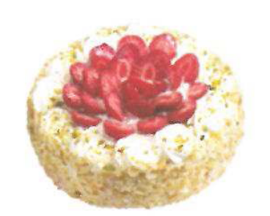 |  |  |  |  | - To tell if the words start with c or g  - To say two words that begin with c and g  - To play the Word Making Game in group  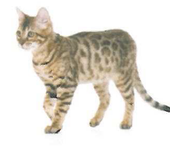
I ask the students to turn to their W.B. I read the instructions and explain the tasks. The students start to do the exercises in the class and then, I assign the rest for homework. |  |  |  |  |  |  |  |  |  |  |  |  |  |  | Homework

Friends, Actions, Things |  |  |  |  |  | Title | 5  1 |  | Unit  Lesson |  |  | English 5th G. |  |  | Subject
 |  |  |  |  |  | Date |  |  |  |  |  |  |  |  | Chapter - Class
come – help - Nice to meet you – ready - computer store - Good morning - Good afternoon - Good evening – Goodnight – Let's – go - have - watch – school – lunch – TV - bed |  |  |  |  |  |  |  |  |  |  |  |  |  |  | Vocabulary
Verification |  |  | Procedure |  |  |  |  |  |  | Aids |  |  |  |  | Objectives
Evaluation:  - In groups of three, introduce each other. Say “This is my friend "… and “Let's…!  - Chant “Good morning!” in pairs.  - Look at the flash cards, tell the time of day and say greeting. |  |  | - I greet the students.  - I revise the previous lesson and check the homework.  - I write the date and the title on the board.  - Page 36:  1- Listen and say.  - I I play the CD twice, ask students to listen carefully.  - The students read the conversation.  2-  - They form groups of three and introduce each other.  - I remind them to make a suggestion at the end of the talk with “Let’s…”  - Page 37 :  3-  - I play the CD, ask Ss to listen carefully to the “Good morning!” Chant.  - The students chant in pairs or groups.  4-  - I ask them to I write the sentences in their books.  - I circulate around the room and let the students I check the ir own books once they  have accomplished the goals. |  |  |  |  |  |  | - Student's book  - Workbook  - Poster (s)  - Flashcards  - Word cards  - CD   |  |  |  |  | - To introduce people to each other, say “This is my friend "… and “Let's…!  - To chant “Good morning!”.  - To tell the times of day and say greetings.
I ask the students to turn to their W.B. I read the instructions and explain the tasks. The students start to do the exercises in the class and then, I assign the rest for homework. |  |  |  |  |  |  |  |  |  |  |  |  |  |  | Homework

Friends, Actions, Things |  |  |  |  |  | Title | 5  2 |  | Unit  Lesson |  |  | English 5th G. |  |  | Subject
 |  |  |  |  |  | Date |  |  |  |  |  |  |  |  | Chapter - Class
cycling - friends – laughing – jumping - As happy as can be – walking – talking – now - Where …? - at home - at school - in his/her room - in the classroom - it's my turn |  |  |  |  |  |  |  |  |  |  |  |  |  |  | Vocabulary
Verification |  |  | Procedure |  |  |  |  |  |  | Aids |  |  |  |  | Objectives
Evaluation:  - Chant "We're playing, we're cycling" in pairs.  - In pairs, talk about what “I'm, he/she's, we/you/they're" doing or not doing.  - In groups of four, ask and answer Yes / No questions about what people are doing. |  |  | - I greet the students.  - I revise the previous lesson and check the homework.  - I write the date and the title on the board.  - Page 38:  1-  - I ask the students to listen, then play the CD.  - The students chant the chant on in pairs, miming or talk about what people are doing or not doing in class.  2-  I ask the students to change the words and chant.  - Page 39:  3-  - I play the CD twice and ask them to listen carefully.  - In pairs, they ask and answer questions about what people are doing.  - I put students in groups of four and let them ask and answer questions about what people are doing, as they did in activity 3 on page 39.  - They check the goal box in their books after they have accomplished the goals. |  |  |  |  |  |  | - Student's book  - Workbook  - Poster (s)  - Flashcards  - Word cards  - CD   |  |  |  |  | - To chant "We're playing, we're cycling".  - To talk about what “I'm, he/she's, we/you/they're" doing or not doing.  - To ask and answer Yes / No questions about what people are doing.
I ask the students to turn to their W.B. I read the instructions and explain the tasks. The students start to do the exercises in the class and then, I assign the rest for homework. |  |  |  |  |  |  |  |  |  |  |  |  |  |  | Homework

Friends, Actions, Things |  |  |  |  |  | Title | 5  3 |  | Unit  Lesson |  |  | English 5th G. |  |  | Subject
 |  |  |  |  |  | Date |  |  |  |  |  |  |  |  | Chapter - Class
sweet – sour – hot – cold – salty – tasty – lemons – cherries – soup – rice – chips - fresh -round - small – big – I like – I don't like – That's right |  |  |  |  |  |  |  |  |  |  |  |  |  |  | Vocabulary
Verification |  |  | Procedure |  |  |  |  |  |  | Aids |  |  |  |  | Objectives
Evaluation:  - Make sentences about food using the words “hot, cold, sour, sweet, salty, tasty".  - In groups, chant "Lemons are sour".  - In pairs, ask questions with “or”, “want”.  - Make sentences, say "I like / I don't like". |  |  | - I greet the students.  - I revise the previous lesson and check the homework.  - I write the date and the title on the board.  - Page 40:  1-  - I ask the students to open their books and play the CD twice.  - The students chant the chant on in groups.  - I write the words on the table.  - I read them and ask the students to read them loudly.  2-  - I put the students in groups and let them make sentences with the words “hot, cold,  sour, sweet, salty, tasty”.  - Page 41:  3-  - I play the CD and ask them to act out the "The 3 Questions Game" in pairs.  4-  - I ask them in pairs to stand up and demonstrate their dialogue with food they have chosen using “or”, “want”, and “like/don’t like”.  - They check the box after they have finished. |  |  |  |  |  |  | - Student's book  - Workbook  - Poster (s)  - Flashcards  - Word cards  - CD     |  |  |  |  | - To talk about food using the words “hot, cold, sour, sweet, salty, tasty".  - To chant "Lemons are sour".  - To ask questions with “or”, “want”.  - To say  "I like /I don't like".
I ask the students to turn to their W.B. I read the instructions and explain the tasks. The students start to do the exercises in the class and then, I assign the rest for homework. |  |  |  |  |  |  |  |  |  |  |  |  |  |  | Homework

Friends, Actions, Things |  |  |  |  |  | Title | 5  4 |  | Unit  Lesson |  |  | English 5th G. |  |  | Subject
 |  |  |  |  |  | Date |  |  |  |  |  |  |  |  | Chapter - Class
sandwiches – notebooks - orange juice - a poster - carrots – pens - Whose … is that? - Maybe |  |  |  |  |  |  |  |  |  |  |  |  |  |  | Vocabulary
Verification |  |  | Procedure |  |  |  |  |  |  | Aids |  |  |  |  | Objectives
Evaluation:  - Look at flashcards with food items (plural) and make the sounds for plural –s.  - In pairs, ask and answer with“have".  - Make sentences, use “and" or “but".  - Ask and answer in pairs using whose and (name)’s. |  |  | - I greet the students.  - I revise the previous lesson and check the homework.  - I write the date and the title on the board.  - Page 42:  1-  - I hold up flashcards with food items (plural) and let students say the word using the right end sound.  - I play the CD twice and ask them to listen and check.  2-  - I play the CD twice.  - I ask the students to point and say the sentences.  3-  - In pairs, I ask each student to make a sentence about their partner using "and/ but".  - Page 43:  4-  - I play the CD twice, I ask the students to listen carefully.  - The students read the dialogue in pairs.  5-  - I ask the students to leave one of their school things on the desk. I let them ask and answer in pairs using whose and (name)’s.  - I form groups of three and ask them to trace and answer.  - They check the goal box in their books after they have accomplished the goals. |  |  |  |  |  |  | - Student's book  - Workbook  - Poster (s)  - Flashcards  - Word cards  - CD     |  |  |  |  | - To make the sounds for plural –s.  - To ask and answer with“have".  - To use “and" or “but".  - To ask and say whose something is using (name)'s.
I ask the students to turn to their W.B. I read the instructions and explain the tasks. The students start to do the exercises in the class and then, I assign the rest for homework. |  |  |  |  |  |  |  |  |  |  |  |  |  |  | Homework

