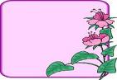

English working paper
Name:
.......................
Unit: Hello
Lesson:1
Classroom:
........................
Activity:
.......................

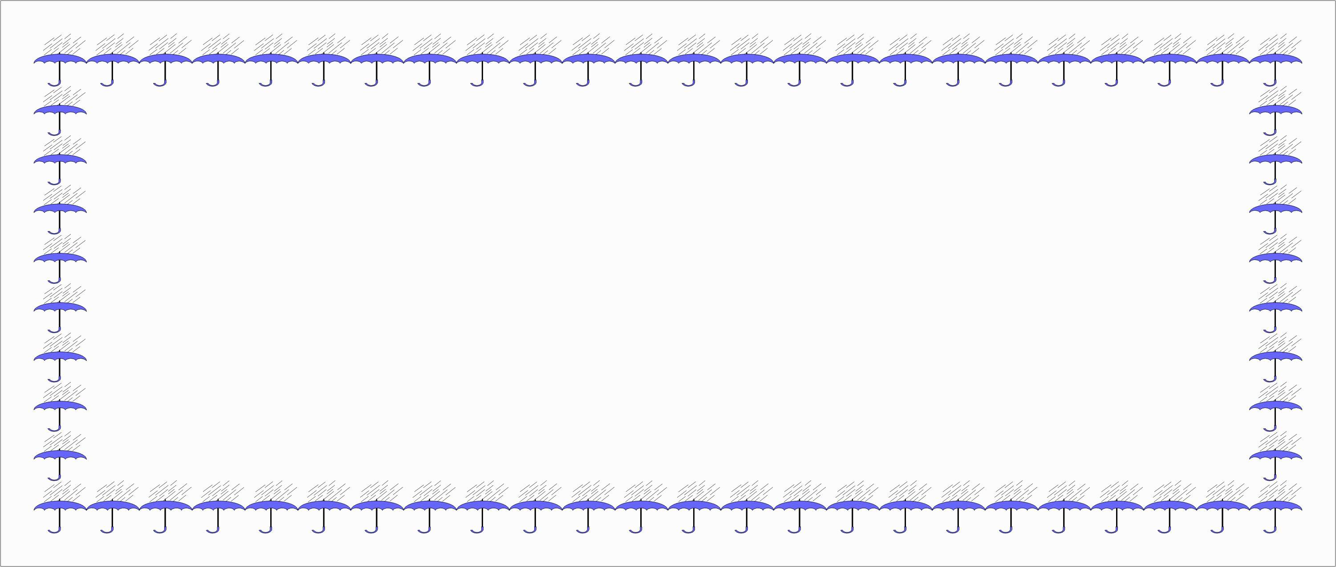
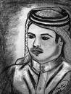
Match countries with nationalities:

Bahrain Spanish
France Egyptian
Egypt Bahraini
Morocco Moroccan
Spain French


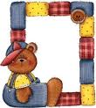

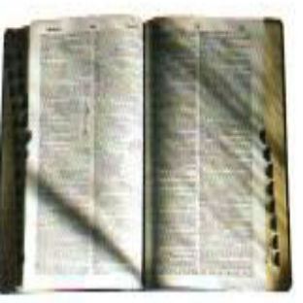
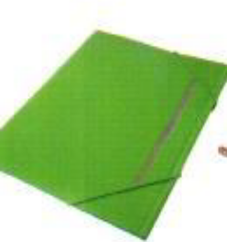
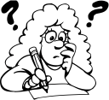
Match
Folder
Laptop
Dictionary

English working paper
Name:
.......................
Module: 1
Lesson: 1a
Classroom:
........................
Activity:
.......................

2- Is he happy? No, he isn't.
1- Are they Saudi? Yes, they are.
3- Are you a teacher? No, I'm not .
Complete:

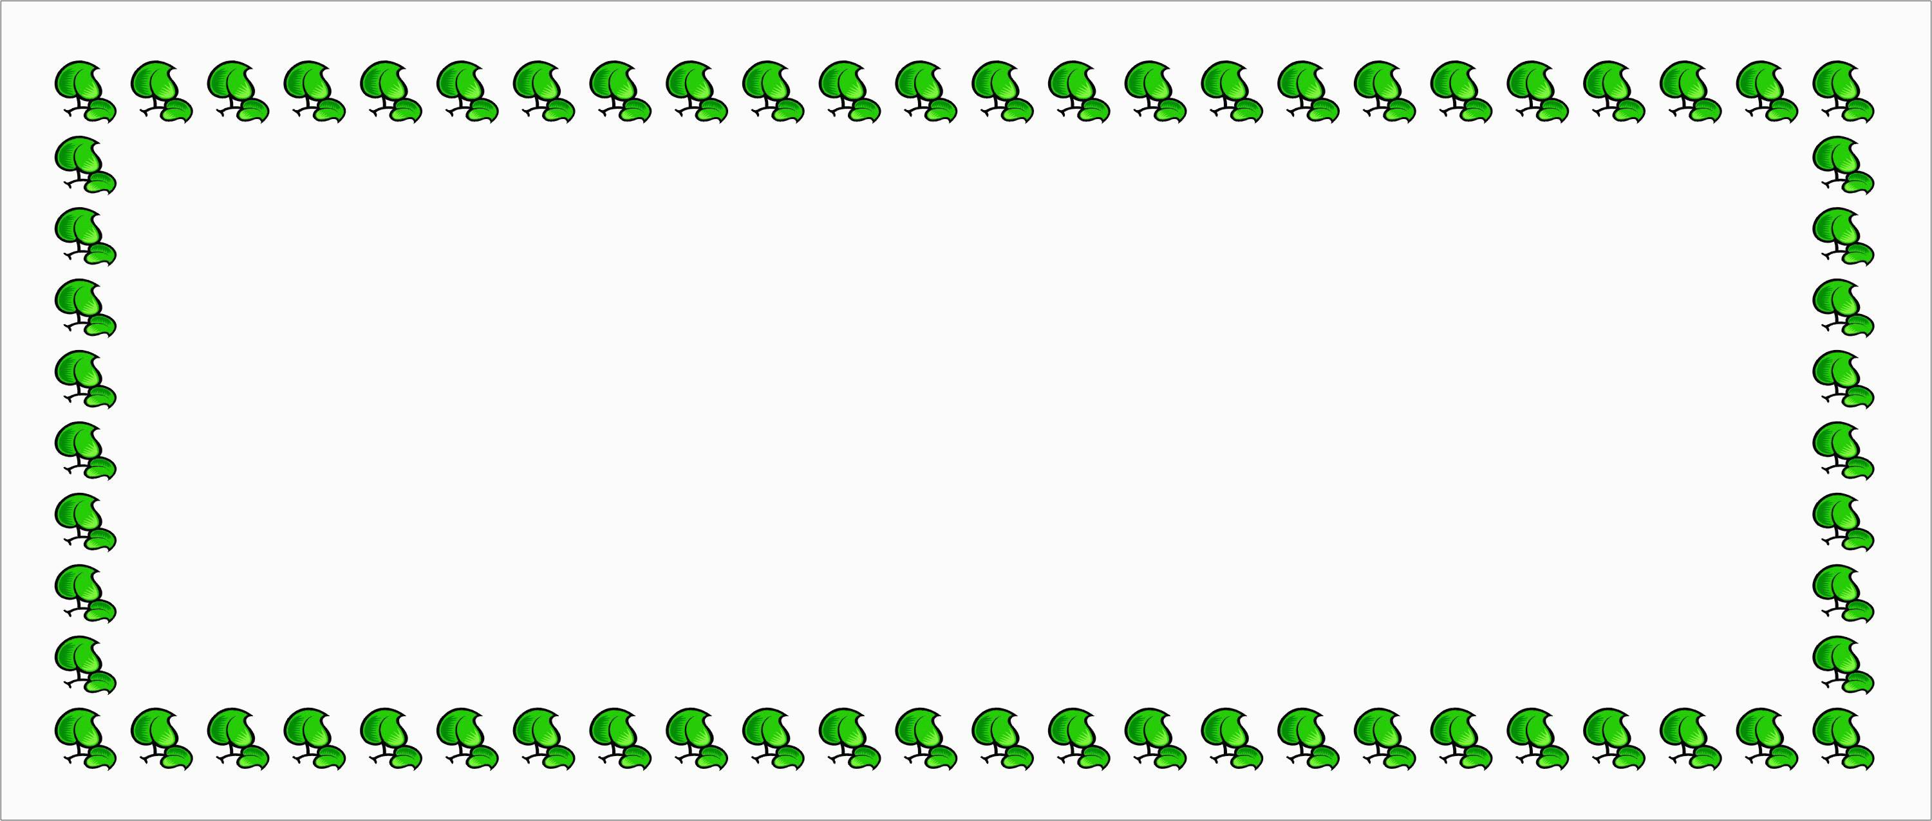

Complete the form then write a paragraph using it:
Sample Answer:
First name: Ahmed
Surname: Jasem
Address: Jeddah – Saudi Arabia
Tel No: 38565846482
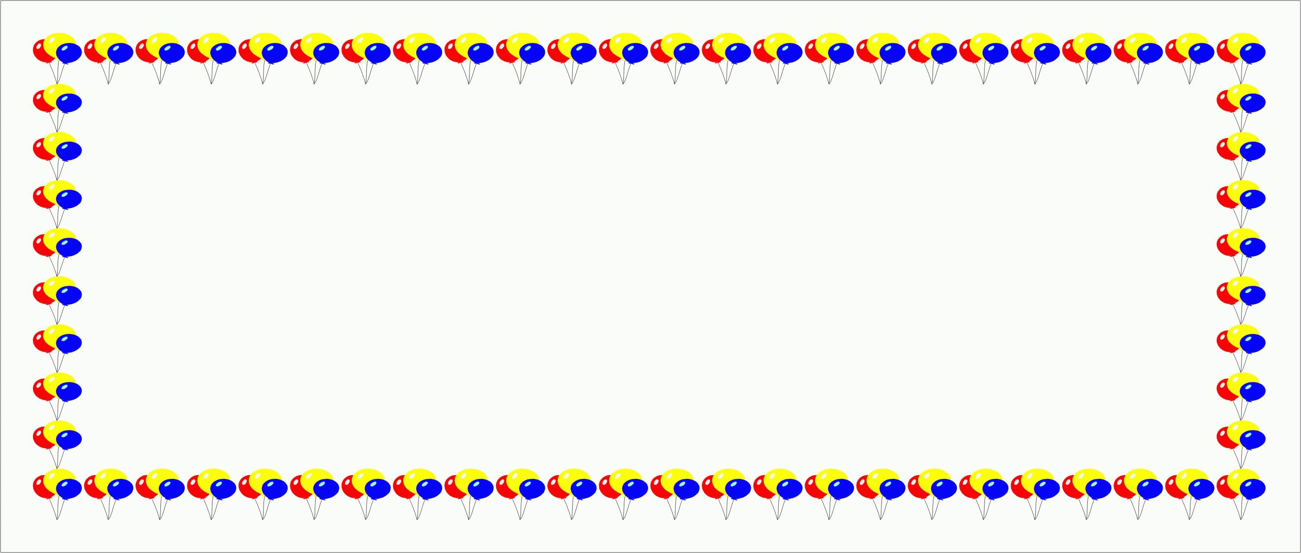



English working paper
Name:
.......................
Module: 1
Lesson:1b
Classroom:
........................
Activity:
.......................
Write the names of these things:
Circle the correct word:
They have a blue car. (It’s – Their) car is expensive.
(Those – These) are my books here.
My ( parent’s – parents’ ) car is very big.
Is that (Alis’ - Ali’s ) house?
I like my sister. (His – Her) dress is beautiful.

sunglasses
bag
watch
mobile phone
English working paper
Name:
.......................
Module: 1
Lesson:1c
Classroom:
........................
Activity:
.......................

Complete with the verb can:


- Can the ride (they/ ride) a horse? No, they can't.
- I can (speak) English, but I can't (speak) French.
- Ali can use the computer. (use the computer). He is very clever.
- You can't drive (drive) the car. You don’t have a car.
- You can't work (work) full time because you are very tired.
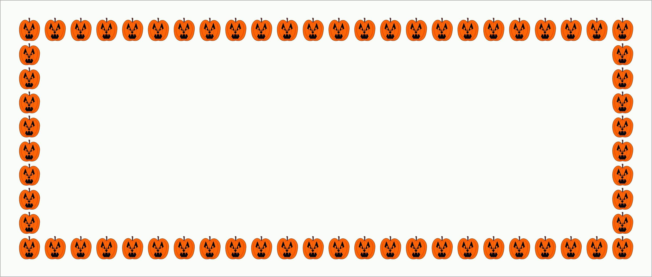
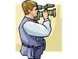
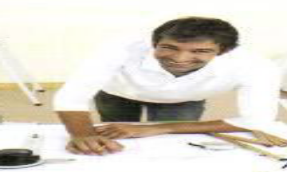

Architect
Photographer
English working paper
Name:
.......................
Module: 1
Lesson:1d
Classroom:
........................
Activity:
.......................

1
2
3
3
What is the time?

it’s two o'clock

It’s half past two

It’s a quarter past two

It’s a quarter to three

Hungry 
Bored 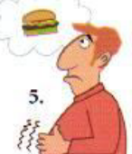

Tired 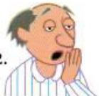

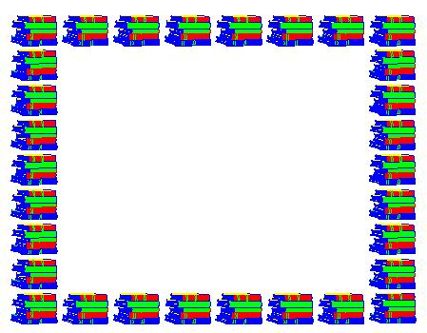


English working paper
Name:
.......................
Unit: 1
Lesson:6
Classroom:
........................
Activity:
.......................
English working paper
Name:
.......................
Module: 1
Lesson:1e
Classroom:
........................
Activity:
.......................
Complete the table:
Age: 15

Hobby: Reading and painting

Job: Student

Personality: I am active and funny.

Writing:

Use the table above to write a paragraph:
I'm a student. I'm fifteen years old. I like reading and painting. I'm an active and funny person.
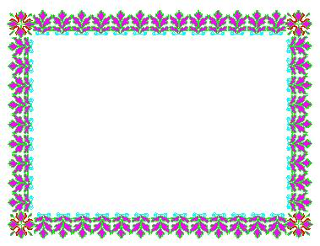

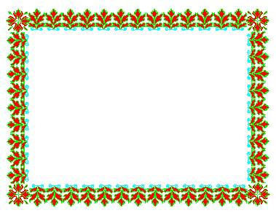
English working paper
Name:
.......................
Module: 1
Lesson: Round-up
Classroom:
........................
Activity:
.......................
Writing:
Write a paragraph about what you can do and what you cannot do.

My name is Mona. I can speak Arabic and English.
I can paint pictures but I can't draw. I can ride a horse but I can't drive a car.
Circle the correct word:

My (sister’s – sisters’) bag is red. It isn’t white.
(Those – These) are my books over there.
He can (ride – rode) the motorbike.
She is (hungry- thirsty). She wants some water.
They have a black dog. (Their – they) dog is interesting.
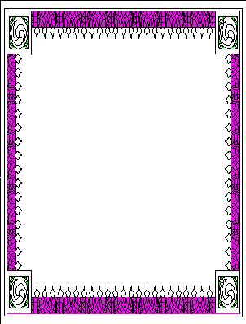
English working paper
Name:
.......................
Module: 2
Lesson:2a
Classroom:
........................
Activity:
.......................
complete the blanks with present simple:

she doesn't play (not play) basketball but she plays (play) tennis.
I get up (get up) early every day.
They don't like (not like) going to cinema.
You work (work) hard every day.
He visits (visit) his grandfather every Friday.

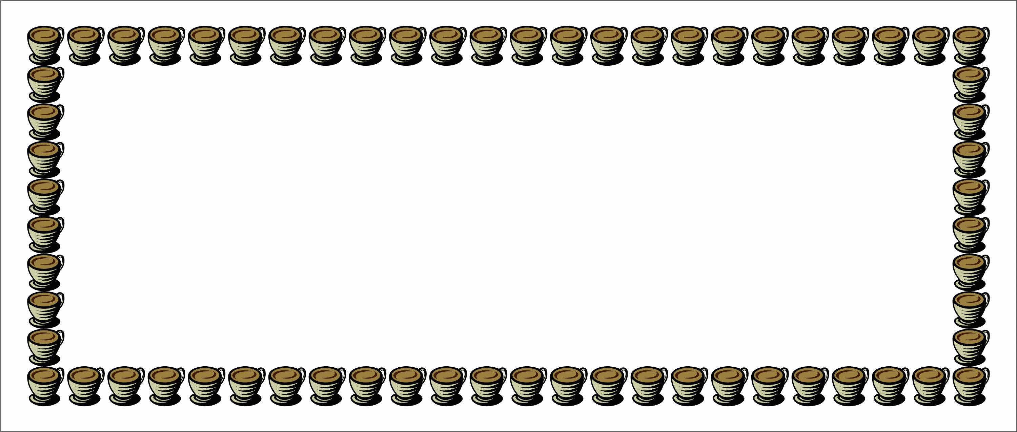

Fill in the space with a preposition:
She works from five to ten.
They go to shopping at the weekend.
I don’t have breakfast on Friday morning.
I study hard on weekdays.




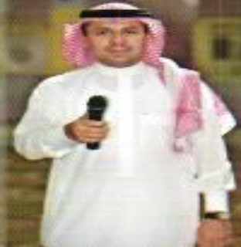

English working paper
Name:
.......................
Module: 2
Lesson:2b
Classroom:
........................
Activity:
.......................
Complete with the present simple:
What do you do (do) every morning?
Does he speak (speak) English?
Yes, he does.
Do they play (play) well? No, they don't.
Write the job:
receptionist
reporter
chef
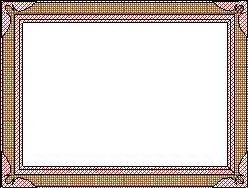

English working paper
Name:
.......................
Module: 2
Lesson:2c
Classroom:
........................
Activity:
.......................

I would like to play (play)football.
He enjoys hanging up (hang up) with his friends.
You can’t stand eating (eat) fish.
I want to go (go) shopping.
I hate drinking (drink) coffee.

Match:
Hang shopping at the mall
Watch a newspaper
Read out with friends
Go TV
Talk on the phone
Take up a sport



English working paper
Name:
.......................
Module: 2
Lesson:2d
Classroom:
........................
Activity:
.......................
Use these adverbs to write sentences:
( always- usually – sometimes – rarely- often)
I always come to work on time.
He usually plays football on Sundays
She sometimes has al lot of work.
Susan is rarely late.
They often come here every Friday.

Download the Net

Check information

Surf a message

Send my e-mail
Match:


English working paper
Name:
.......................
Module: 2
Lesson:2e
Classroom:
........................
Activity:
.......................
Make sentences by putting the words in the correct order:
surfs – he – every – the Net- day
He surfs the Net every day.
stand – can’t – I – drinking – coffee.
I can't stand drinking coffee.
Playing- I – tennis – hate
I hate playing tennis.

Write a short paragraph about


how you spend your free time.
Writing:
I sometimes help my mother in housework. I go shopping with my friends every Friday. I always read books. I often surf the net.



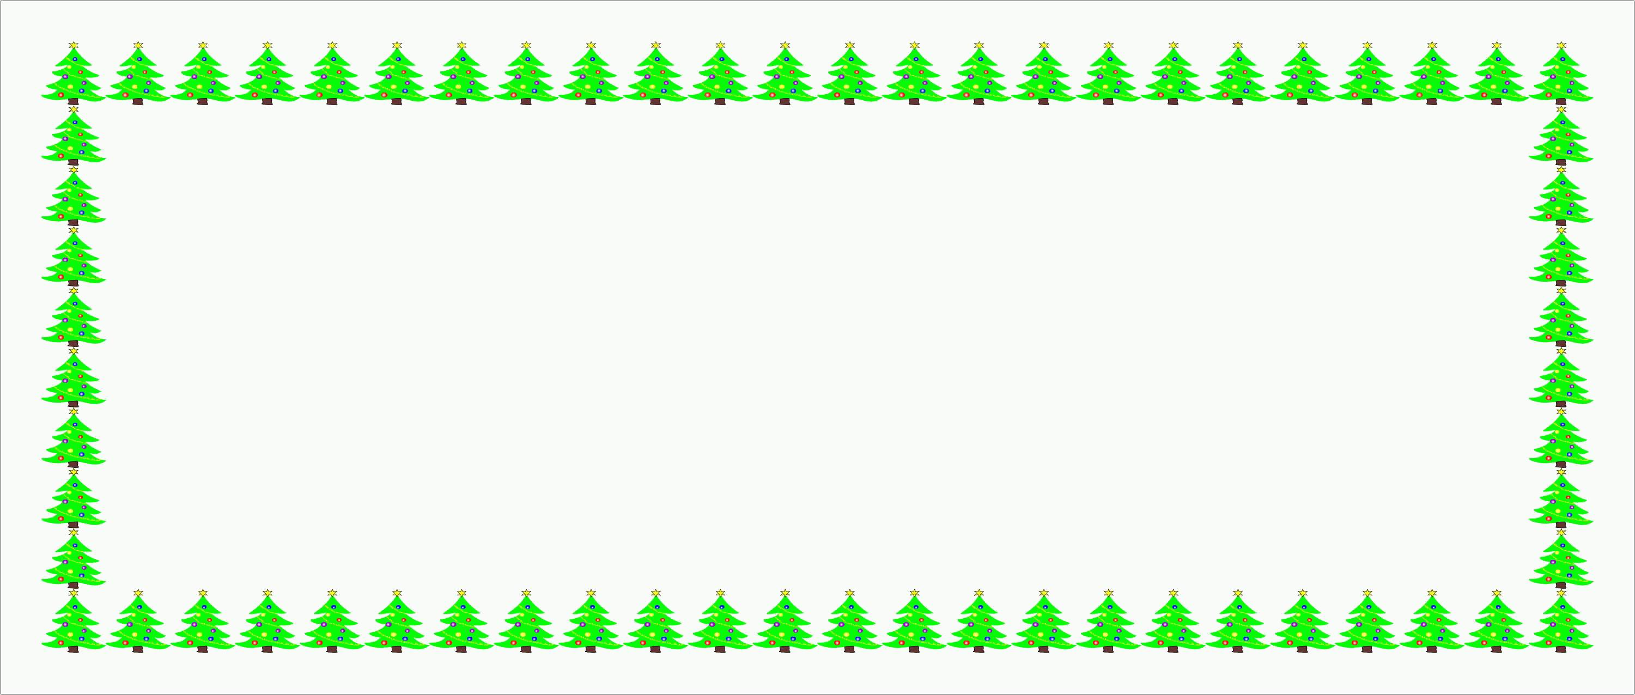

English working paper
Name:
.......................
Module: 2
Lesson: Round-Up
Classroom:
........................
Activity:
.......................
Writing:

Write a paragraph about what your friend likes and dislikes.
They like reading. They like walking. They like watching TV.
They can’t stand shopping. They can’t stand playing boxing.
He (work- works) every day (to- from) seven (to – at) two.
(Do- Does) you play – plays) tennis?
He (watches – surfs) the net every Friday.
The film starts (at –in) 7:00.
Choose the correct answer:


English working paper
Name:
.......................
Unit: 3
Lesson:4
Classroom:
........................
Activity:
.......................
Complete with the present progressive:
she is drawing (draw) a picture at the moment.
She is getting (getting) married next year.
The children is eating (eat) lunch now.
She is looking for (look for) her books.
They are coming (come) tomorrow.
English working paper
Name:
.......................
Module: 3
Lesson:3a
Classroom:
........................
Activity:
.......................


Writing:
Write an e-mail to your friend telling him/ her about your news.
Dear Hala,
I’m going to graduate next month. I hope it will be a good day. I’m really worried. I hope you will come.
Take care,
Mona

English working paper
Name:
.......................
Module: 3
Lesson: 3b
Classroom
:
........................
Activity:
.......................


Write the names of the items:

bed
painting
rug
bedside table
mirror
wardrobe

Circle the correct answer:
(Whose – Who’s) books are these? They are (mine- my)
(Whose – Who’s) that? He is (hers – her) husband.
They have a dog. (Their – they) dog is clever.
Is this Ali’s pen? Yes, it is (his- he’s)
It is (my – mine) dress.

English working paper
Name:
.......................
Module: 3
Lesson:3c
Classroom:
........................
Activity:
.......................




Complete the spelling.
Library
Stadium
Underground
bookshop


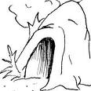

Circle the correct answer:

(There’s – Is there) a museum near your house?

There (is – are) two boys playing in the street.

(There are – Are there) clothes here? No, there (isn’t – aren’t )

There (is – are) (a –an) underground station here.


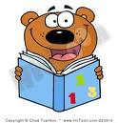
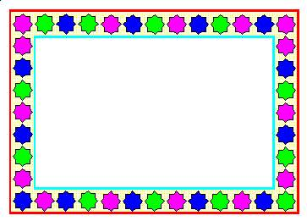

English working paper
Name:
.......................
Module: 3
Lesson:3d
Classroom:
........................
Activity:
.......................
Choose:
Look, it’s (rain – raining).
They (go – are going) to school everyday.
She (is getting – gets) married next year.
Now, she (is watching – watch ) TV.
I (go – am going) to the cinema every Friday.

What is the weather like?

It's snowing It's cloudy
It's raining

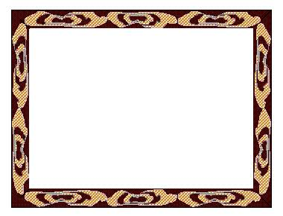

English working paper
Name:
.......................
Module: 3
Lesson:3e
Classroom:
........................
Activity:
.......................
Write an e-mail to your friend telling him/ her about your neighbourhood and your house.

Dear Hala,
How is it going? I hope you are fine. I am writing to tell you about my neighbourhood and house. My neighbourhood is fantastic. It has many shops, mall and cinema. I live in a big house with modern furniture. It has five rooms, 3 bed rooms, a living room and a study, a kitchen and 2 bathrooms. I hope you will visit me.
Write back soon,
Heba

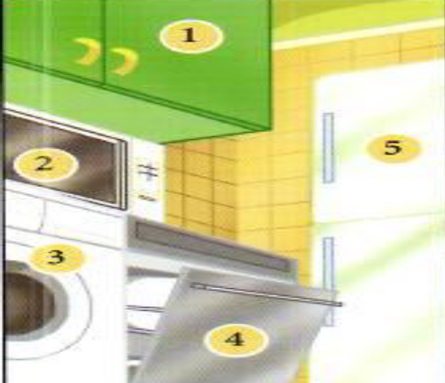
cupboard
microwave
washing machine
dishwasher
fridge
English working paper
Name:
.......................
Module: 3
Lesson: Round-up
Classroom:
........................
Activity:
.......................

- Bus room
- Air machine
- Besides station
- Washing conditioner
- Bed table


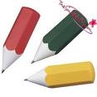

Circle the correct word:
This house isn’t (our – ours).

I love Egypt, (special – especially ) in Summer.

(Who’s – Whose) book is that? It is (my –mine)

She (is cooking – cooks) lunch now.

He (is playing – plays) football everyday.

English working paper
Name:
.......................
Module: 4
Lesson:4a
Classroom:
........................
Activity:
.......................

A bottle of coke
A can of pizza
A slice of milk
A glass of tea
A cup of soup
A bowl of water

- There is some fruits in the fridge.

- There aren’t any milk in the fridge.

- There is no cheese in the sandwiches but there is some jam.

- Is there any coke there?

- Would you like some tea?


English working paper
Name:
.......................
Module: 4
Lesson:4b
Classroom:
........................
Activity:
.......................
Complete the spelling.
Aubergines
Lettuce
Cherries
Plums
peaches
Choose the correct word:

How (much – many) hours do you study?

Would you like (a few- a little) peas in your salad?

How (much – many) money does it cost?

We usually eat (a lot of – much ) apples.

We don’t have (much – many) time.



English working paper
Name:
.......................
Module: 4
Lesson:4c
Classroom:
........................
Activity:
.......................
Complete:
The prophet Mohammed (P.B.U.H.) said, "I and the guardian of the orphan will be in Heaven like that" indicating his forefinger and middle finger.


Fill in the space
1- My room is untidy. I want to arrange it.
2- This is your brother. I don’t like him.
3- We will go to cinema. You can come with us.

English working paper
Name:
.......................
Module: 4
Lesson:4d
Classroom:
........................
Activity:
.......................
Write using (should - should not)
He plays football. He hurts his arm.
He shouldn't play football.
She wants to go out but she is tired.
She shouldn't go out.
She is very fat. She doesn’t go to the gym.
She should go to the gym.

Complete:

- My head hurts. I have headache

- My throat hurts. I have sore throat

- My back hurts. I have backache

- My stomach hurts. I have stomachache


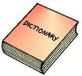

English working paper
Name:
.......................
Module: 4
Lesson:4e
Classroom:
........................
Activity:
.......................
Write the meaning:

work out to exercise
do aerobics to do exercises usually in classes
join the gym to sign up to the gym
fit to be healthy and strong
Writing:
Write a paragraph to your friend who is sick giving him/ her some advices.
Dear Andy, I think you shouldn’t spend hours in front of computer. You shouldn’t play computer games. I think you should go to doctor who should check your eyes and do tests.

English working paper
Name:
.......................
Unit: 3
Lesson:6
Classroom:
........................
Activity:
.......................
English working paper
Name:
.......................
Module: 4
Lesson: Round-up
Classroom:
........................
Activity:
.......................


Choose the correct word:

Do you want (some – any) orange juice?
I like apple (but/ and) I don’t like apple juice.
She is fit (but- because) she goes to the gym.
Give me ( a bowl – a bottle) of soup.
Would you like ( much – many) water?
You (should – shouldn’t ) go to the gym to be fit.

Dear Hala,
I hope you are fine. I want to be fit so I am thinking of taking up sport or join a gym. What do you think I should do? Give me your advice.
See you soon,
Heba

Write an e-mail to your friend asking him / her for advice as you want to be fit.




English working paper
Name:
.......................
Module: 5
Lesson: 5a
Classroom:
........................
Activity:
.......................
Write the past simple form.
Fly
Land
Eat
Study
Flew
Landed
Ate
Studied
Correct the words in the brackets.
1- I went (go) to the cinema last Friday.
2- My mother visited (visit) her friend yesterday.
3- They travelled (travel) to Paris last year.
4- she came (come) to my house two days ago.
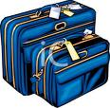

English working paper
Name:
.......................
Module: 5
Lesson: 5b
Classroom:
........................
Activity:
.......................
Complete the spelling.
Chemistry
Physics
Geography
History
Complete the sentences with past simple:

Who did you see (you/ see) yesterday?
When did she come (she/come) to the party?
Did you see (see) my mother yesterday? No, I didn't.
Did she visit (visit) Egypt last year? Yes, she did.
What did you do (you/ do) last night?

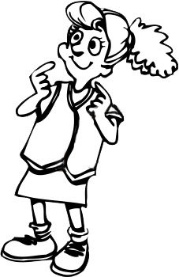

English working paper
Name:
.......................
Module: 5
Lesson: 5c
Classroom:
........................
Activity:
.......................
Fill in the space....
Sightseeing
Camping
windsurfing
hiking
Fill in the space.
1- Where were you yesterday? I was at the supermarket.

2- Were there many people in the party yesterday?

3- She was at the museum last Friday.

English working paper
Name:
.......................
Module:5
Lesson:5d
Classroom:
........................
Activity:
.......................

Complete with the verb could or can:

Could you write (write) at the age of 4? No, I couldn't.
Can you speak (speak) English? Yes, I can.
She couldn't come yesterday because she was ill.
He could walk when he was at the age of 5.

Write
Write a short biography about a person you admire.

Prophet Muhammad had all the necessary qualities for success in every aspect of life. But, more importantly, he was able to lead his community to success in every field. Islamic leadership is considered a trust and a responsibility and is not to be taken lightly. Prophet Muhammad taught that a strong leader must have strong faith and belief in a higher entity, themselves and their ideas. Every great leader, regardless of religion, had faith and belief. Prophet Muhammad through his excellent communication skills and his ability to keep the overall good of society in mind defines what an ultimate leader should be.

English working paper
Name:
.......................
Module: 5
Lesson: 5e
Classroom:
........................
Activity:
.......................

I was shocked when I saw the murder, but luckily he didn’t see me.
Yesterday, I decided to go out, but suddenly it was raining.
I was running but unfortunately fall down.
Complete with suitable adverbs:

Write the meanings in Arabic:
Burglary سرقة

Security guard حارس أمن

Get away يفلت

Shout يصرخ
English working paper
Name:
.......................
Module: 5
Lesson: Round-up
Classroom:
........................
Activity:
.......................
Writing:
Write an e-mail to your friend telling him/ her about a day you spent with your cousins.
Dear Hala,
Last Thursday, I went out with my cousins. We went shopping. We bought a lot of clothes. We went to a restaurant to have lunch. We ate pizza. Finally, we went home
Heba

Choose the correct word:
What course did you (take – took) at the college?
She (could – couldn’t ) speak at the age of 1.
(suddenly – luckily) when I was working, the machine stopped.
She speaks English (good – well)
I can (easy – easily) pass the exam.
English working paper
Name:
.......................
Module: 6
Lesson:6a
Classroom:
........................
Activity:
.......................
Complete with the future going to:

- What time you are going to visit (time/you/ visit) Dubai this holiday?
- She is going to travel (travel) next summer.
- They are going to buy (buy) a new car next month.
- I'm going to visit (visit ) my uncle in Paris next month.
- The party is going to take place (take place ) in the park next week.

Write an e-mail to your friend talking about the Teacher,s Day event you are going to attend and telling him about the activities.

Dear Hala,
I hope you are fine. I am going to the Teacher’s Day. I am going to take part in football. I am going to go at 9:00 am. I am going to go with my friends.
Heba

English working paper
Name:
.......................
Module: 6
Lesson:6b
Classroom:
........................
Activity:
.......................

He canceled his trip yesterday because he was tired.
I borrow some books from my friend.
I lend clothes to my sister.

Complete

lend

borrow

cancel

- A: borrow / books?
B: sorry/ read.
Could you borrow me your books?
Sorry, I have to study.
- A: go/ shopping/ with me?
B: sorry/ tired.
Could you go shopping with me?
Sorry, I have to visit my grandparents.
- A: lend/ your dress?
B: afraid/ wear/ at the party.
Could you lend me your dress?
I'm afraid, I have to attend my friend's wedding.

English working paper
Name:
.......................
Unit: 1
Lesson:6
Classroom:
........................
Activity:
.......................
English working paper
Name:
.......................
Module: 6
Lesson:6c
Classroom:
........................
Activity:
.......................
Correct the following sentences:
How about go to cinema?
How about going to cinema?
Let’s play football.
Let’s playing football.
Why don’t we visiting your grandmother?
Why don’t we visit your grandmother?

Match:

Bear shark chicken elephant
English working paper
Name:
.......................
Module: 6
Lesson: 6d
Classroom:
........................
Activity:
.......................
Write the meanings in Arabic.

Festival مهرجان/احتفال
Sacrifice أُضحية
Prayer صلاة/مصلّ
Religious ديني
Celebrate يحتفل
Generosity الكرم
Choose the correct word:

I saw (somebody – nobody) walking in the park.
Let’s go (somewhere- any where) together.
I have (anything – nothing) to give to you.
I know (everyone- someone) in the party. They are all my friends.
He didn’t win (anything – something).
English working paper
Name:
.......................
Module: 6
Lesson:6e
Classroom:
........................
Activity:
.......................

Match:

Happy Eid Get well soon. Congratulation

Write an e-mail to your friend inviting him/ her to your party after graduation

Hi Hala,
I write to invite you to my party after graduation. I hope you will come. This party will be on Thursday 21st. It will finish early. We will do many activities. I hope it will be enjoyable.
I hope you can come. Waiting for your reply
Heba

English working paper
Name:
.......................
Module: 6
Lesson: Round-up
Classroom:
........................
Activity:
.......................
Complete :
There isn’t anything (any)in the house.
I'm going to visit (visit) my friend tomorrow.
She has to (has to/ have to) study for the exam.
Write:
January
April
June

twenty first
twenty second
twenty third

Cow
rabbit
camel

Three months

Three ordinals

Three animals

English working paper
Name:
.......................
Module: 7
Lesson:7a
Classroom:
........................
Activity:
.......................

I want to buy a bag. Let’s see the red (one- ones)
She wants to give me these gloves but I want the red (one – ones)
I don’t have (enough – too) money to buy clothes.
This is (too – enough) heavy. I can not carry it.
It isn’t big (too – enough) I want another one.

Write names of the things:

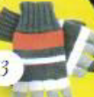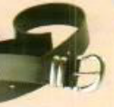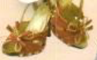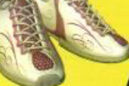

gloves belt sandals trainers tie

English working paper
Name:
.......................
Module: 7
Lesson:7b
Classroom:
........................
Activity:
.......................
Complete:

Ahmed is taller (tall) than Omar.
Hana is more handsome (handsome) than her sister.
She is better (good) than her friend.
The museum is farther (far) than the park.
This exam is worse (bad) than the previous one.

Write few sentences to compare two of your friends.

Nawaf is chubbier than Ashraf.
Nawaf is more handsome than Ashraf.
Ashraf is slimmer than Nawaf.
Ashraf is younger than Nawaf.

Writing:
English working paper
Name:
.......................
Module: 7
Lesson:7c
Classroom:
........................
Activity:
.......................
Write the names of these means of transport:

plane bus tram ship

Complete the table with the correct form of the adjectives
Adjectives | Comparative  Form | Superlative  Form
warm | warmer | warmest
rude | ruder | rudest
lazy | lazier | the laziest
big | bigger | biggest
different | more different | the most different
good | better | the best
bad | worse | the worst
much/many | more | most
far | farther/further | farthest/furthest

English working paper
Name:
.......................
Module: 7
Lesson: 7d
Classroom:
........................
Activity:
.......................
Write a paragraph describing to your friend how to go
to a place near your house.
I’m pleased to see you. You can visit the shopping mall. It is full of many interesting place. It is near the hotel. There are many shops to go shopping, cinema, restaurants and café. You can take a taxi to go there.

through
out of
around
Match:
English working paper
Name:
.......................
Unit: 3
Lesson:4
Classroom:
........................
Activity:
.......................
English working paper
Name:
.......................
Module: 7
Lesson:7e
Classroom:
........................
Activity:
.......................

Writing:
Write a paragraph about a person you admire.

I admire my uncle. He is a police man. He is my favourite uncle. I love him very much.
He is brave. He helps people. He is helpful. He is also friendly. He is hard working. He can work all day and night.

English working paper
Name:
.......................
Module: 7
Lesson: Round-up
Classroom
:
........................
Activity:
.......................

Writing:
Choose two of your friends and write a paragraph comparing them.
Mona and Noha are my friends. Noha is taller than Mona. Mona is slimmer than Noha. Mona is friendlier than Noha. Noha is chubbier than Mona.

Choose the correct answer:
Go (through – past) the park and the post office is on your left.
It is (too – enough) expensive. I can not buy it.
I can (pay – get) in cash.
I have a lot of dresses but the red (one – ones) is wonderful.
I want to buy earrings. I choose the silver (one- ones)

English working paper
Name:
.......................
Module: 8
Lesson:8a
Classroom:
........................
Activity:
.......................

Complete the spelling.
Volcano
Waterfall
Desert
Mountain

Complete with present perfect:

I haven't travelled (not travel ) by plane.
Has he rode (he/ ride) a horse before?
He never had (never/ have) an accident.
You have spent (spend) the summer holiday in mountains.
Have you ever tried (ever/ try) windsurfing?
English working paper
Name:
.......................
Module: 8
Lesson:8b
Classroom:
........................
Activity:
.......................
Complete with these words:
(break down – out of order- lost – run out of)
I have run out of petrol.
My car has break down and I can not fix it.
I have lost my bag.
The lift is out of order and I am stuck in it.
Choose the correct word:

I (lost – have lost)my wallet yesterday.
I (travel – have traveled) twice a year.
She (visited- has visited)Egypt last year.
She (has broken – broke) her leg.
They (went – have gone) shopping last week.

English working paper
Name:
.......................
Module: 8
Lesson:8c
Classroom:
........................
Activity:
.......................
report these sentences:
“Use your dictionary, Ali,” said the teacher.
The teacher told Ali to use his computer.
“Please pay attention, Rida,” said the instructor.
The instructor asked Rida to pay attention.

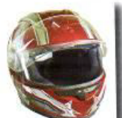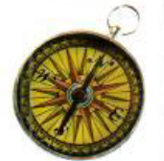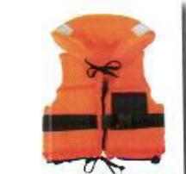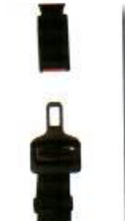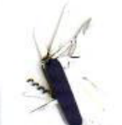

helmet compass life jacket seat belt penknife
English working paper
Name:
.......................
Module: 8
Lesson: 8d
Classroom:
........................
Activity:
.......................
Writing:
Use the information above to write a paragraph
about the country you have chosen.

Egypt is a beautiful country in Africa. Its population is about 77 millions. Most people there speak Arabic. It has the longest river called Nile. The highest mountain is Katarina.

Location: western South America
Capital: Lima
Population: 28 million
Official language: Spanish
Highest mountain: the Andes
Largest lake: Lake Titicaca

English working paper
Name:
.......................
Module: 8
Lesson:8e
Classroom:
........................
Activity:
.......................

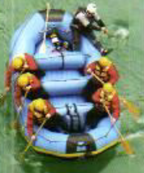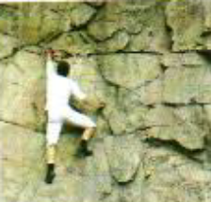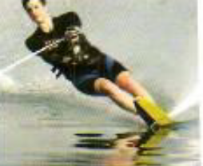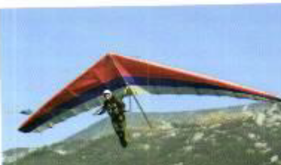

Hang-gliding waterskiing rock climbing white-water rafting

- My sister and I went shopping yesterday. My
sister and I (we) bought wonderful things.

- This is a wonderful park. We come to the park (here) every
Friday.

- I usually go to the shopping centre. I go to the
Shopping centre (it) to buy new clothes.
English working paper
Name:
.......................
Module: 8
Lesson: Round-up
Classroom:
........................
Activity:
.......................

(of- out of – to – down)
- We run out of milk yesterday.
- According to the dictionary, port means left in sailing.
- My car broke down and I couldn’t fix it.
- The lift is out of order. We can not use it.
Choose the correct word:

They (traveled- have traveled) twice a year.
These clothes aren’t (useful – suitable) to the children.
I (have visited- visited) my uncle yesterday.
He (has gone- has been ) to the supermarket and still there.
This car has broken (up – down) . It can not work.

