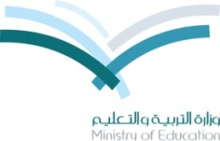
intermediat school أسئلة الفترة الأولى للصف أول متوسط
1st period (1st term ) 1439 الفصل الدراسي الأول 1439
First intermediate stage
اسم الطالبة : .......................................................................

Q1. Read then answer:
Ali is a good schoolboy. He is 13 years old. He lives in Al-Madina with his family. His father name is Bader.
His father is a teacher. Ali and his family have a big house .It has four bedrooms
, three bathrooms, a living-room and a dining room . Ali loves his family. He likes English subject.
A- Choose the correct words:
1- He lives in [ Al-Madina – Dammam].
2-His father is a [driver – teacher ].
B. Put ( √ ) or ( X) :
1. Ali loves his family ( ).
2. He likes Arabic subject ( ).
___________________________________________________________________________________________
Q2:A/ Circle the correct words:
1.I ( 've got / 's got ) a dog .
2. ( This / These ) is my brother.
3. ( who's / whose ) bike is this ? it is mine.
-------------------------------------------------------------------------------------------------------------------------------------
B/ Choose the correct plural :

1. baby :( babies / babys ) 2. woman: ( women / womans ).
------------------------------------------------------------------------------------------------------------------------------------- C/ Write the word under the picture :
Math / skirt / football / chef .
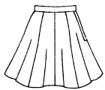
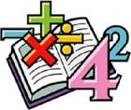

.................... ……………………… ……………………… ........................
__________________________________________________________________________________________________
D/ Cross out the odd word :
1 . Art , English , Arabic , Saturday .
2. chubby hair tall short .
_________________________________________________________________________________________________
Q3:A :write the correct letter :
1. ( c…....p ) 2. ( n…….rse ). 3( .bi..….e )

Good luck

