English test , first period , level 2
Student's name :…………………………………………………………….-
A-Write the correct answer :
One nigh t - room only - bed and breakfast - return

1-R/O………………….
2- B&B…………………
3- 1 Nt…………………
4-Rtn…………………..
B-Circle the correct answer :
1) a- Do he can swim ?
b- Can he swim ?
2) a- Are you Brazilian?
b- You are Brazilian?
C-Match the word with the pictures :
A calendar - a compass - a toiletries - a road sign

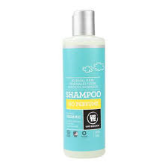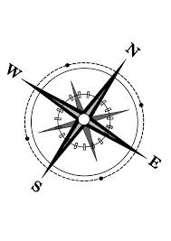
……………………… …………………………. ………………………….. …………………………………….
-------------------------------------------------------------------------------------------------------------------------------
D-Write the correct prefixes : ( im - in - un )
1-…….formal . 2- ……polite. 3-…….happy. 4-……..measurable.
E-Change from passive to active :
1- America was discovered by Columbus in 1492.
………………………………………………………………………………………………………………………………..
Good luck,
T- Soha

