المادة: لغة انجليزية اسم الطالب :.................................................................................الصف : السادس -----------
Give directions:-
Stop / turn left / turn right / cross the street

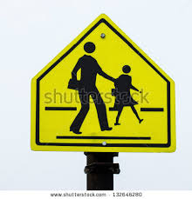
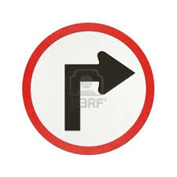

………………………...... ……………………… ……………………… ………………………….
Match :-

Turn off your mobile phone.

Throw rubbish in the rubbish bin.

Don't take picture.
============================================================Look and choose a or b:-

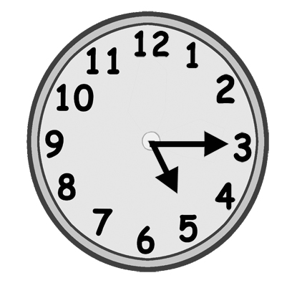
1. a. It’s a quarter to five.
b. It’s a quarter past five.
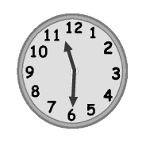

2. a. It’s half past eleven.
b. It’s a quarter past eleven.
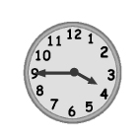

3-. a. It’s a quarter to four.
b. It’s a quarter past three.

رقم المهارة | المهارة | اتقنت | لم تتقن
35 | Use the intensifiers so / very
Rewrite using very / so :
very
1- The sports centre was noisy.
----------------------------------------------------------
2- The Ferris wheel was scary.
so
----------------------------------------------------------

رقم المهارة | المهارة | اتقنت | لم تتقن
46 | Write simple sentences to convey personal information.
74 | Write short answers to simple questions.
Answer the questions:

a - What do you collect?
I collect ……………………………………………………………………………….....

b- How many stickers have you got ?
I'v got………………………………………………

c- Where were you yesterday evening ?
I was at ------------------------------

رقم المهارة | المهارة | اتقنت | لم تتقن
27 | identify places in a town using the Past Simple of the verb to be .

لم تتقن
رقم المهارة | المهارة | اتقنت | لم تتقن
25 | Talk about rules using the imperative .
رقم المهارة | المهارة | اتقنت | لم تتقن
28 | Identify different times of the day morning------etc

