Rearrange the following to make meaningful sentences
م43*:تطبيق قواعد الترقيم الاساسيه

- late – am – sorry – I
…………………………………………………..
- are – No, – you – early
…………………………………………………..

Answer the following questions with yes/no
م27*:السؤال والاجابه عن الانشطهاليوميه
م44*:كتابة اجابات قصيره على اسئله مكتوبه
1-Do you have an orange? ………………………………… .

2-Do you have any sugar ?
…………………………………….. .
Fill in the missing word:
م41*: كتابة كلمات وعبارات بسيطه وقصيره لاكمال فقره
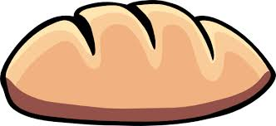
Please pass me some………………
………..you are
م25*: السؤال والاخبار عن الوقت
م38*:قراءة وادراك الجمل البسيطه
Read and match
1-It's three o'clock. A – 7:15
2-It's one thirty. B - 3:00
3-It's seven fifteen. C - 1:30
Match the sound to its word:
م*5+م4*: التعرف على بعض الحروف المدمجة الساكنه
Br / cl / tr / dr

Cloudy / brown / tree / dress

complete the following using ( between / next to / on the right / on the left):
م14*:وصف المكان او الموقع باستخدام حروف الجر المكانيه

- The mosque is ……………..the park and the
supermarket.
- The supermarket is ………………………..
- The park is ………………………….
4-the hospital is…………………the airport.
