اختبار الفترة الثانية انجليزي الثاني المتوسط الفصل الثاني 1439 هـ / 2018 م

Do as shown between brockets : -
1 - Mo khtar - drink - water - sports drinks
( use not only but also )
.....................................................................................
2 - In two months time ( in - on - at )
( choose )
3 - Fatimah has to ( clean - cleaning - cleaned ) the kitchen floor

4 - I think ( study - studying - studyed ) hard is good habit
( choose )
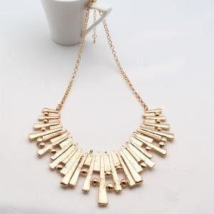
Match : -
1 - necklace
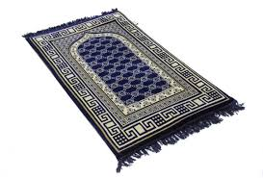
2 - prayer mak
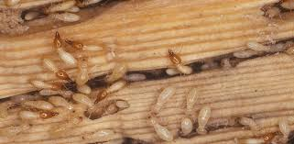
3 - torch
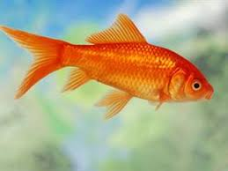
4 - Fish
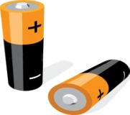
5 - battery

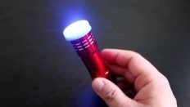
6 - wood worm

