اسم الطالب:....................................الصف / رابع.....................الفترة 4
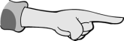
Choose :
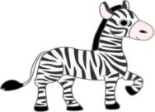
1- (These / Those ) are books .
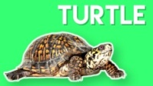
2 – This is ( Zebra / Vase ).
3 - Do you have a pet ? (yes , No ) I have.
4 – What’s the matter? I am .............................. 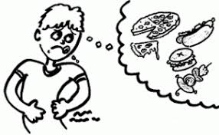

Answer the questions:
What Day is it today? It’ s .........................................
What is the weather like today? It’s .....................................
What’s the matter ? I am ...................................

Rearrange :
Saturday – Monday – Wednesday – Friday – Sunday- Tuesday
Thursday

1 - ........................................... 2- ............................................ 3 - ...................................
4..............................................5- ..............................................6- .....................................
7-....................................................

Good luck
Nabil

