المملكة العربية السعودية
وزارة التربية والتعليم
إدارة التعليم بمنطقة ........
المتوسطة الـ..........
اختبار الفصل ألدراسي الثاني للعام 1438 - 1439 هــ

التاريخ: .... / 8 / 1439هــ
المادة : لغة انجليزية
الصف : ثاني متوسط
الزمن : ساعتان ونص
اختبار الدور ..........

اسم الطالبة / ..................................................................................................................... رقم الجلوس / ...........................................

السؤال | الدرجة رقماً | الدرجة كتابةً | المصححة | المراجعة | المدققة
الأول 5 درجات
الثاني 5 درجات
الثالث 5 درجات
الرابع 5 درجات
الخامس 2 درجة
التقويم المستمر
4 درجات
المجموع
26درجة

Composition I-
____
5
Q1: write a paragraph about The Five Pillars of Islam using these words :
( Arkan Al-Islam / the profession / prayer / giving alms / fasting / Hajj)
……………………………………………………………………………………………………………………………………………………………………………………………………………………………………………………………………………………………………………………………………………………………………………………………………………………………………………………………………………………………………………………………………………………………………………………………………………………………………………………………………………………………………………………………………………………………………………………………………………………………………………………………
____
5
II- Comprehension
- Read the passage then answer the following questions:
ABUOT A FOOT
Did you know …. ?
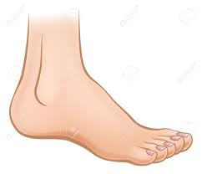
There are 26 bones in each foot .
The best time to buy shoes is in the afternoon .
we take about 8000 steps in one day .
we walk about 100,000 km in our life .
In English you say feet , not foot .
Q1: How many bones are there in a foot ?
……………………………………………………………………………………………………………………….
Q2: Put ( ) for the true sentence and ( X ) for false sentence :
- The best time to buy shoes is in the morning ( )
- In English you say feet , not foots ( )
Q3: Choose :
- We take about ( 2000 / 4000 / 8000 ) steps in one day .
- we walk about 100,000 km in our ( day / month / life )

III- Grammar
_____
5
Q1: Underline the right word :
- Are you afraid ( of - to - by ) any animals ?
- Let's ( go – goes – going ) swimming in the sea .
- Where is Mum, Omar ? There's a phone call for ( her - she - him ) .
- We have four lessons ( in - on - at ) the morning .
- Horses are ( fast - faster - the fastest ) than elephants .
- Pilgrims ( could - can - be able ) fly to Jeddah now .
Q2: Write sentence using ( has to ) or ( have to ) :
Ranya / dinner / for her family. ( cook )
…………………………………………………………………………………………… ……………….
Q3: Write the sentences in a short way :
- There was a woman . She was carrying eggs .
..............................................................................................................
Vocabulary IV-
_____
5
Q1: Write each word under suitable picture :
( Luggage - Pipe - Prayer mat - Torch )
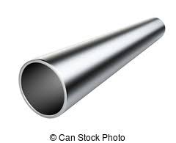 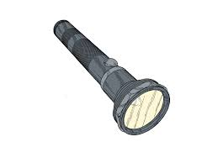 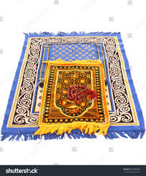 ……………………. …………………… …………………. ………………… ………………………

Q2: Match :
- a- Tower - a strong heavy shoe
- b- Tent - enjoy talking to people
- c- a friendly person - a home you can carry
- d- a boot - a tall , thin building
Q3: Underline the odd word :
- meals - food - diet - exercise
- elephant - jumbo jet - air bus - plane

V- Spelling
____
2
Q1: Find the missing letter :
- Pas……a [ t - d - h ]
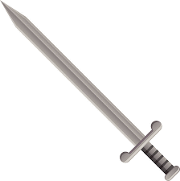
- Hel………et [ m - n - u ]
Q2: Circle the correct spelling :

- Sword - Soord - Ciord
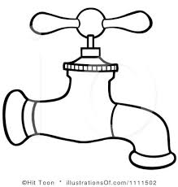

tap - tab - teab
**********************************************
End of Questions : with my best wishes

