المملكة العربية السعودية
وزارة التربية والتعليم
إدارة التعليم بمنطقة ..........
المتوسطة الـ............
اختبار الفصل ألدراسي الثاني للعام 1438 - 1439 هــ

التاريخ: .... / 8 / 1439هــ
المادة : لغة انجليزية
الصف : أول متوسط
الزمن : ساعتان ونص
اختبار الدور ..........

اسم الطالبة / ..................................................................................................................... رقم الجلوس / ...........................................

السؤال | الدرجة رقماً | الدرجة كتابةً | المصححة | المراجعة | المدققة
الأول 5 درجات
الثاني 5 درجات
الثالث 5 درجات
الرابع 5 درجات
الخامس 2 درجة
التقويم المستمر
4 درجات
المجموع
26درجة

Composition I-
____
5
Q1: use these words to write a paragraph about yourself :
( Name – age - nationality – town or city – father's job )
…………………………………………………………………………………………………………………………………………………………………………………………………………………………………………………………………………………………………………………………………………………………………………………………………………………………………………………………………………………………………………………………………………………………………………………………………………………………………………………………………………………
____
5
II- Comprehension
- Read the passage then answer the following questions:
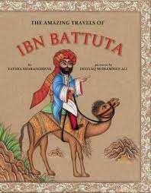
Ibn Battuta was born in Morocco in 1304. In 1325 he travelled on Hajj to Makkah. And he didn’t stop travelling for the next 30 years! He started from Tangier, and after Makkah, he travelled all over the Islamic world. He visited Saudi Arabia, Egypt, Turkey, Iran, Iraq and Afghanistan. Then he continued to India. In Delhi the Sultan, Mohammed Tuglaq, asked him to go to China, where he visited Shanghai and Beijing. He returned to Morocco after 25 years.
Q1: Where was Ibn Battuth born in ?
……………………………………………………………………………………………………………………
Q2: Put ( ) for the true sentence and ( X ) for false sentence :
- In 1325 he travelled on Hajj to Madinah ( )
- he travelled all over the Arabic world ( )
Q3: Choose :
- In Delhi the Sultan asked him to go to ( China - India - Morocco ) .
- He returned to Morocco after ( 25 – 30 – 1304 ) years .

III- Grammar
_____
5
Q1: Underline the right word :
- They have a P.E lesson ( at - in - on ) 11:45 .
- Speaking English is ( difficult – difficulter – more difficult ) than reading English .
- How ( many - much - some ) tomatoes do we need?
- There are 7 ( children - child - childs ) late .
Q2: Choose . (So do I) or (So am I) :
I am very cold : …………………………………………………..
I want to watch TV : ………………………………………….
Q3: Give the past simple tense :
- ask : …………………………. live : ……………………………………
Q4: Write sentence using ( going to ) :
- - Jack / watch football . …………………………………………………………………………………………
Vocabulary IV-
_____
5
Q1: Write each word under suitable picture :
( Seatbelt - Tiger - Map - Labtop )
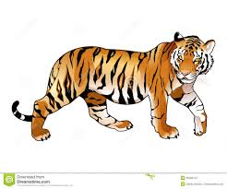 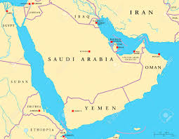 ……………………. …………………….. …………………. ………………………

Q2: Match :
- a- A bottle of - hot
- b- school - lights
- c- traffic - book
- d- the summer - water
Q3: Find the odd word :
- Pineapple - Banana - Orange - Potato
- Aunt - Baby - Cousin - Uncle.

V- Spelling
____
2
Q1: Find the missing letter :
- Ba……….er [ k - c - x ]
- Nur………e [ s - z - c ]
- Ze………ra [ b - p - d ]
- Pai…………ts [ n - m - u ]
**********************************************
End of Questions : with my best wishes

