اختبار الفترة الأولى انجليزي الأول المتوسط الفصل الأول

Answer the following question 1 -

How old are you ?
.............................................................

2 – write a or on
1 - …………. garden
2 - …………. egg
3 - …………... bus

3 – choose the correct answer
1 – I'm ( eat - eating - ate ) break fast
2 – She ( is - am - are ) watching TV

Match the following words with the pictures
1 – book
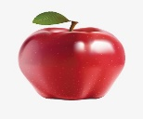
2 – solider
3 – ball
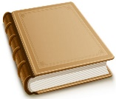
4 – apple

