اختبار الفترة الأولى انجليزي الثاني المتوسط الفصل الأول

Choose the correct answer : - 1 -
1 – ( Do - Does - Are ) you like pissa ?
2 – The lion roared ( hot - correctly – loudly )

2 – Answer :
a – Chang the following into past
1 – have ……………….
2 – come ……………….
3 – go ……………….

b – Change the following adjectives into adverbs :
1 – clear
2 – Careful
3 - Match : 1 - train
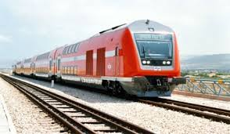
2 - Ambulance
3 - car
Arrang the following letters to malke
acorrect word :
1 – mna oli pec ……………………………..
2 – ro perter . …………………………….

