1 - Do as shown between brackets :
1 –We have lived here since two years .
( correct )
……………………………………………………………………………………………
2 - semi's father will travelled to London next month ?
( correct )
……………………………………………………………………………………………
3 - could you get me some thing to eat ?
( answer with accept )
……………………………………………………………………………………………
4 - ………………………….. continue - conserve
( add - ation )
5 - twelve hundred
( write it as number )
……………………………………………………………………………………………
6 - w - - k
Mar - -
( complete )
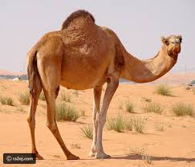
- Match:
-lamp
-camel
- fan

