ملف مادة الرياضيات
للصف الثاني ثانوي
مقرر 4

السيرة الذاتية للطالبة

اسمي /..........................................................
مدرستي/ ......................................................
معلمتي/........................................................
حكمة أعجبتني/................................................
قدوتي في الحياة/...............................................
هواياتي/.........................................................
حلمي/...........................................................

الجــــــــــدول
 | 1 | 2 | 3 | 4 | 5 | 6 | 7 | 8
الأحد
الاثنين
الثلاثاء
الأربعاء
الخميس

أهــم المواعيــد
اليوم | التاريخ | الحصة | نوع الموعد

الفصل الأول
العلاقات والدوال النسبية

1-ضرب العبارات النسبية وقسمتها.
2-جمع العبارات النسبية وطرحها.
3-تمثيل دوال المقلوب بيانيا.
4-تمثيل الدوال النسبية بيانيا.
5-دوال التغير.
6-حل المعادلات والمتباينات النسبية.
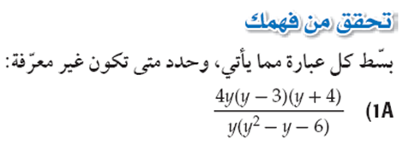
......................................................................................................................................................

......................................................................................................................................................

......................................................................................................................................................

......................................................................................................................................................

......................................................................................................................................................

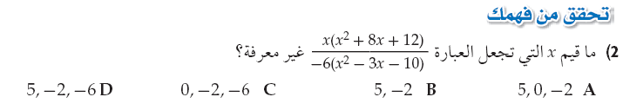
......................................................................................................................................................

......................................................................................................................................................

......................................................................................................................................................

......................................................................................................................................................

......................................................................................................................................................

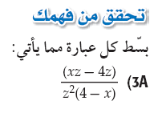
......................................................................................................................................................

......................................................................................................................................................

......................................................................................................................................................

......................................................................................................................................................


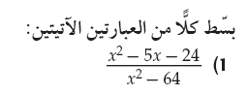
......................................................................................................................................................

......................................................................................................................................................

......................................................................................................................................................

......................................................................................................................................................

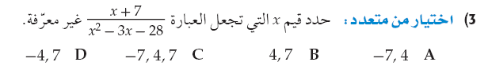
......................................................................................................................................................

......................................................................................................................................................

......................................................................................................................................................

......................................................................................................................................................

......................................................................................................................................................

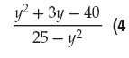
......................................................................................................................................................

......................................................................................................................................................

......................................................................................................................................................

......................................................................................................................................................

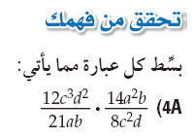
......................................................................................................................................................

......................................................................................................................................................

......................................................................................................................................................

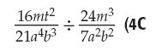
......................................................................................................................................................

......................................................................................................................................................

......................................................................................................................................................

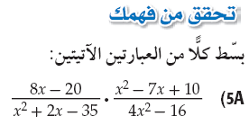
......................................................................................................................................................

......................................................................................................................................................

......................................................................................................................................................

......................................................................................................................................................

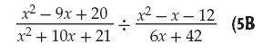
......................................................................................................................................................

......................................................................................................................................................

......................................................................................................................................................

......................................................................................................................................................
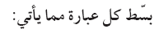
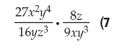
......................................................................................................................................................

......................................................................................................................................................

......................................................................................................................................................

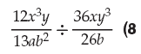
......................................................................................................................................................

......................................................................................................................................................

......................................................................................................................................................

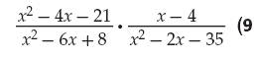
......................................................................................................................................................

......................................................................................................................................................

......................................................................................................................................................

......................................................................................................................................................

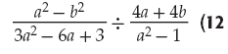
......................................................................................................................................................

......................................................................................................................................................

......................................................................................................................................................

......................................................................................................................................................

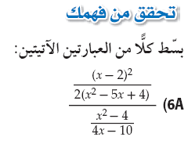
......................................................................................................................................................

......................................................................................................................................................

......................................................................................................................................................

......................................................................................................................................................

......................................................................................................................................................

......................................................................................................................................................

......................................................................................................................................................

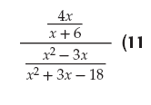
......................................................................................................................................................

......................................................................................................................................................

......................................................................................................................................................

......................................................................................................................................................

......................................................................................................................................................

......................................................................................................................................................


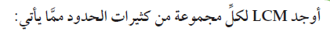
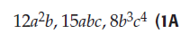
......................................................................................................................................................

......................................................................................................................................................

......................................................................................................................................................

......................................................................................................................................................

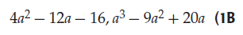
......................................................................................................................................................

......................................................................................................................................................

......................................................................................................................................................

......................................................................................................................................................

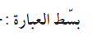
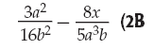
......................................................................................................................................................

......................................................................................................................................................

......................................................................................................................................................

......................................................................................................................................................

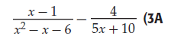
......................................................................................................................................................

......................................................................................................................................................

......................................................................................................................................................

......................................................................................................................................................

......................................................................................................................................................


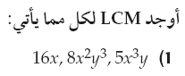
......................................................................................................................................................

......................................................................................................................................................

......................................................................................................................................................

......................................................................................................................................................
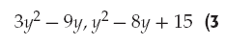
......................................................................................................................................................

......................................................................................................................................................

......................................................................................................................................................

......................................................................................................................................................

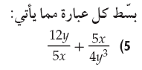
......................................................................................................................................................

......................................................................................................................................................

......................................................................................................................................................

......................................................................................................................................................

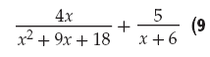
......................................................................................................................................................

......................................................................................................................................................

......................................................................................................................................................

......................................................................................................................................................

......................................................................................................................................................

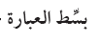
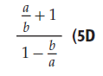
......................................................................................................................................................

......................................................................................................................................................

......................................................................................................................................................

......................................................................................................................................................

......................................................................................................................................................

......................................................................................................................................................

......................................................................................................................................................

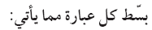
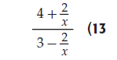
......................................................................................................................................................

......................................................................................................................................................

......................................................................................................................................................

......................................................................................................................................................

......................................................................................................................................................

......................................................................................................................................................

......................................................................................................................................................

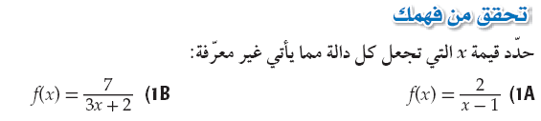
......................................................................................................................................................

......................................................................................................................................................

......................................................................................................................................................

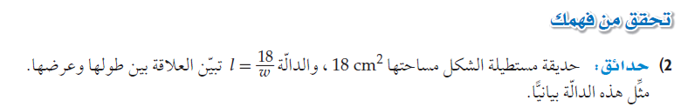
.................................................................................
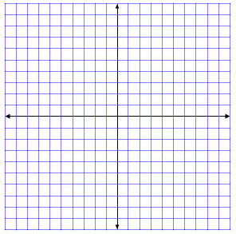

.................................................................................

.................................................................................

.................................................................................

.................................................................................

.................................................................................


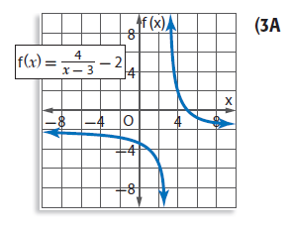
......................................................................................................................................................

......................................................................................................................................................

......................................................................................................................................................


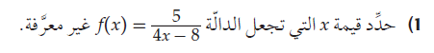
......................................................................................................................................................

......................................................................................................................................................

......................................................................................................................................................

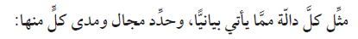
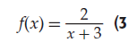
.................................................................................

.................................................................................

.................................................................................

.................................................................................

.................................................................................

.................................................................................

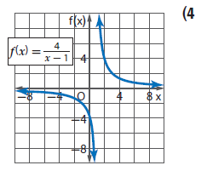
......................................................................................................................................................

......................................................................................................................................................

......................................................................................................................................................


مثل الدالة بيانيا
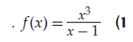
.................................................................................

.................................................................................

.................................................................................

.................................................................................

.................................................................................

.................................................................................

.................................................................................

.................................................................................

مثل الدالة بيانيا
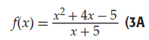
.................................................................................

.................................................................................

.................................................................................

.................................................................................

.................................................................................

.................................................................................

.................................................................................

.................................................................................


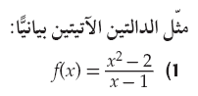
.................................................................................

.................................................................................

.................................................................................

.................................................................................

.................................................................................

.................................................................................

.................................................................................

.................................................................................

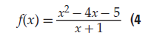
.................................................................................

.................................................................................

.................................................................................

.................................................................................

.................................................................................

.................................................................................

.................................................................................

.................................................................................

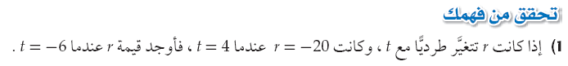
......................................................................................................................................................

......................................................................................................................................................

......................................................................................................................................................

......................................................................................................................................................

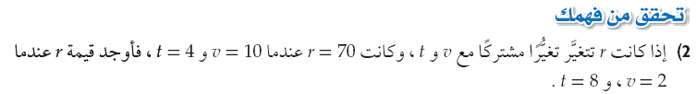
......................................................................................................................................................

......................................................................................................................................................

......................................................................................................................................................

......................................................................................................................................................

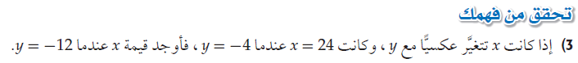
......................................................................................................................................................

......................................................................................................................................................

......................................................................................................................................................

......................................................................................................................................................

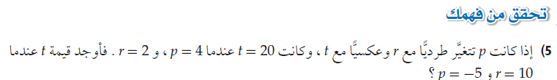
......................................................................................................................................................

......................................................................................................................................................

......................................................................................................................................................

......................................................................................................................................................


......................................................................................................................................................

......................................................................................................................................................

......................................................................................................................................................

......................................................................................................................................................

......................................................................................................................................................

......................................................................................................................................................

......................................................................................................................................................

......................................................................................................................................................

......................................................................................................................................................

......................................................................................................................................................

......................................................................................................................................................

......................................................................................................................................................

......................................................................................................................................................

......................................................................................................................................................

......................................................................................................................................................

......................................................................................................................................................

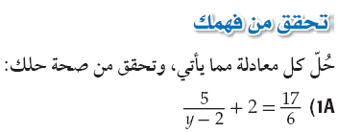
......................................................................................................................................................

......................................................................................................................................................

......................................................................................................................................................

......................................................................................................................................................

......................................................................................................................................................

......................................................................................................................................................

......................................................................................................................................................

......................................................................................................................................................

......................................................................................................................................................

......................................................................................................................................................

......................................................................................................................................................

......................................................................................................................................................

......................................................................................................................................................

......................................................................................................................................................

......................................................................................................................................................


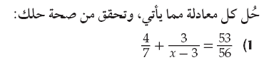

......................................................................................................................................................

......................................................................................................................................................

......................................................................................................................................................

......................................................................................................................................................

......................................................................................................................................................

......................................................................................................................................................

......................................................................................................................................................

......................................................................................................................................................

......................................................................................................................................................

......................................................................................................................................................

......................................................................................................................................................

......................................................................................................................................................

......................................................................................................................................................

......................................................................................................................................................

......................................................................................................................................................


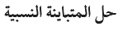
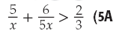
......................................................................................................................................................

......................................................................................................................................................

......................................................................................................................................................

......................................................................................................................................................

......................................................................................................................................................

......................................................................................................................................................

......................................................................................................................................................

......................................................................................................................................................

......................................................................................................................................................

......................................................................................................................................................

......................................................................................................................................................

......................................................................................................................................................

......................................................................................................................................................

......................................................................................................................................................

......................................................................................................................................................

......................................................................................................................................................

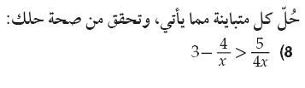
......................................................................................................................................................

......................................................................................................................................................

......................................................................................................................................................

......................................................................................................................................................

......................................................................................................................................................

......................................................................................................................................................

......................................................................................................................................................

......................................................................................................................................................

......................................................................................................................................................

......................................................................................................................................................

......................................................................................................................................................

......................................................................................................................................................

......................................................................................................................................................

......................................................................................................................................................

......................................................................................................................................................

......................................................................................................................................................

الفصل الثاني
المتتابعات والمتسلسلات

1-المتتابعات بوصفها دوال
2-المتتابعات والمتسلسلات الحسابية
3- المتتابعات والمتسلسلات الهندسية
4-المتسلسلات الهندسية غير المنتهية
5-نظرية ذات الحدين
6-البرهان بالاستقراء الرياضي

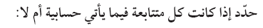

......................................................................................................................................................

......................................................................................................................................................

......................................................................................................................................................

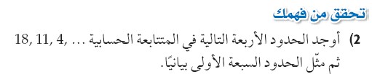

.................................................................................

.................................................................................

.................................................................................

.................................................................................

.................................................................................

.................................................................................

.................................................................................

.................................................................................

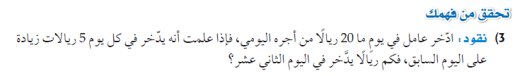
......................................................................................................................................................

......................................................................................................................................................

......................................................................................................................................................

......................................................................................................................................................

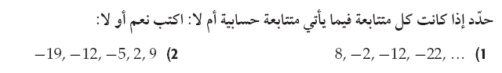
......................................................................................................................................................

......................................................................................................................................................

......................................................................................................................................................

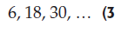
.................................................................................

.................................................................................

.................................................................................

.................................................................................

.................................................................................

.................................................................................

.................................................................................

.................................................................................

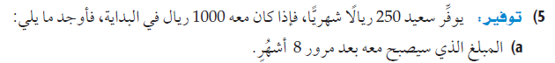
......................................................................................................................................................

......................................................................................................................................................

......................................................................................................................................................
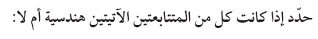
......................................................................................................................................................

......................................................................................................................................................

......................................................................................................................................................

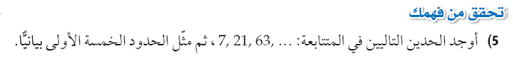
.................................................................................

.................................................................................

.................................................................................

.................................................................................

.................................................................................

.................................................................................

.................................................................................

.................................................................................


......................................................................................................................................................

......................................................................................................................................................

......................................................................................................................................................

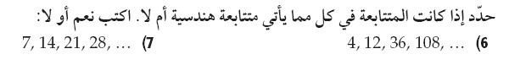
......................................................................................................................................................

......................................................................................................................................................

......................................................................................................................................................

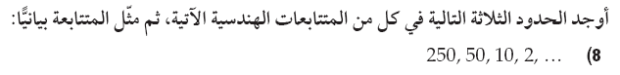
.................................................................................

.................................................................................

.................................................................................

.................................................................................

.................................................................................

.................................................................................

.................................................................................

.................................................................................

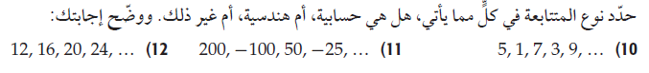
......................................................................................................................................................

......................................................................................................................................................

......................................................................................................................................................


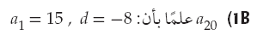
......................................................................................................................................................

......................................................................................................................................................

......................................................................................................................................................

......................................................................................................................................................


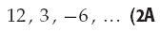
......................................................................................................................................................

......................................................................................................................................................

......................................................................................................................................................

......................................................................................................................................................

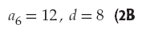
......................................................................................................................................................

......................................................................................................................................................

......................................................................................................................................................

......................................................................................................................................................

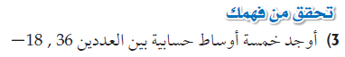
......................................................................................................................................................

......................................................................................................................................................

......................................................................................................................................................

......................................................................................................................................................



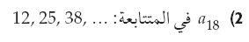
......................................................................................................................................................

......................................................................................................................................................

......................................................................................................................................................

......................................................................................................................................................


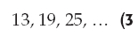
......................................................................................................................................................

......................................................................................................................................................

......................................................................................................................................................

......................................................................................................................................................

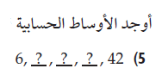
......................................................................................................................................................

......................................................................................................................................................

......................................................................................................................................................

......................................................................................................................................................


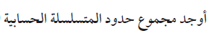
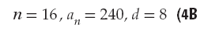
......................................................................................................................................................

......................................................................................................................................................

......................................................................................................................................................

......................................................................................................................................................

......................................................................................................................................................

......................................................................................................................................................

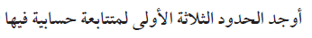
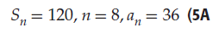
......................................................................................................................................................

......................................................................................................................................................

......................................................................................................................................................

......................................................................................................................................................

......................................................................................................................................................

......................................................................................................................................................

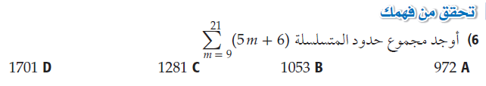
......................................................................................................................................................

......................................................................................................................................................

......................................................................................................................................................

......................................................................................................................................................

......................................................................................................................................................

......................................................................................................................................................


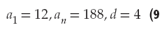
......................................................................................................................................................

......................................................................................................................................................

......................................................................................................................................................

......................................................................................................................................................

......................................................................................................................................................

......................................................................................................................................................

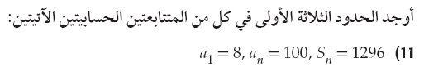
......................................................................................................................................................

......................................................................................................................................................

......................................................................................................................................................

......................................................................................................................................................

......................................................................................................................................................

......................................................................................................................................................

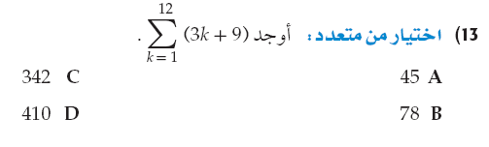
......................................................................................................................................................

......................................................................................................................................................

......................................................................................................................................................

......................................................................................................................................................

......................................................................................................................................................

......................................................................................................................................................

......................................................................................................................................................
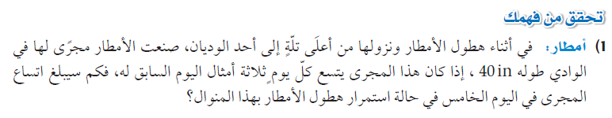
......................................................................................................................................................

......................................................................................................................................................

......................................................................................................................................................

......................................................................................................................................................

......................................................................................................................................................


......................................................................................................................................................

......................................................................................................................................................

......................................................................................................................................................

......................................................................................................................................................

......................................................................................................................................................

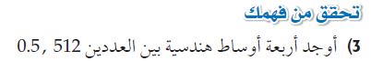
......................................................................................................................................................

......................................................................................................................................................

......................................................................................................................................................

......................................................................................................................................................

......................................................................................................................................................

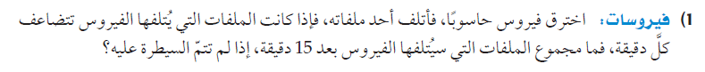
......................................................................................................................................................

......................................................................................................................................................

......................................................................................................................................................

......................................................................................................................................................

......................................................................................................................................................

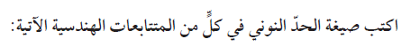
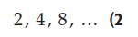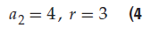
......................................................................................................................................................

......................................................................................................................................................

......................................................................................................................................................

......................................................................................................................................................

......................................................................................................................................................

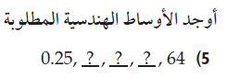
......................................................................................................................................................

......................................................................................................................................................

......................................................................................................................................................

......................................................................................................................................................

......................................................................................................................................................

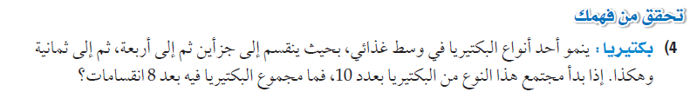
......................................................................................................................................................

......................................................................................................................................................

......................................................................................................................................................

......................................................................................................................................................

......................................................................................................................................................

......................................................................................................................................................


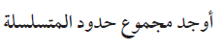
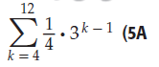
......................................................................................................................................................

......................................................................................................................................................

......................................................................................................................................................

......................................................................................................................................................

......................................................................................................................................................

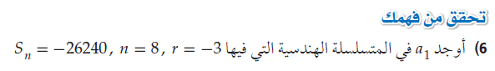
......................................................................................................................................................

......................................................................................................................................................

......................................................................................................................................................

......................................................................................................................................................

......................................................................................................................................................
......................................................................................................................................................

......................................................................................................................................................

......................................................................................................................................................

......................................................................................................................................................

......................................................................................................................................................

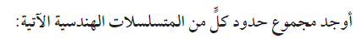
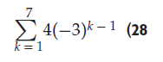
......................................................................................................................................................

......................................................................................................................................................

......................................................................................................................................................

......................................................................................................................................................

......................................................................................................................................................

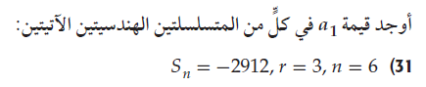
......................................................................................................................................................

......................................................................................................................................................

......................................................................................................................................................

......................................................................................................................................................

......................................................................................................................................................

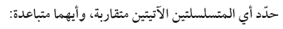
......................................................................................................................................................

......................................................................................................................................................

......................................................................................................................................................

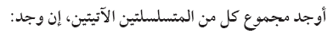

......................................................................................................................................................

......................................................................................................................................................

......................................................................................................................................................

.....................................................................................................................................................

.....................................................................................................................................................

.....................................................................................................................................................

.....................................................................................................................................................

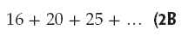
......................................................................................................................................................

......................................................................................................................................................

......................................................................................................................................................

......................................................................................................................................................

......................................................................................................................................................

......................................................................................................................................................

......................................................................................................................................................


......................................................................................................................................................

......................................................................................................................................................

......................................................................................................................................................

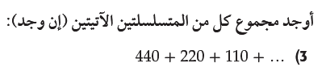
......................................................................................................................................................

......................................................................................................................................................

......................................................................................................................................................

......................................................................................................................................................

......................................................................................................................................................

......................................................................................................................................................

......................................................................................................................................................

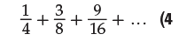
......................................................................................................................................................

......................................................................................................................................................

......................................................................................................................................................

......................................................................................................................................................

......................................................................................................................................................

......................................................................................................................................................

......................................................................................................................................................
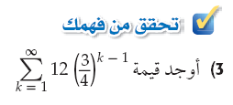
......................................................................................................................................................

......................................................................................................................................................

......................................................................................................................................................

......................................................................................................................................................

......................................................................................................................................................

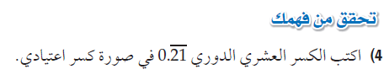
......................................................................................................................................................

......................................................................................................................................................

......................................................................................................................................................

......................................................................................................................................................

......................................................................................................................................................

......................................................................................................................................................

......................................................................................................................................................

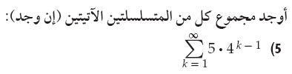
......................................................................................................................................................

......................................................................................................................................................

......................................................................................................................................................

......................................................................................................................................................

......................................................................................................................................................

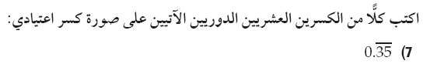
......................................................................................................................................................

......................................................................................................................................................

......................................................................................................................................................

......................................................................................................................................................

......................................................................................................................................................

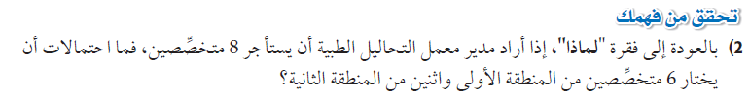
......................................................................................................................................................

......................................................................................................................................................

......................................................................................................................................................

......................................................................................................................................................

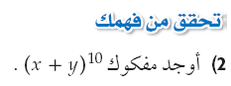
......................................................................................................................................................

......................................................................................................................................................

......................................................................................................................................................

......................................................................................................................................................

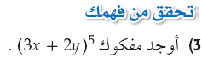
......................................................................................................................................................

......................................................................................................................................................

......................................................................................................................................................

......................................................................................................................................................

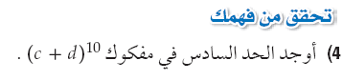
......................................................................................................................................................

......................................................................................................................................................

......................................................................................................................................................

......................................................................................................................................................


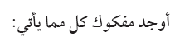
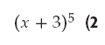
......................................................................................................................................................

......................................................................................................................................................

......................................................................................................................................................

......................................................................................................................................................


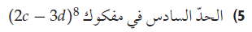
......................................................................................................................................................

......................................................................................................................................................

......................................................................................................................................................

......................................................................................................................................................

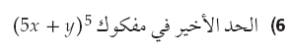
......................................................................................................................................................

......................................................................................................................................................

......................................................................................................................................................

......................................................................................................................................................

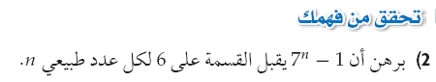
......................................................................................................................................................

......................................................................................................................................................

......................................................................................................................................................

......................................................................................................................................................

......................................................................................................................................................

......................................................................................................................................................

......................................................................................................................................................

......................................................................................................................................................

......................................................................................................................................................

......................................................................................................................................................

......................................................................................................................................................

......................................................................................................................................................

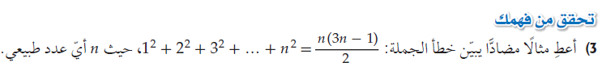
......................................................................................................................................................

......................................................................................................................................................

......................................................................................................................................................

......................................................................................................................................................

......................................................................................................................................................

......................................................................................................................................................


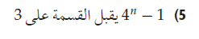
......................................................................................................................................................

......................................................................................................................................................

......................................................................................................................................................

......................................................................................................................................................

......................................................................................................................................................

......................................................................................................................................................

......................................................................................................................................................

......................................................................................................................................................

......................................................................................................................................................

......................................................................................................................................................

......................................................................................................................................................

......................................................................................................................................................

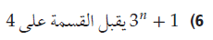
......................................................................................................................................................

......................................................................................................................................................

......................................................................................................................................................

......................................................................................................................................................

......................................................................................................................................................

الفصل الثالث
الاحتمـــــــــــــالات

1-تمثيل فضاء العينة
2-الاحتمال باستعمال التباديل والتوافيق
3-الاحتمال الهندسي
4-احتمالات الحوادث المستقلة والحوادث غير المستقلة
5-احتمالات الحوادث المتنافية
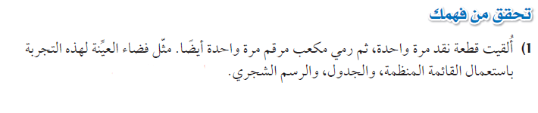......................................................................................................................................................

......................................................................................................................................................

......................................................................................................................................................

......................................................................................................................................................

......................................................................................................................................................

......................................................................................................................................................

......................................................................................................................................................

......................................................................................................................................................

......................................................................................................................................................

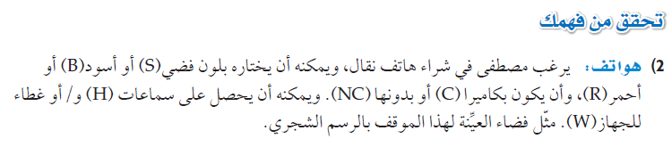

......................................................................................................................................................

......................................................................................................................................................

......................................................................................................................................................

......................................................................................................................................................

......................................................................................................................................................

......................................................................................................................................................

......................................................................................................................................................

......................................................................................................................................................


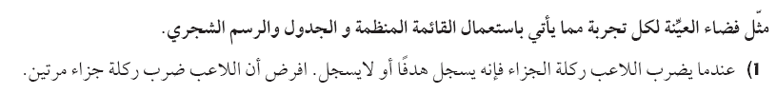
......................................................................................................................................................

......................................................................................................................................................

......................................................................................................................................................

......................................................................................................................................................

......................................................................................................................................................

......................................................................................................................................................

......................................................................................................................................................

......................................................................................................................................................

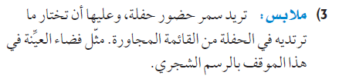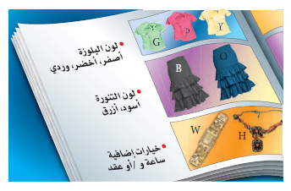
......................................................................................................................................................

......................................................................................................................................................

......................................................................................................................................................

......................................................................................................................................................

......................................................................................................................................................

......................................................................................................................................................

......................................................................................................................................................

......................................................................................................................................................

......................................................................................................................................................
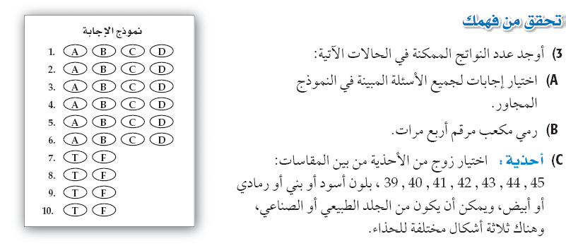

......................................................................................................................................................

......................................................................................................................................................

......................................................................................................................................................

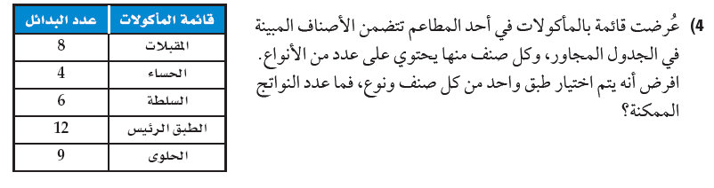
......................................................................................................................................................

......................................................................................................................................................

......................................................................................................................................................


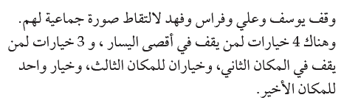
.....................................................................................................................................................

.....................................................................................................................................................

.....................................................................................................................................................

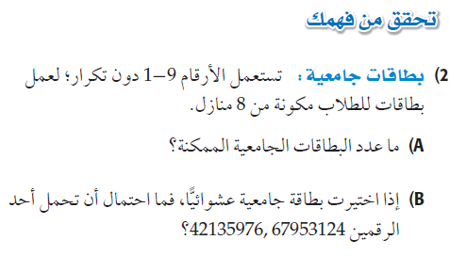
.....................................................................................................................................................

.....................................................................................................................................................

.....................................................................................................................................................

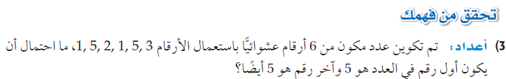
.....................................................................................................................................................

.....................................................................................................................................................

.....................................................................................................................................................


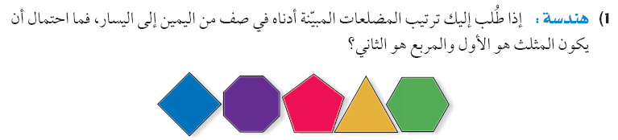

.....................................................................................................................................................

.....................................................................................................................................................

.....................................................................................................................................................

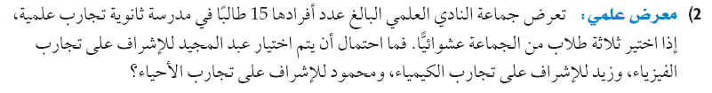
.....................................................................................................................................................

.....................................................................................................................................................

.....................................................................................................................................................

.....................................................................................................................................................

.....................................................................................................................................................

.....................................................................................................................................................

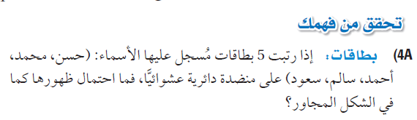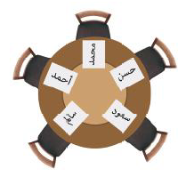
.....................................................................................................................................................

.....................................................................................................................................................

.....................................................................................................................................................

.....................................................................................................................................................

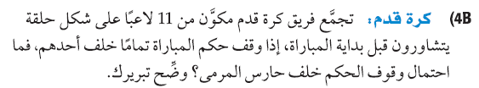
.....................................................................................................................................................

.....................................................................................................................................................

.....................................................................................................................................................

.....................................................................................................................................................

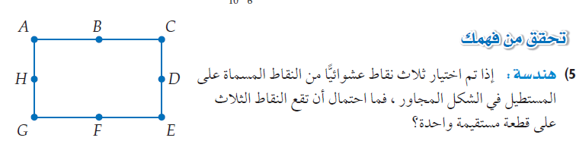

.....................................................................................................................................................

.....................................................................................................................................................

.....................................................................................................................................................

.....................................................................................................................................................

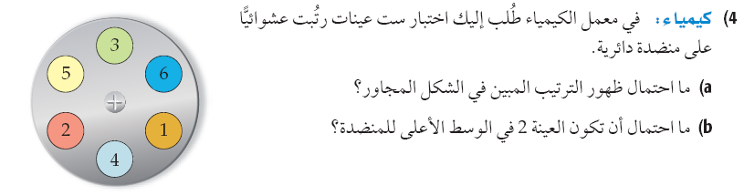
.....................................................................................................................................................

.....................................................................................................................................................

.....................................................................................................................................................

.....................................................................................................................................................

.....................................................................................................................................................

.....................................................................................................................................................

.....................................................................................................................................................

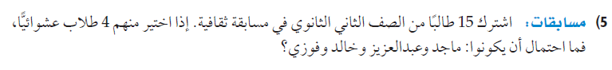
.....................................................................................................................................................

.....................................................................................................................................................

.....................................................................................................................................................

.....................................................................................................................................................

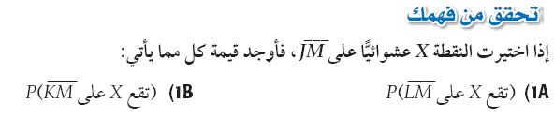
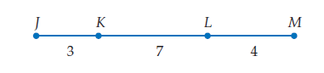
......................................................................................................................................................

......................................................................................................................................................

......................................................................................................................................................

......................................................................................................................................................

......................................................................................................................................................

......................................................................................................................................................

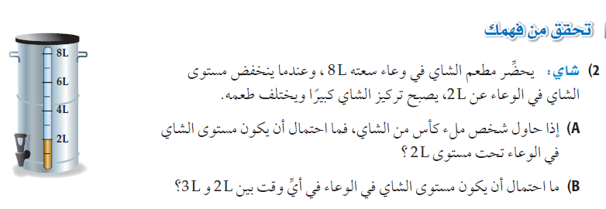
......................................................................................................................................................

......................................................................................................................................................

......................................................................................................................................................

......................................................................................................................................................

......................................................................................................................................................

......................................................................................................................................................

......................................................................................................................................................

......................................................................................................................................................


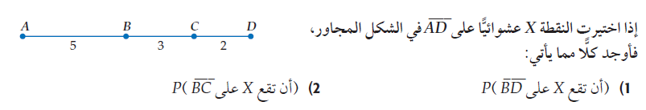
......................................................................................................................................................

......................................................................................................................................................

......................................................................................................................................................

......................................................................................................................................................

......................................................................................................................................................

......................................................................................................................................................

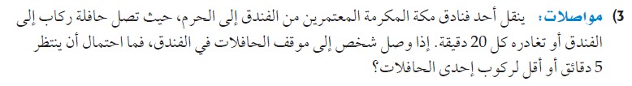
......................................................................................................................................................

......................................................................................................................................................

......................................................................................................................................................

......................................................................................................................................................

......................................................................................................................................................

......................................................................................................................................................


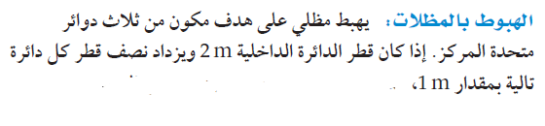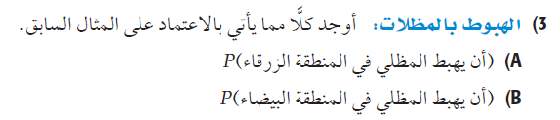


......................................................................................................................................................

......................................................................................................................................................

......................................................................................................................................................

......................................................................................................................................................

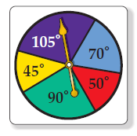
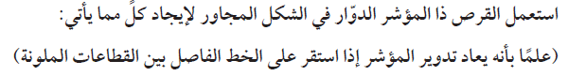

......................................................................................................................................................

......................................................................................................................................................

......................................................................................................................................................

......................................................................................................................................................


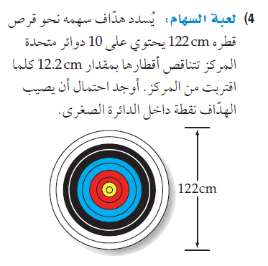

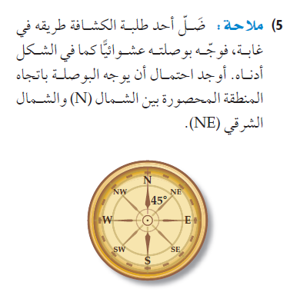

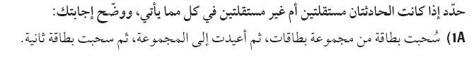
.....................................................................................................................................................

.....................................................................................................................................................

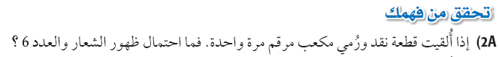

.....................................................................................................................................................

.....................................................................................................................................................

.....................................................................................................................................................

.....................................................................................................................................................

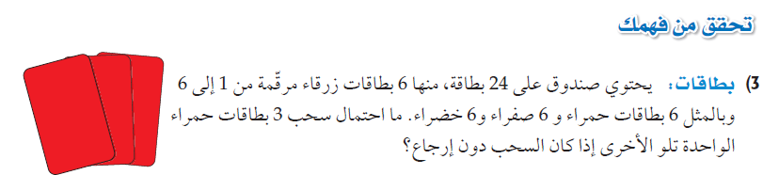

.....................................................................................................................................................

.....................................................................................................................................................

.....................................................................................................................................................

.....................................................................................................................................................


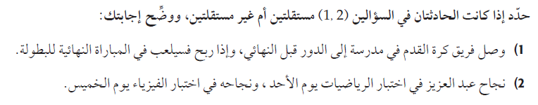
.....................................................................................................................................................

.....................................................................................................................................................

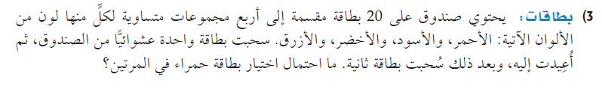
.....................................................................................................................................................

.....................................................................................................................................................

.....................................................................................................................................................

.....................................................................................................................................................

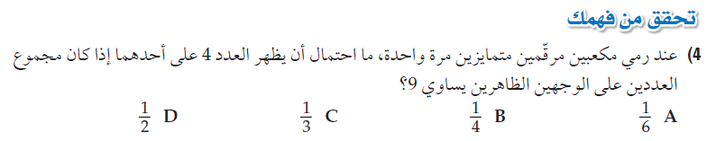

.....................................................................................................................................................

.....................................................................................................................................................

.....................................................................................................................................................

.....................................................................................................................................................

.....................................................................................................................................................

.....................................................................................................................................................


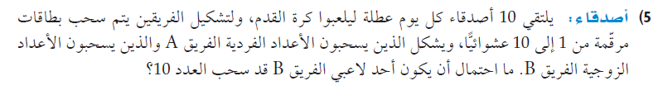
.....................................................................................................................................................

.....................................................................................................................................................

.....................................................................................................................................................

.....................................................................................................................................................

.....................................................................................................................................................

.....................................................................................................................................................


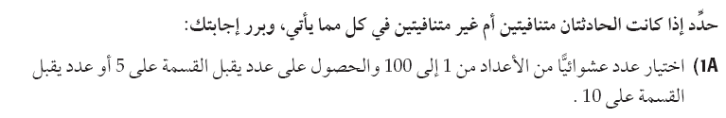
......................................................................................................................................................
......................................................................................................................................................


6 | 5 | 4 | 3 | 2 | 1
(1,6) | (1,5) | (1,4) | (1,3) | (1,2) | (1,1) | 1
(2,6) | (2,5) | (2,4) | (2,3) | (2,2) | (2,1) | 2
(3,6) | (3,5) | (3,4) | (3,3) | (3,2) | (3,1) | 3
(4,6) | (4,5) | (4,4) | (4,3) | (4,2) | (4,1) | 4
(5,6) | (5,5) | (5,4) | (5,3) | (5,2) | (5,1) | 5
(6,6) | (6,5) | (6,4) | (6,3) | (6,2) | (6,1) | 6

......................................................................................................................................................

......................................................................................................................................................

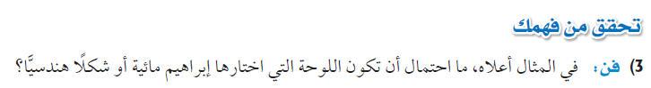
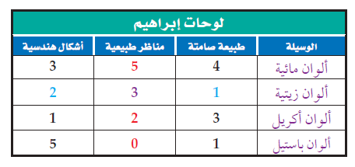
......................................................................................................................................................

......................................................................................................................................................


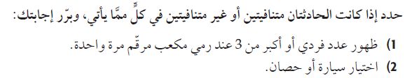
......................................................................................................................................................

......................................................................................................................................................

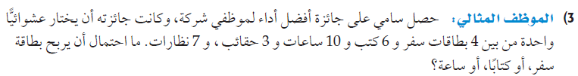
......................................................................................................................................................

......................................................................................................................................................

......................................................................................................................................................

......................................................................................................................................................

.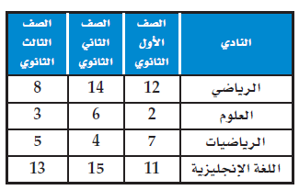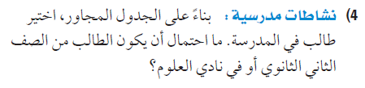
......................................................................................................................................................

......................................................................................................................................................

......................................................................................................................................................

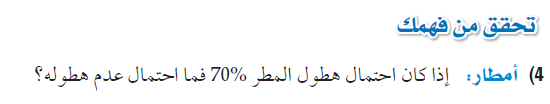
......................................................................................................................................................

......................................................................................................................................................

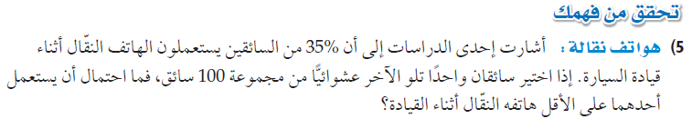
......................................................................................................................................................

......................................................................................................................................................

......................................................................................................................................................

......................................................................................................................................................


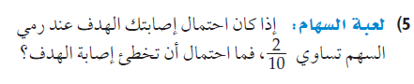
......................................................................................................................................................

......................................................................................................................................................

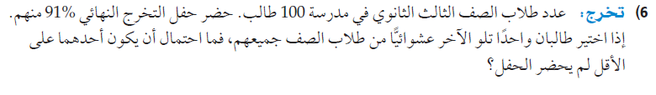
......................................................................................................................................................

......................................................................................................................................................

......................................................................................................................................................

......................................................................................................................................................

الفصل الرابع
حساب المثلثات
1-الدوال المثلثية في المثلثات القائمة الزاوية
2-الزوايا وقياساتها
3-الدوال المثلثية للزوايا
4-قانون الجيوب
5-قانون جيوب التمام
6-الدوال الدائرية
7-تمثيل الدوال المثلثية بيانيا
8-الدوال المثلثية العكسية
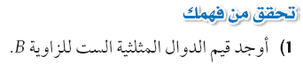
......................................................................................................................................................

......................................................................................................................................................

......................................................................................................................................................

......................................................................................................................................................

......................................................................................................................................................

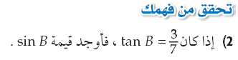
......................................................................................................................................................

......................................................................................................................................................

......................................................................................................................................................

......................................................................................................................................................

......................................................................................................................................................


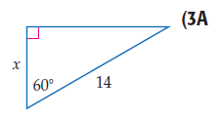

......................................................................................................................................................

......................................................................................................................................................

......................................................................................................................................................

......................................................................................................................................................

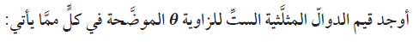
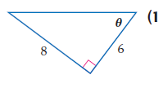
......................................................................................................................................................

......................................................................................................................................................

......................................................................................................................................................

......................................................................................................................................................

......................................................................................................................................................

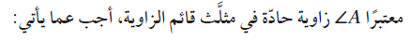
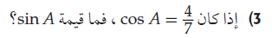
......................................................................................................................................................

......................................................................................................................................................

......................................................................................................................................................

......................................................................................................................................................

......................................................................................................................................................

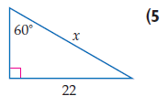
......................................................................................................................................................

......................................................................................................................................................

......................................................................................................................................................

......................................................................................................................................................
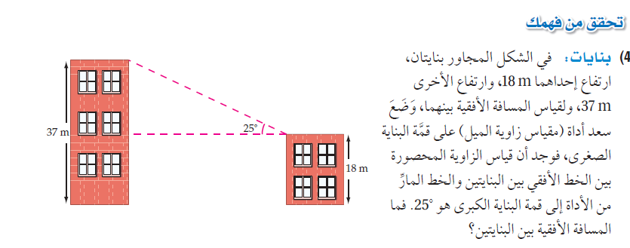
......................................................................................................................................................

......................................................................................................................................................

......................................................................................................................................................

......................................................................................................................................................

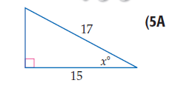
......................................................................................................................................................

......................................................................................................................................................

......................................................................................................................................................

......................................................................................................................................................

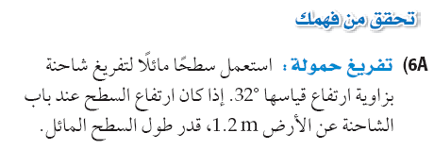

......................................................................................................................................................

......................................................................................................................................................

......................................................................................................................................................

.....................................................................................................................................................

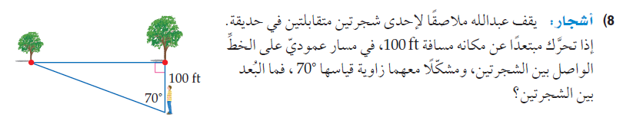
......................................................................................................................................................

......................................................................................................................................................

......................................................................................................................................................

......................................................................................................................................................

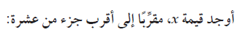
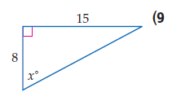
......................................................................................................................................................

......................................................................................................................................................

......................................................................................................................................................

......................................................................................................................................................

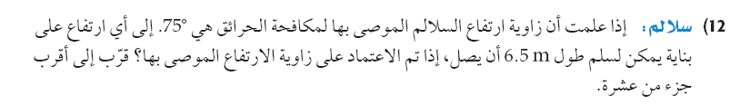

......................................................................................................................................................

......................................................................................................................................................

......................................................................................................................................................

......................................................................................................................................................

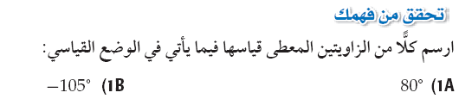



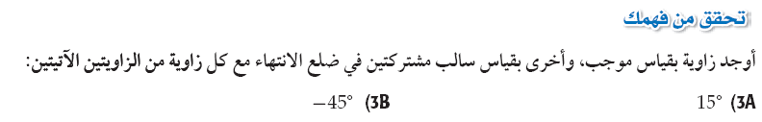

......................................................................................................................................................

......................................................................................................................................................

......................................................................................................................................................

......................................................................................................................................................


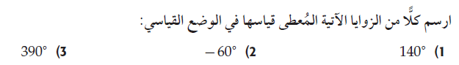

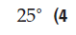
......................................................................................................................................................

......................................................................................................................................................

......................................................................................................................................................

......................................................................................................................................................

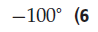
......................................................................................................................................................

......................................................................................................................................................

......................................................................................................................................................

......................................................................................................................................................

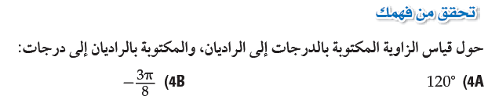
......................................................................................................................................................

......................................................................................................................................................

......................................................................................................................................................

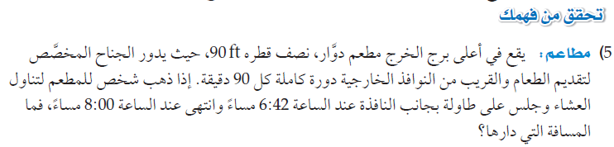
......................................................................................................................................................

......................................................................................................................................................

......................................................................................................................................................

......................................................................................................................................................


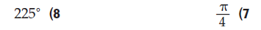
......................................................................................................................................................

......................................................................................................................................................

......................................................................................................................................................

......................................................................................................................................................

......................................................................................................................................................

......................................................................................................................................................

......................................................................................................................................................

......................................................................................................................................................

......................................................................................................................................................

......................................................................................................................................................

......................................................................................................................................................

......................................................................................................................................................

......................................................................................................................................................

......................................................................................................................................................


أوجد الزاوية المرجعية للزاوية الآتية:
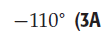
......................................................................................................................................................

......................................................................................................................................................

......................................................................................................................................................


أوجدي القيمة الدقيقة للزاوية المثلثية الآتية باستخدام الزاوية المرجعية:









