
Kingdom of Saudi Arabia
Ministry of Education
Tabuk Educational Zone
The 1st Intermediate school

_48_
48

The Final Exam
First term
First Session
1435-1436 H
First grade

اختبار كامل المنهج
for 1st Grade intermediate (1435 / 36 A.H.)
Seat No: ……….................................................................. : s nameۥStudent

Reviewed by | Corrected by | Marks | Question’s No.
 |  |  | Question 1
 |  |  | Question 2
 |  |  | Question 3
 |  |  | Question 4
 |  |  | Question 5
___48___  48 |  |  | TOTAL

10

10

I- Composition
Q1: Write a paragraph about Riyadh Zoo using these words :
AlMalaz district - lions – monkeys – tigers – elephants
Any suitable answer for the student .
2marks for ideas - 1 for structure - 2 for writing techniques
................................................................................................

( 1 )
II- Comprehension
10

10
Q2: Read the following passage then, answer the questions:
Fahad is a student. He is 13 years old . He goes to school at seven o'clock
in the morning and comes back at 1 o'clock in the afternoon. His parents love him because he is clever and he helps them. Fahad likes English and maths and he wants to be a pilot one day.
A- Answer the following questions:
1- How old is Fahad ?
He is 13 years old . (2 m)
2- Why do his parents love him ?
His parents love him because he is clever and he helps them. (2 m)
3- Does he go to school at 5 o'clock ?
No, he doesn't. (2 m)
B- Tick true or false in the following sentences:
1- Fahad is a student . √□ T(1 m) □ F
2- He comes back home at 3 o'clock in the afternoon. □ T ×□ F(1 m)
C- Choose the correct word:
1- Fahad wants to be a { vet – farmer – pilot } one day. (1 m)
2- Fahad likes { science – English – history }(1 m)
12

12

III- Grammar

Q3: A- Choose the correct answers :

1- ( I - He - They ) am Omar . (1 m)
2- It is ( her - its - his ) camera . (1 m)
3- It's ( Fatimah - Fatimahs - Fatimah's ) computer . (1 m)
4- I am ( eat - ate - eating ) breakfast . (1 m)
5- I ( like - likes - liking ) swimming . (1 m)
6- They ( don't - doesn't - does ) like shopping . (1 m)
7- I ( was - were - is ) late . (1 m)
8- Thank you for ( help - helps - helping ) me with my English . (1 m)

( 2 )
B - Do as shown between brackets :

1- a-an apple . b-a garden . (2 m)
c-a bus . d-an egg .
( Use a or an )


2- Are they playing ?
Yes, they are. (2 m) {Complete the answer }

IV- Vocabulary
10

10

Q4: A- Match the opposites :

early | 7(½m) | in | 1
outside | 1(½m) | midday | 2
open | 8(½m) | wet | 3
never | 6(½m) | hot | 4
dry | 3(½m) | north | 5
midnight | 2(½m) | always | 6
south | 5(½m) | late | 7
cold | 4(½m) | closed | 8
 |  | scruffy | 9

B- Put the right words under the right pictures:
library – policeman - computer – winter – kebab -son - toothache







toothache(1m) policeman (1m) son (1m) winter (1m) computer (1m) library (1m)
( 3 )
V- Spelling
6

6

Q5: A- Write the missing litter :

 | 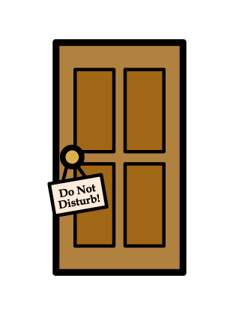 |  | 
bed(½m) | Door(½m) | lion(½m) | fish (½m)
( l - m - d - r - f )

 |  |  |   
raich  chair(1m) | potato(1m)  otatop | nrreg peper  green pepper(1m) | cloud(1m)  loudc
B- Choose the right spelling :

( 4 )

